Activity 2: Large organisations

Task 1: Research a company – Novartis
Read through the information below. To find more about Novartis, you can visit their website www.novartis.com/about and watch two short videos.

Novartis is a large international pharmaceutical organisation based in Basel, Switzerland. It researches, manufactures and sells pharmaceuticals.
A breakdown of Novartis employees’ activity by location is shown below. Most operations take place in Europe.
Employee breakdown for location and country. 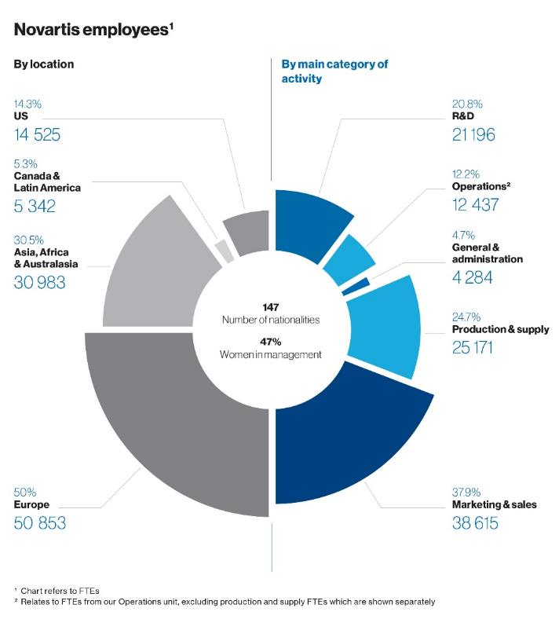
Novartis in Society: Integrated report 2022 (c) Novartis AG

Novartis has a history of developing innovative treatments that aim to address challenging health issues. These mainly focus on areas where there are gaps in currently available treatments.
The company focuses on five main therapeutic areas:
- cardiovascular diseases such as stroke prevention and heart failure;
- haematology-related diseases such as leukaemia and other blood cancers;
- solid cancer tumours such as glioblastoma and prostate cancer;
- immunology that includes autoimmune diseases such as lupus and multiple sclerosis;
- brain diseases such as dementia.
In addition, Novartis is developing new treatments for eye-related conditions that include diabetic eye disease, and respiratory diseases such as chronic obstructive pulmonary disease (COPD).

Task 2: Create a fact file
Create a fact file on Novartis including key information such as the location, number of employees and key areas of work.
Provide specific details of any work undertaken in the following areas:
- research and development
- data analysis
- clinical testing/trials
- quality control/assurance
- product development
- scientific publishing
- manufacturing

Task 3: Create a job mind map
By carrying out some research into Novartis, you will create a mind map to show the variety of science-related roles for people who work within Novartis.
Draw a mind map to show some of the different types of jobs and professional roles that are advertised on the Novartis job search.
Go to www.novartis.com/careers
Use the job search to find one job in each of the following areas:

- research and development
- data analysis
- clinical testing/trials
- quality control
- quality assurance
- product development
- scientific publishing
- manufacturing.

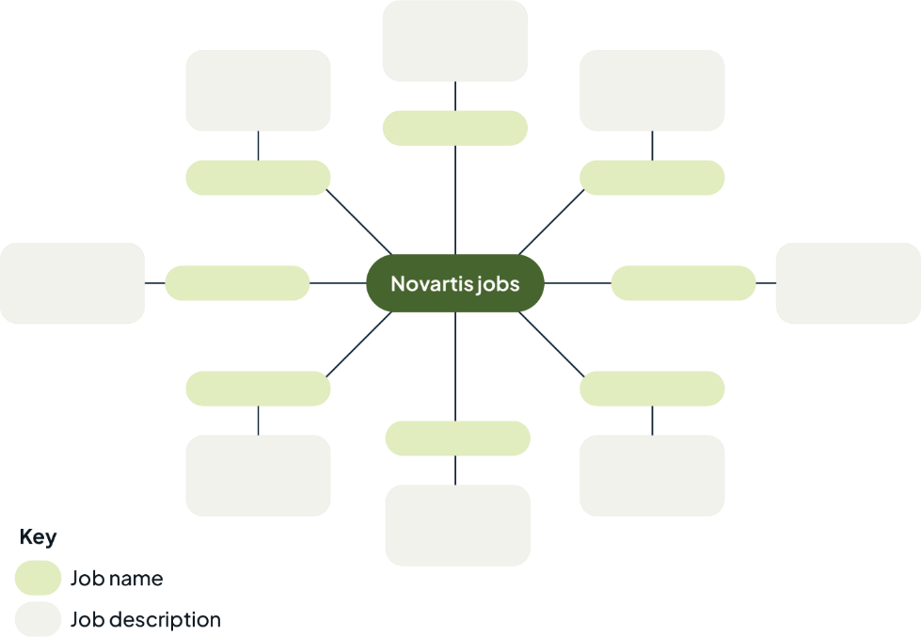
For each job, add one short sentence to describe the role.
Arrange your mind map like the template to the right.

