
Processor components
To help you remember how the processor works, you can use this activity sheet to capture your notes.

Arithmetic logic unit | 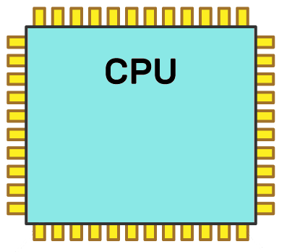  ALU  Control Unit  Clock  Registers  Bus  Bus  Bus  Bus | Clock
 |  | Buses
Control unit |  | Registers



A games developer has been to see their manager to report issues with their laptop. The games developer explains that it is taking twice as long to build each section of code as it has done in the past. The games developer has a reliable and fast internet connection, so this is not the reason for the issue. Explore the possible reasons why the games developer may be experiencing issues with build time.

