
Digital Production, Design and Development
Digital Environments


Apply it activity briefs
Ella’s personal training   | Ella is a personal trainer who has decided to set up her own fitness suite. She has rented a room at the local leisure centre, which already has some fitness machines and weights.  She has a high specification laptop which she can use for administrative tasks, but is keen to invest in more technology for other areas of the business. She has received a grant of £10,000 from the local council through an initiative to improve the health and wellbeing of the local population.  Ella is looking to invest in hardware to develop her business.
Photo by Cliff Booth from Pexels: https://www.pexels.com/photo/photo-of-women-exercising-4056616/

Delivereaze   | Delivereaze is a grocery delivery business that has offices in several locations and a fleet of vehicles that operate across the country.  They have an administrative team who are based in offices, who are responsible for booking in and scheduling deliveries. The drivers are given a printed schedule each day and a route to follow. Drivers must provide proof of delivery via uploading a photo of the groceries on the customer's doorstep.  The company currently has a number of stand alone servers that support business operations. For example, they have a web server, a mail server, a database server and a print server.  The company has hardware and software requirements and is specifically interested in virtualisation.
Photo by Kindel Media from Pexels: https://www.pexels.com/photo/man-in-orange-shirt-holding-black-and-orange-plastic-box-with-fresh-vegetables-6868797/
Beanz   | Beanz is an independent coffee retailer and has four outlets in a large city. The owner of the business places orders centrally for the supplies for all four outlets based on each outlet’s sales information. Managers at each branch have to report centrally about the sales performance of each outlet.  The business is currently in the process of upgrading their IT systems so that each coffee shop will have an Electronic Point of Sale (EPOS) system. Each coffee shop will also need to have a link to “head office” (based at the business owner’s home) for the sales data to be uploaded at the end of each day. The coffee shops are going to install tablets that will display orders that have been entered into the till for the barista to fulfil. Wireless internet access will also be provided for customers.  The business has network requirements and are also considering implementing cloud technology.
Photo by Dmitry Zvolskiy from Pexels: https://www.pexels.com/photo/top-view-photo-of-restaurant-2253643/
Hills Road Surgery   | Hills Road Surgery is a doctors practice (GP) based in a small town.  The surgery holds lots of sensitive personal information about patients. This information includes contact details, personal medical history and details of medication prescribed.  The surgery has data storage and recovery requirements to ensure they keep their patient records and sensitive information secure.
Photo by Antoni Shkraba from Pexels: https://www.pexels.com/photo/doctor-checking-the-back-of-a-patient-5215013/
Trainer trader  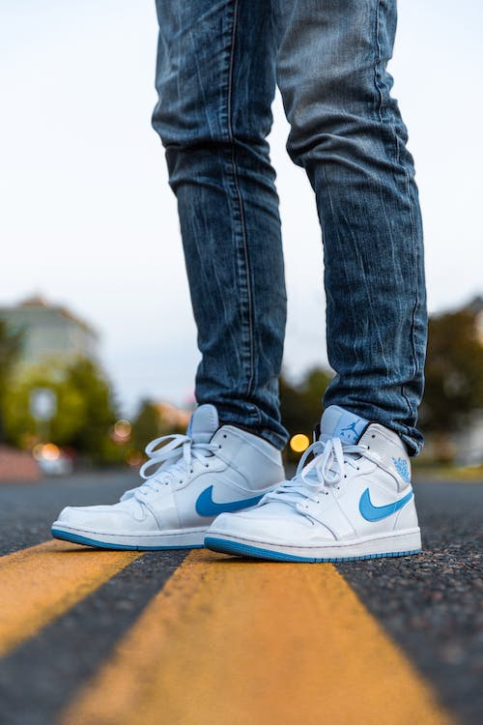 | Trainer Trader is a supplier of limited edition designer trainers that was started by Sam whilst they were studying at University.  Sam currently sells trainers via third party retail sites. The business is doing really well and Sam wants to develop their own online purchasing site. This will enable them to manage orders more efficiently and not have to pay fees each time they sell a pair of trainers.  As the business has developed Sam has employed more staff to help meet customer demand. Sam now employs a team of five staff who all work in a small office attached to the distribution warehouse. Currently all staff have a networked PC with all applications installed on the individual computers.  Sam is looking to improve opportunities for collaboration amongst their team of staff. Sam is also keen to develop a new purchasing website to support the rapidly increasing number of web sales.
Photo by Arthur Ogleznev from Pexels: https://www.pexels.com/photo/person-wearing-white-and-blue-air-jordan-1-s-1102777/

