
RAID
Redundant Array of Independent Disks (RAID) is a physical storage and recovery system. It is a type of storage that writes across multiple hard drives within the same system. Use this activity sheet to make notes on the different types of RAID implementation.

 | RAID 1  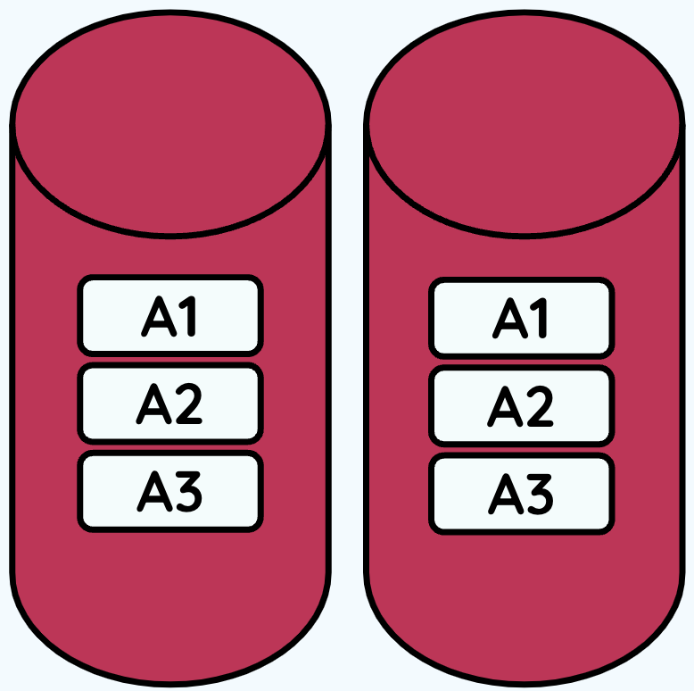 | RAID 5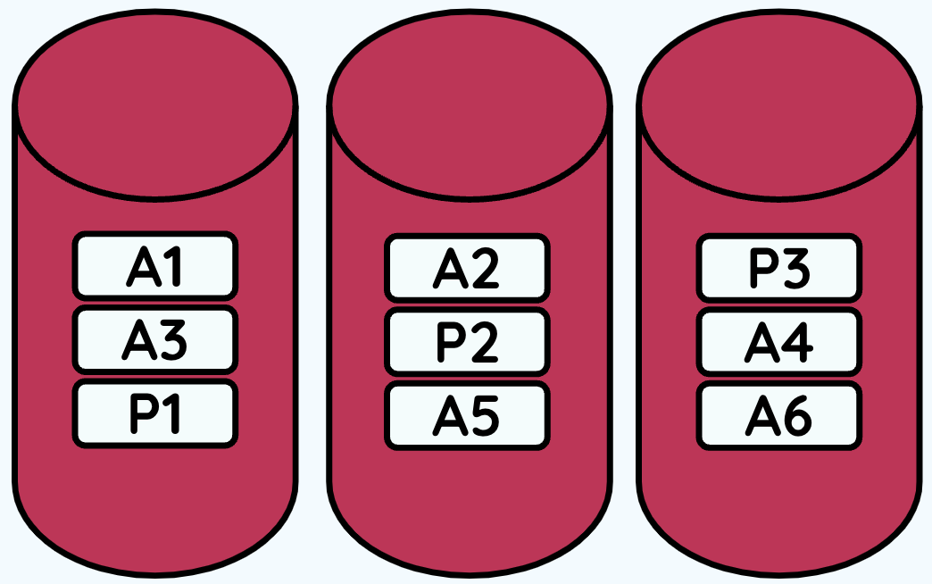 | RAID 10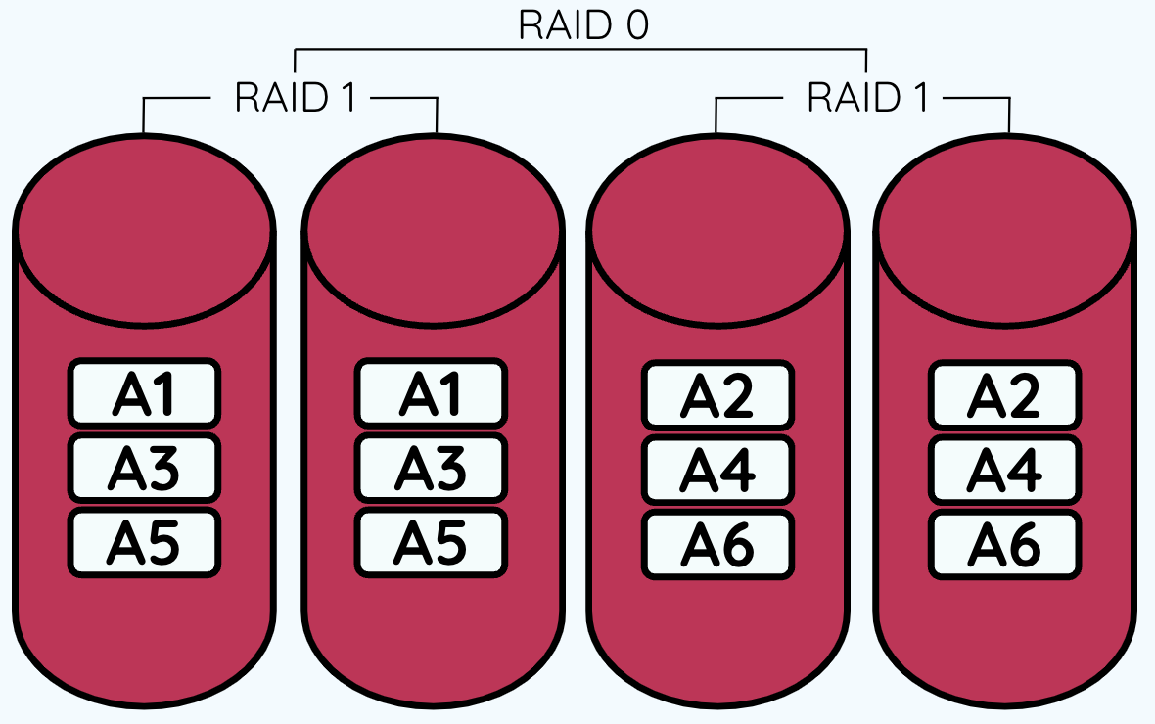
Minimum no. of disks required
Mirrored | (Y/N) | (Y/N) | (Y/N)
Redundancy
Read performance
Write performance
Stiped | (Y/N) | (Y/N) | (Y/N)
Parity | (Y/N) | (Y/N) | (Y/N)



