
RAID
Redundant Array of Independent Disks (RAID) is a physical storage and recovery system. It is a type of storage that writes across multiple hard drives within the same system. Use this worksheet to make notes on the different types of RAID implementation.

 | RAID 1  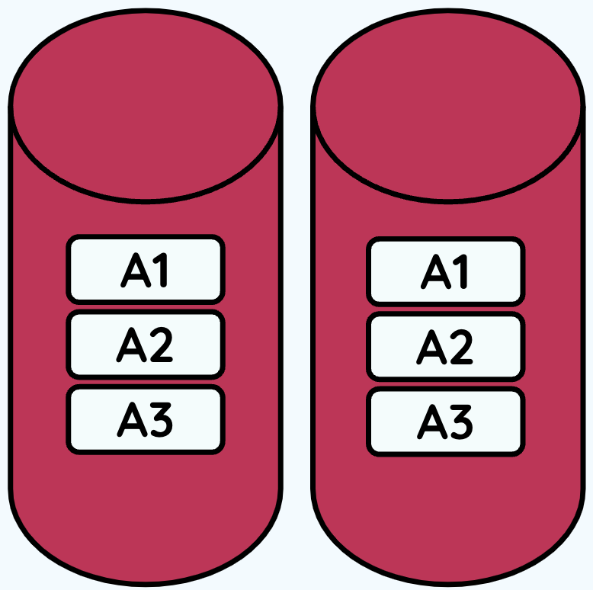 | RAID 5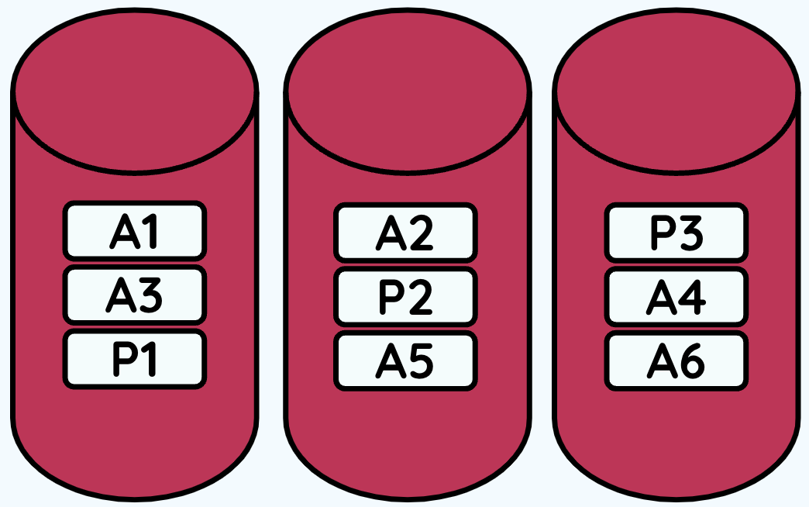 | RAID 10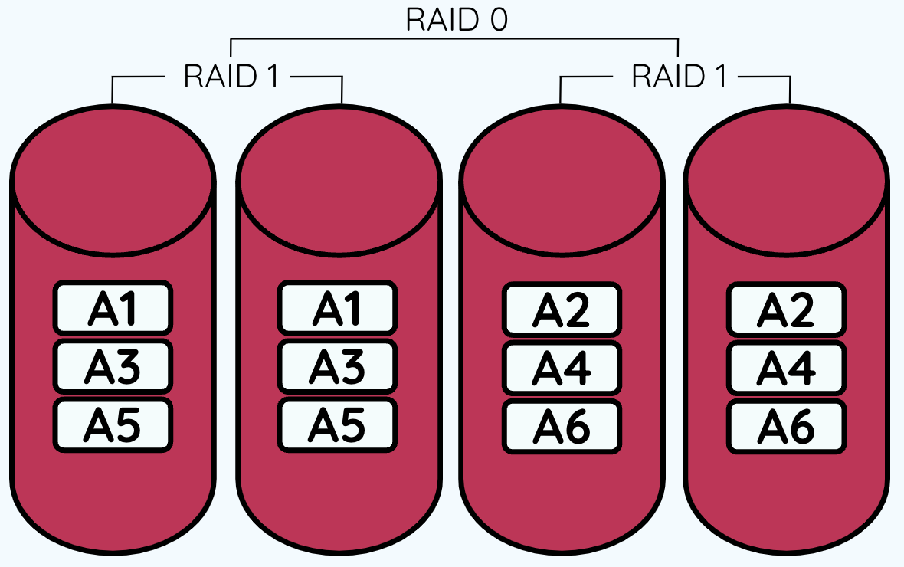
Minimum no. of disks required | 2 | 3 | 4
Mirrored | Y | N | Y
Redundancy | Excellent | Good | Excellent
Read performance | Good | Good | Excellent
Write performance | Slow | Very fast | Fast
Stiped | N | Y | Y
Parity | N | Y | Y


