
Advantages and limitations of transmission media

Transmission medium | Description | Cost | Speed | Distance | Considerations
Copper cable/Ethernet cable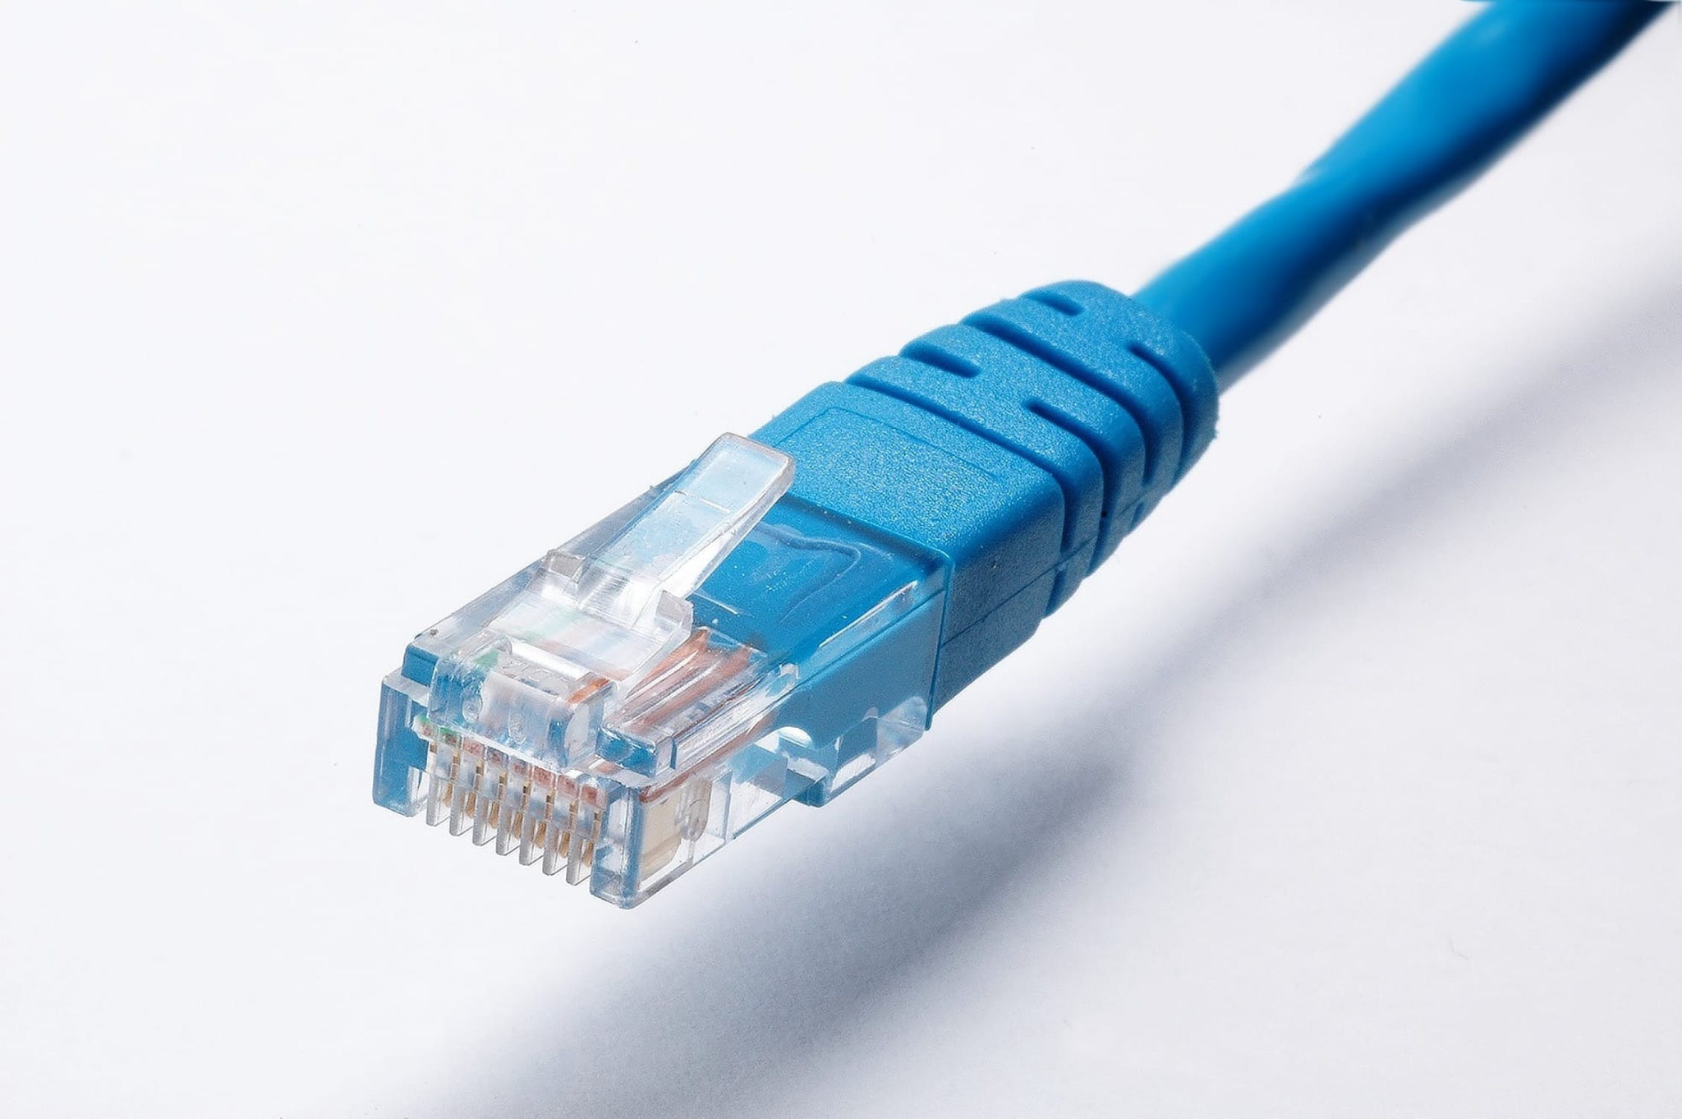 | Wired transmission medium. It uses electrical signals to transmit data. | Cheaper to buy and install than a fibre-optic cable. | Data transfer is slower compared to a fibre-optic cable, but speeds are generally faster than via Wi-Fi. | The signals in copper cables degenerate over long distances, such as 100m for Cat 5. | More prone to signal disturbances than a fibre-optic cable.  Typically more stable than wireless connections.  More time-consuming to expand compared to wireless connections.
Fibre-optic cable  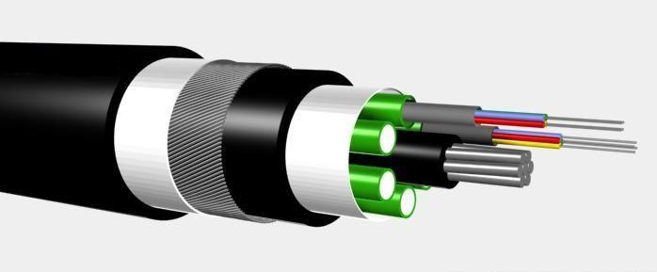 | Wired transmission medium. It uses light pulses as signals to transmit data. | More expensive to buy and install than a copper cable. | Data transfer is faster than with a copper cable. | Performs well over long distances (up to 100km). | Less prone to signal disturbances than a copper cable or wireless transmission.  Typically more stable than wireless connections.
Wi-Fi  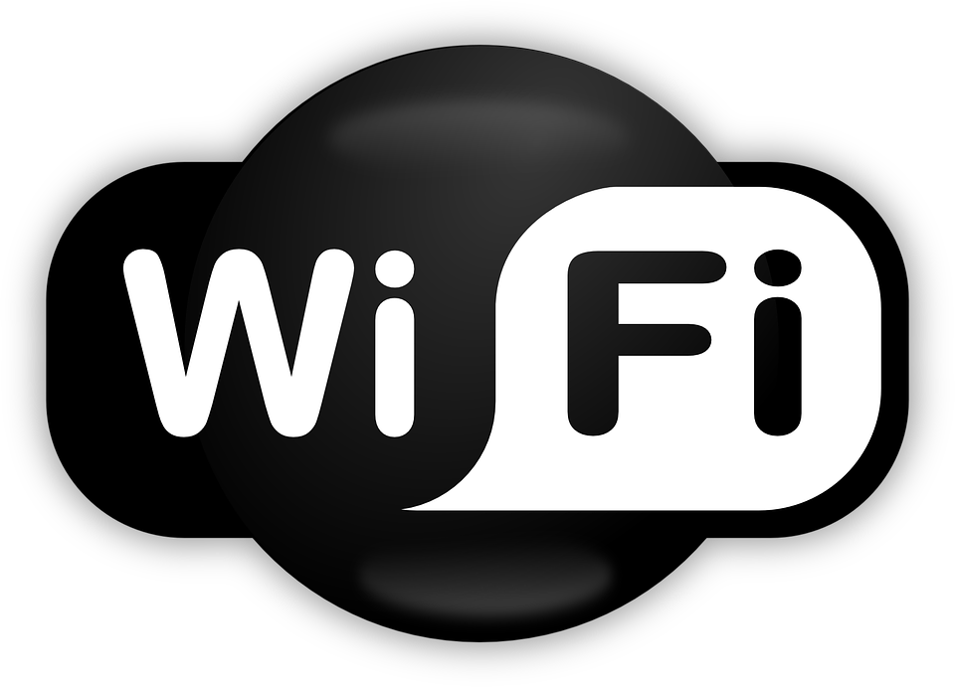 | Wireless transmission medium. It uses radio frequencies to send signals. Wi-Fi is typically used to connect multiple devices to a network and/or the internet. | It is cheaper to set up a small wireless network than a wired network. | As more devices connect to a single wireless access point, the speed of individual connections decreases. This is because the connection is shared. | Wi-Fi signals can transmit data up to 50 metres.  The strength of the network connectivity is reduced as you move away from the access point. | Multiple users can access the network with minimal configuration (typically a shared key).  Wi-Fi networks are more susceptible to hacking, particularly when used in public spaces.  Wireless connections allow increased mobility for users, as devices can move around and stay connected to the network.
Bluetooth   | Wireless transmission medium. It uses radio frequencies to transmit data. Bluetooth is typically used to connect devices over a small area like a wireless mouse, keyboard, or speaker system to a computer. | Bluetooth devices such as keyboards are more expensive to buy than wired versions. | Data transfer via Bluetooth is much slower than via Wi-Fi. | Data can only be transmitted up to 10 metres, which is much shorter than via Wi-Fi. | Reduced interference from other wireless devices compared to Wi-Fi.  Bluetooth devices use less power than Wi-Fi–enabled devices.  Bluetooth can be vulnerable to hacking because users often leave their connections exposed.

Scenarios .
Read the scenarios carefully and decide which transmission medium would be most suitable for the situation being described.

Underline your chosen transmission medium.

- The chef goes live!

A chef creates live, online content and would like to purchase a new headset so that they can listen to questions from their viewers whilst continuing to cook. The chef needs to be able to move freely around the kitchen whilst using the headset.

What type of transmission medium does the chef need?

Copper cable Fibre-optic cable Wi-Fi Bluetooth

- A local coffee shop

A coffee shop owner has had requests from their customers for free access to the internet whilst they are in the shop. The owner already has an internet connection and would like to share this internet connection with their customers. The tables in the shop are regularly moved around and it is often very busy.

What type of transmission medium will the coffee shop owner need to use?

Copper cable Fibre-optic cable Wi-Fi Bluetooth

- The online gamer

An online gamer requires a new mouse and keyboard. They want to be able to change positions frequently without having to worry about wires getting in the way and knocking things over.

What type of transmission medium should the online gamer look for when purchasing the keyboard and mouse?

Copper cable Fibre-optic cable Wi-Fi Bluetooth

- Print on demand

A homeowner wants to purchase a printer that anyone in the household can print to. Their house has three floors. The printer will be placed in the entrance hall on the bottom floor and needs to be accessible from the top floor. They have just renovated the home and do not want to install any new wiring in the building.

What type of transmission medium should the homeowner look for when purchasing the printer?

Copper cable Fibre-optic cable Wi-Fi Bluetooth

- The TV studio

A new TV studio is being designed. The studio will be producing news clips for an online streaming service. They will need to be able to send large video files at high speeds around the network for review and editing purposes. The network connection must be stable and secure. They are prepared to pay a large amount of money for the most effective solution.

What type of transmission medium should the TV studio use?

Copper cable Fibre-optic cable Wi-Fi Bluetooth

- The bakery

A small bakery has three desktop computers that they would like to connect together to allow the bakers to share recipes and send invoices to customers. The desktop computers are in a fixed location and are all quite close to each other. The bakery has a minimal budget for setting up this small network. They have a lot of old bakery equipment that could potentially interfere with a signal, and they would like the connection to be as stable as possible within their low budget.

What type of transmission medium should the bakery use?

Copper cable Fibre-optic cable Wi-Fi Bluetooth

Explorer task .
Justify your choices for each scenario below.

1
2
3
4
5
6

Image sources:
https://www.pexels.com/photo/cable-connection-connector-cord-415043/
https://commons.wikimedia.org/wiki/File:Optical_fiber_cable.jpg
https://pixabay.com/vectors/wifi-access-internet-logo-network-158401/
https://pixabay.com/vectors/bluetooth-icon-bluetooth-logo-670069/

