
Network types and models
There are lots of different ways that a network can be created. Read the sections below to learn more about the different types of network and network models.

Network types .

Local Area Network (LAN)
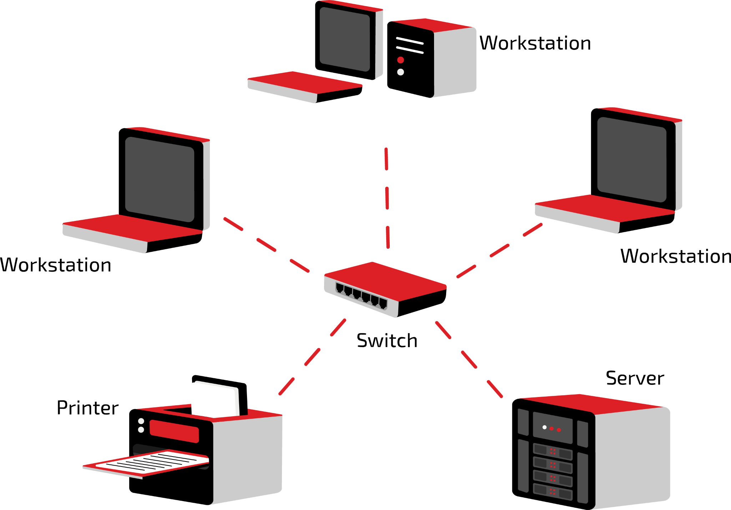
A local area network (LAN) refers to a network that is formed when devices in the same building or on a single site are connected. A network in your home, workplace, or school/college will be a LAN.

One characteristic of a local area network is that the infrastructure (cabling and network communication devices) will be owned and maintained by the organisation (or the organisation may employ someone to do this for them).

A wireless local area network (WLAN) is basically the same as a LAN but without the cables connecting the devices. Instead they are connected using wireless technology.

Wide Area Network (WAN)

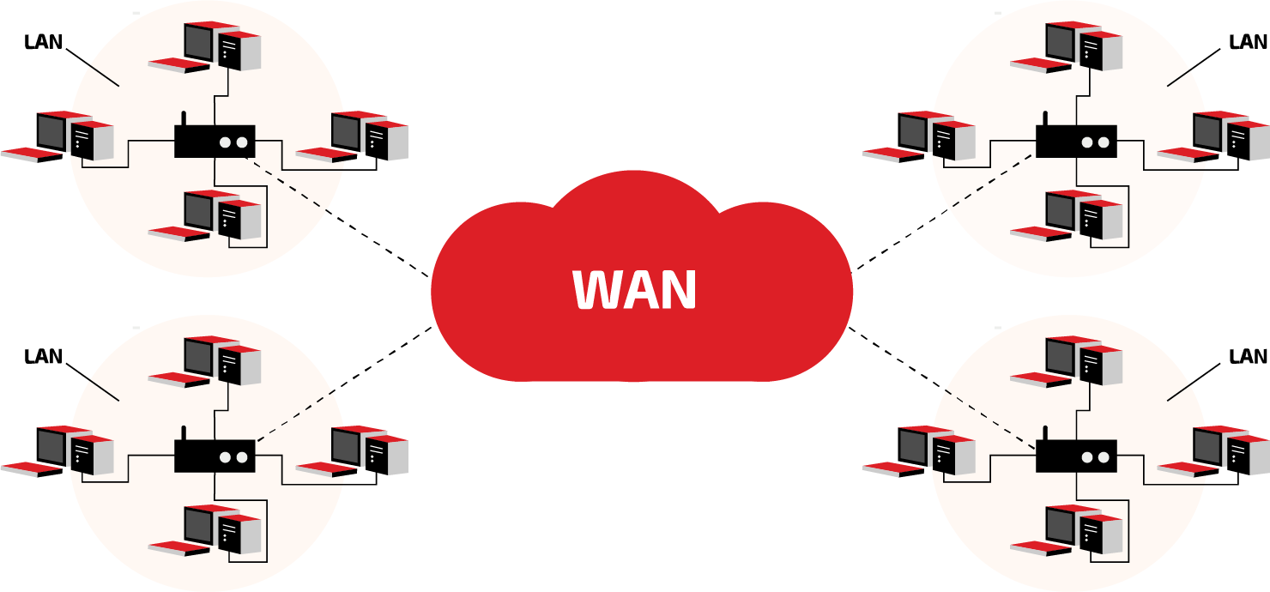
When two or more networks are connected across a large geographical area, they form a wide area network (WAN). The largest example of a WAN is the internet.

Many WANs will make use of telecommunication links owned and managed by other companies. Organisations that run their own WANs will often lease bandwidth from telecommunication companies.


A wireless wide area network (WWAN) uses mobile phone signals or satellites to transmit signals over a wide area.

Personal Area Network (PAN)

A personal area network (PAN) is used to connect personal devices over a very small area.

They can be created using Ethernet, FireWire, or USB cables.

A wireless personal area network (WPAN) most commonly uses Bluetooth technology, which uses short-range radio signals.

You create a WPAN when you connect a smartwatch to a mobile phone or a wireless headset to your laptop.

Network models

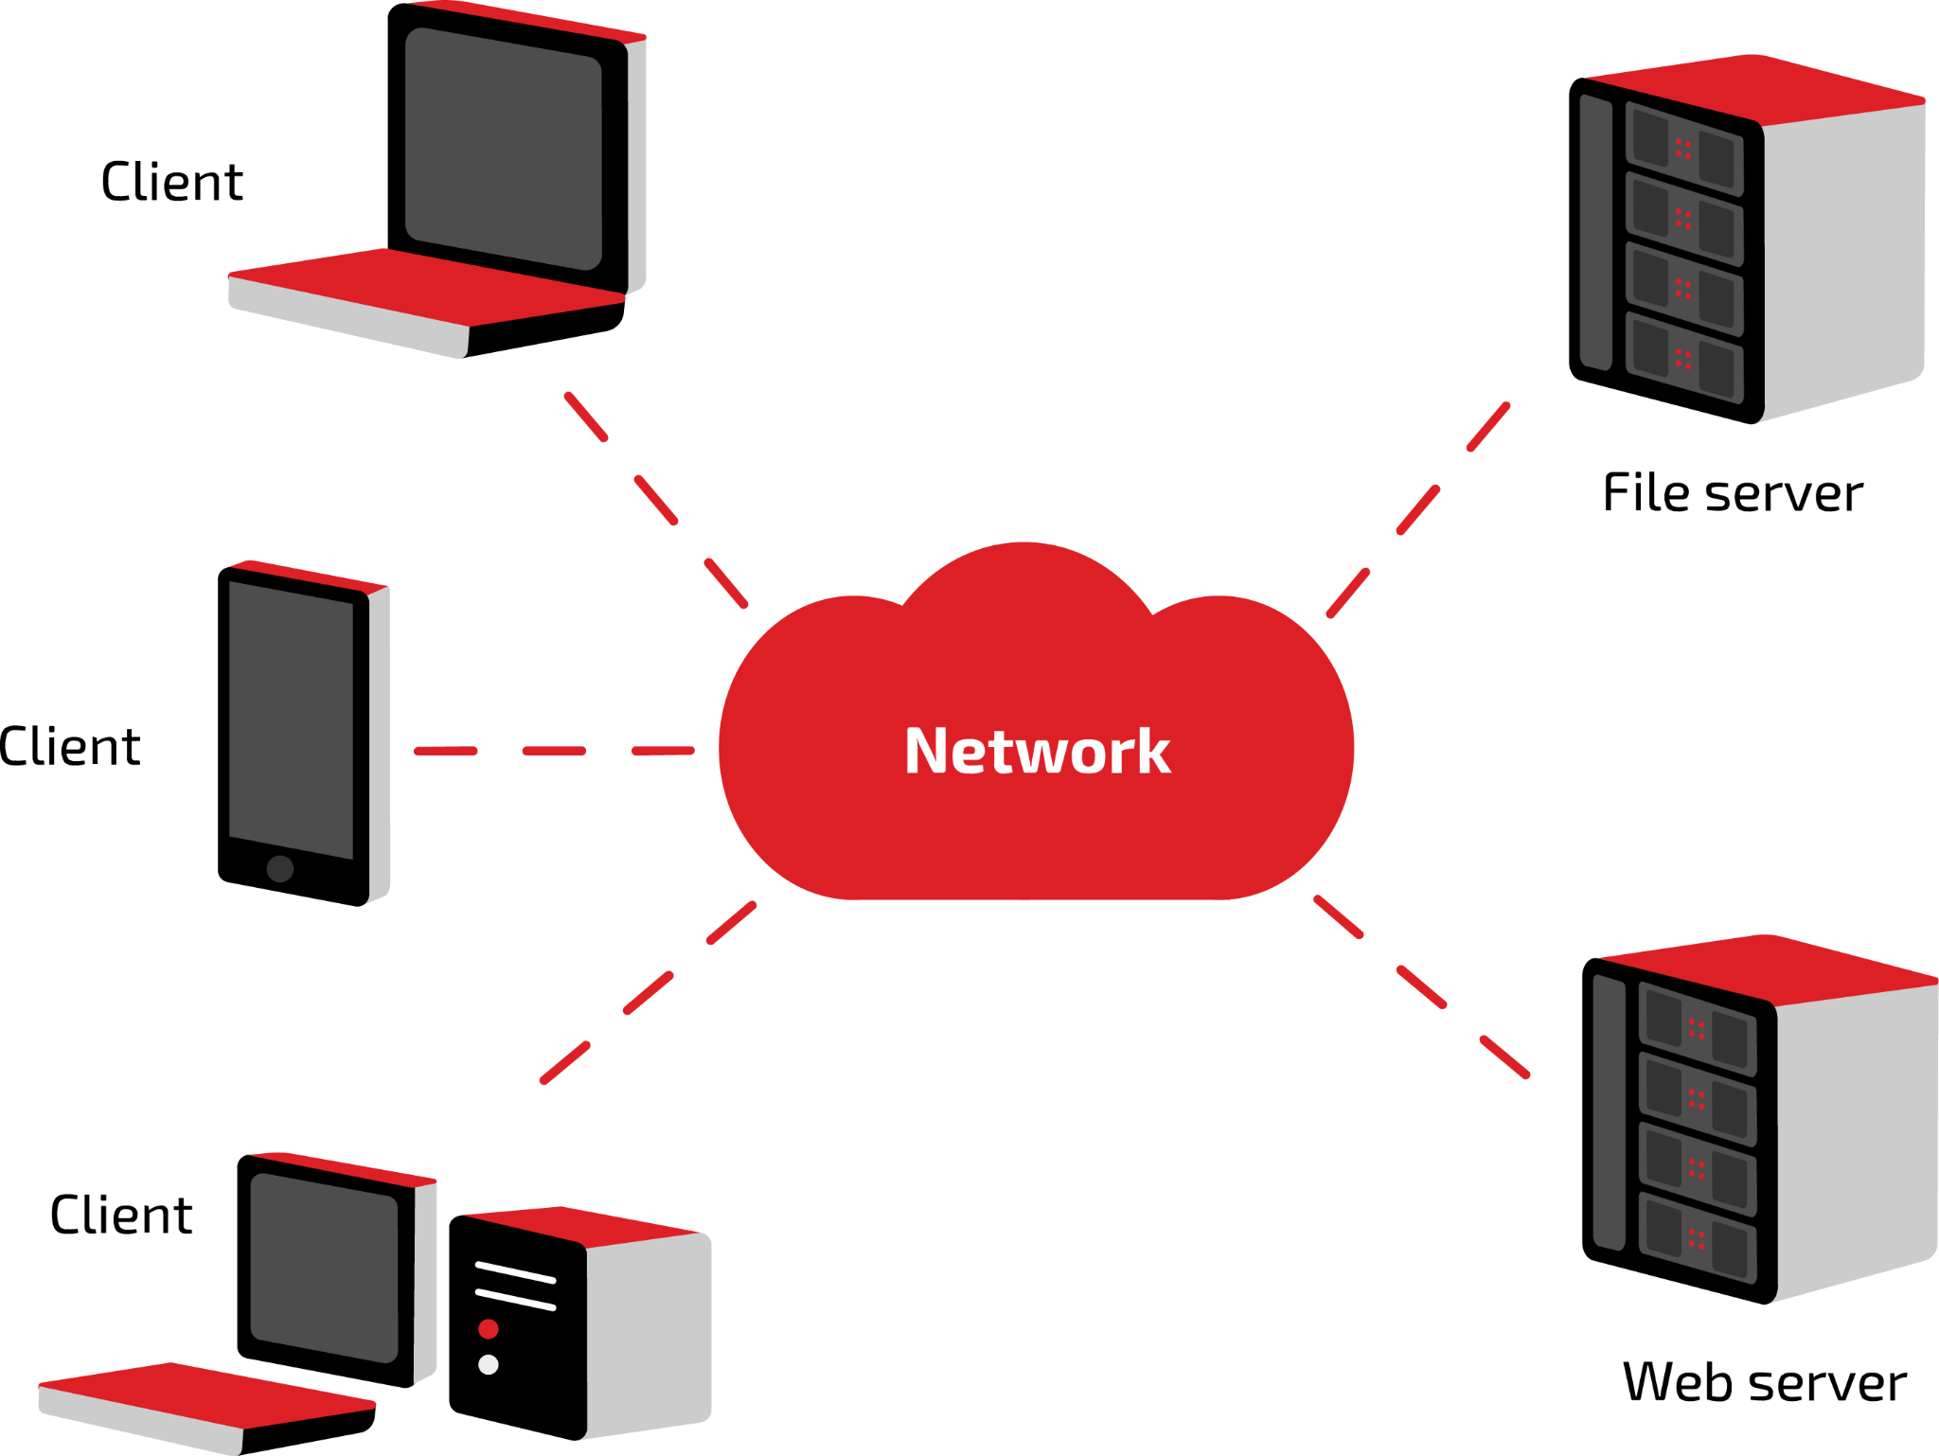
Client–server model

In the client–server model, a dedicated server will fulfil requests for one or more clients.
Typical servers will be web servers, email servers, and servers that host games.
If the server fails, users will lose service, unless there is a failover system in place.

Peer-to-peer model
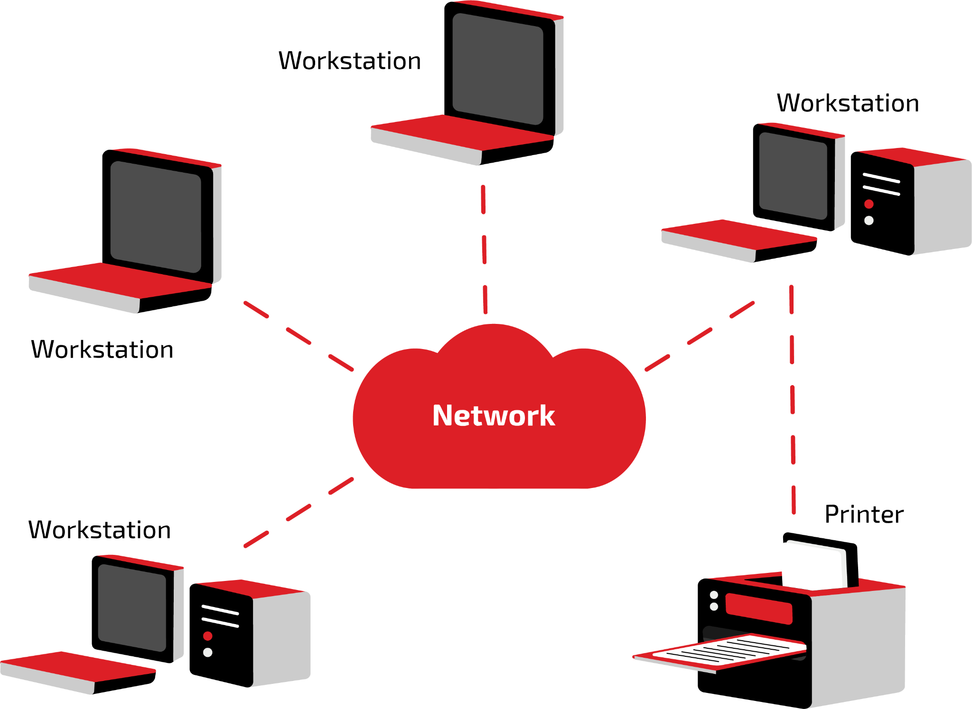

In a peer-to-peer model, each device can be configured to share its resources such as processing power or internet bandwidth.
This model does not have a network authentication server or dedicated servers for other functions. This makes it cheaper to set up than a client–server model.

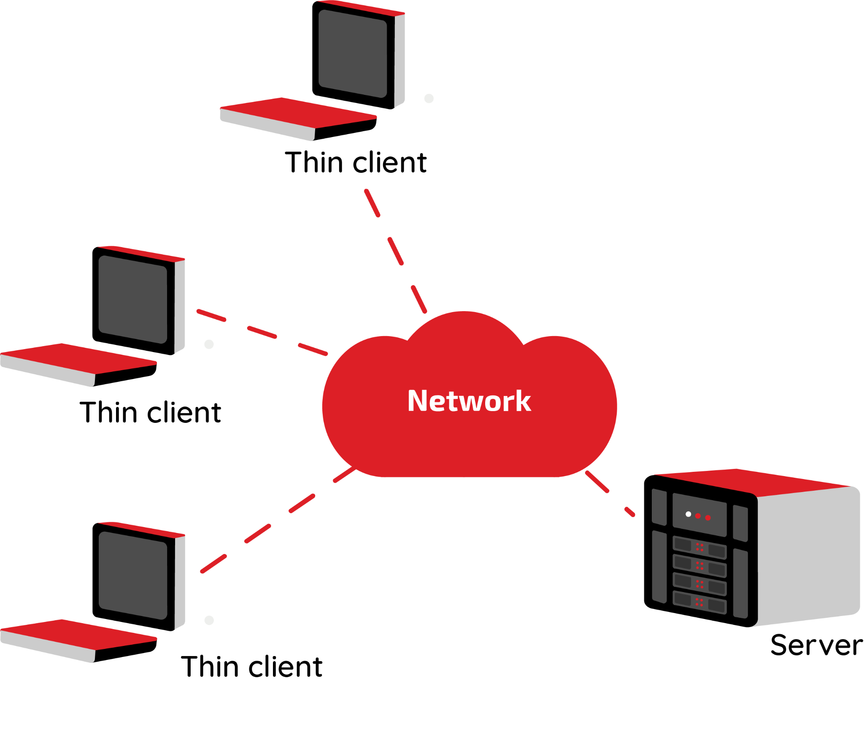
Thin client model

Unlike a standard computer, a thin client is a device that has limited resources such as main memory, secondary storage, and processing capability.
Application servers such as database servers are used to perform most of the data processing. Files can be stored and accessed from file servers.
Thin clients are low-cost machines. They share the resources of a few more expensive servers.

Activity
You have been tasked with setting up a small network for a charity that has moved to a new office. Research the effects of bandwidth and latency on networks and the impact this may have on the employees’ work at the charity.
Prepare a short explanation to share with the CEO of the charity.
You should include these key terms in your explanation:
Bandwidth Latency Transmission medium

Propagation delay Distance Network traffic

Bandwidth is the maximum rate of data transfer of a communication channel over a type of transmission medium. The relationship between bandwidth and bit rate is directly proportional: the greater the amount of data that can be transmitted over a channel, the more bits can be transmitted per second.

Propagation delay refers to the amount of time it takes for the first bit to travel over a link between sender and receiver, whereas network latency refers to the total amount of time it takes to send an entire message. Sometimes the time that it takes for the signal to travel from the transmitter to the receiver can be noticeable, especially over long distances and if there is a lot of network traffic.

If the charity does not have sufficient bandwidth or experiences high latency, the work of the employees could be affected as they will have to wait to upload/download documents or they may experience issues with video communications which typically require higher bandwidth.

