End-of-unit assessment
1. Explain one advantage of using volumetric construction.
(2)

……………………………………………………………………………………………………………………………………………………………………………………………

……………………………………………………………………………………………………………………………………………………………………………………………

……………………………………………………………………………………………………………………………………………………………………………………………

……………………………………………………………………………………………………………………………………………………………………………………………

2. Figure 1 shows a section of a SIP.

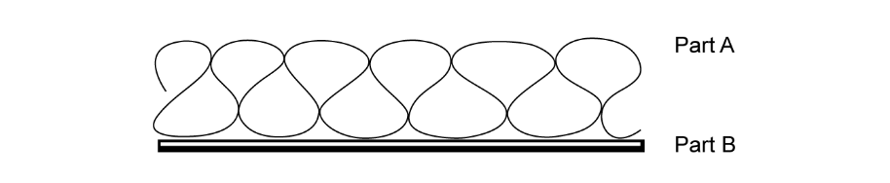
Figure 1

a) State what is meant by the initials SIP.
(1)
……………………………………………………………………………………………………………………………………………………………………………………………
b) Name the parts labelled A and B on Figure 1.
(2)
Part A…………………………………………………………………………………………………………………………………………………………………………
Part B…………………………………………………………………………………………………………………………………………………………………………

3. Give two advantages of using panelised sections in the construction industry. (2)
………………………………………………………………………………………………………………………………………………………………………………………

……………………………………………………………………………………………………………………………………………………………………………………………

……………………………………………………………………………………………………………………………………………………………………………………………

………………………………………………………………………………………………………………………………..…………………………………………………………

4. This figure shows an orthographic drawing of the front and side elevation of a modular construction.
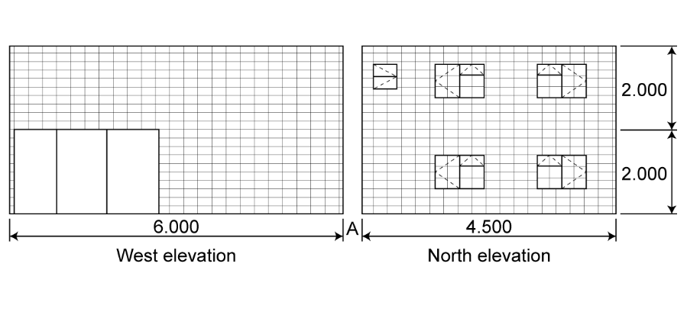
All dimensions are in metres.
Draw an isometric sketch of the modular construction.
Your teacher will provide you with isometric paper. (9)

5. Figure 2 shows a small construction site cleared and levelled.
Planning permission has been granted to build 22 houses comprising of shared ownership and homes for rent. The site is on the edge of a completed housing development of over 500 homes, but it has limited road access and on-site parking. The build programme is 12 months.
The developer is considering using one of two modern methods of construction:
- volumetric construction techniques or
- the use of SIP panels.
Evaluate the two construction methods being considered and produce a justified recommendation for the developer.
(12)
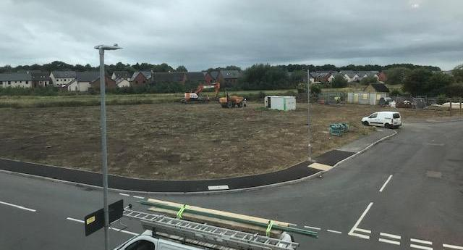
Figure 2

………………………………………………………………………… ………………………………………………………………………………………………………………..

……………………………………………………………………………………………………………………………………………………………………………………………

……………………………………………………………………………………………………………………………………………………………………………………………

………………………………………………………………………………………………………………………………………………………………………………………….

……………………………………………………………………………………………………………………………………………………………………………………………

……………………………………………………………………………………………………………………………………………………………………………………………

……………………………………………………………………………………………………………………………………………………………………………………………

……………………………………………………………………………………………………………………………………………………………………………………………

……………………………………………………………………………………………………………………………………………………………………………………………

……………………………………………………………………………………………………………………………………………………………………………………………

……………………………………………………………………………………………………………………………………………………………………………………………

……………………………………………………………………………………………………………………………………………………………………………………………

……………………………………………………………………………………………………………………………………………………………………………………………

……………………………………………………………………………………………………………………………………………………………………………………………

……………………………………………………………………………………………………………………………………………………………………………………………

……………………………………………………………………………………………………………………………………………………………………………………………

……………………………………………………………………………………………………………………………………………………………………………………………

……………………………………………………………………………………………………………………………………………………………………………………………

……………………………………………………………………………………………………………………………………………………………………………………………

……………………………………………………………………………………………………………………………………………………………………………………………

……………………………………………………………………………………………………………………………………………………………………………………………

……………………………………………………………………………………………………………………………………………………………………………………………

……………………………………………………………………………………………………………………………………………………………………………………………

……………………………………………………………………………………………………………………………………………………………………………………………

……………………………………………………………………………………………………………………………………………………………………………………………

……………………………………………………………………………………………………………………………………………………………………………………………

