Activity 2: Cancer profile
Decode medical terms:
Acute:
Myeloid:
Leukaemia:
Name of cancer: Acute myeloid leukaemia (AML)
Context of cancer: AML is an aggressive cancer of specific white blood cells called myeloid cells.
Age of onset: The risk of developing AML increases with age. It's most common in people over 75.

Causes: Stem cells in bone marrow produce too many immature white blood cells called blast cells. These cells cannot fight infections like a normal white blood cell and their overproduction leads to a decrease in red blood cells.
Risk factors: Previous chemotherapy or radiotherapy, having an underlying blood disorder or genetic disorder e.g. Down’s syndrome, exposure to benzene or cigarette smoke, increasing age.
Symptoms: Pale skin, tiredness, breathlessness, frequent infections, unusual and frequent bleeding e.g. nosebleeds, losing weight.
Treatment: Chemotherapy to kill the leukaemia cells and bone marrow or stem cell transplant to achieve a cure.

Pictures:
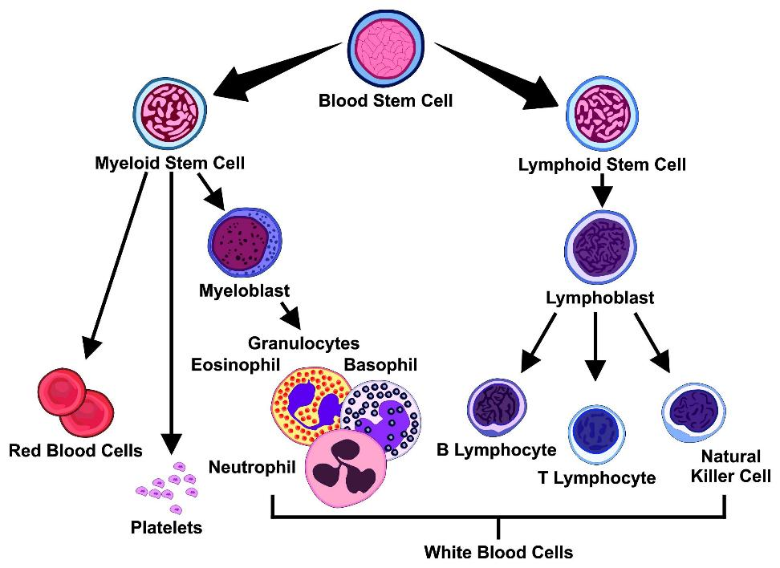
Image © Shutterstock/udaix
References:
www.nhs.uk/conditions/acute-myeloid-leukaemia

