Activity 2: The cell cycle
This diagram shows the stages in the cell cycle.
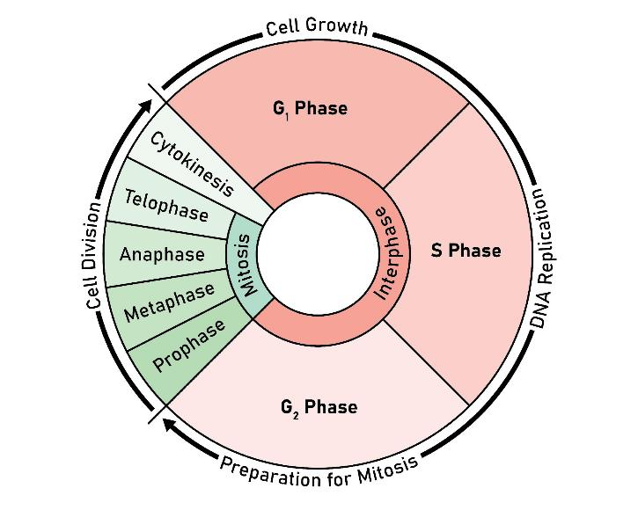
Image © Shutterstock/Kooto

- For each description below, write the name of the stage being described.
Name of stage | Description
 | The cell grows, produces proteins and prepares for DNA replication.
 | DNA is replicated, creating two identical copies for the daughter cells.
 | The cell prepares for mitosis, checking for DNA integrity and errors.
 | DNA is copied.
 | The cell divides into two identical daughter cells.

Checkpoints and genes
- At the end of each stage there is a checkpoint to make sure the cell is ready for the next stage.
- The p53 gene detects DNA damage so the cell can pause for repairs.
- DNA repair genes help correct errors in the DNA.
- p53 can trigger apoptosis (cell death) if the damage is too severe.
- Proto-oncogenes are genes that promote controlled cell growth and division.

- A change in a gene (a mutation) can cause a cell to become cancerous. Use what you have learned from completing this activity to suggest the different reasons why.

