Activity: Classifying pressure injuries
Image 1:
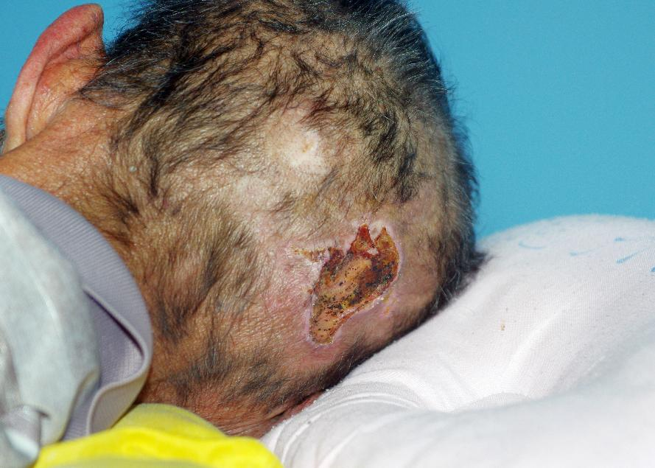
Image © Shutterstock/phichet chaiyabin

Image 2:
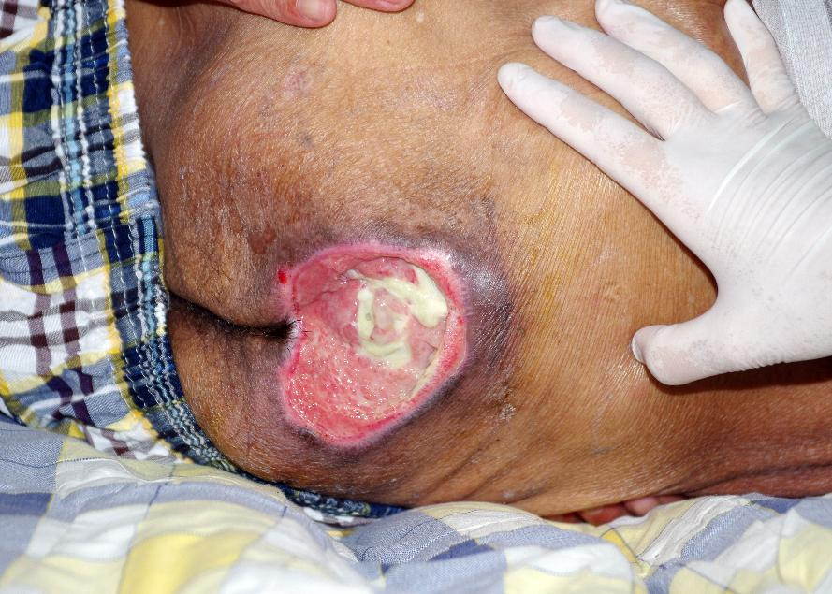
Image © Shutterstock/phichet chaiyabin

Image 3:
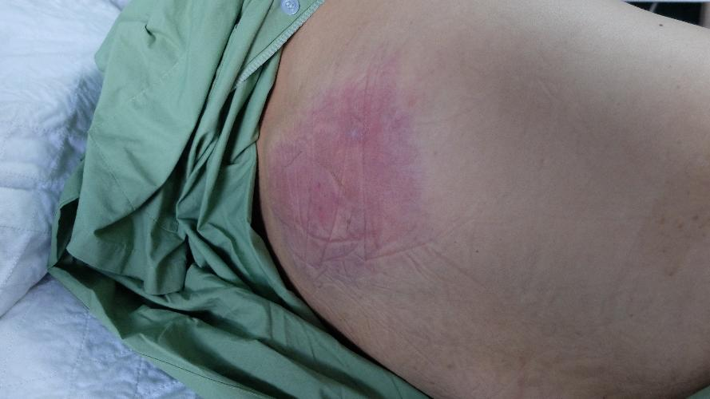
Image © Shutterstock/Casa nayafana

Image 4:
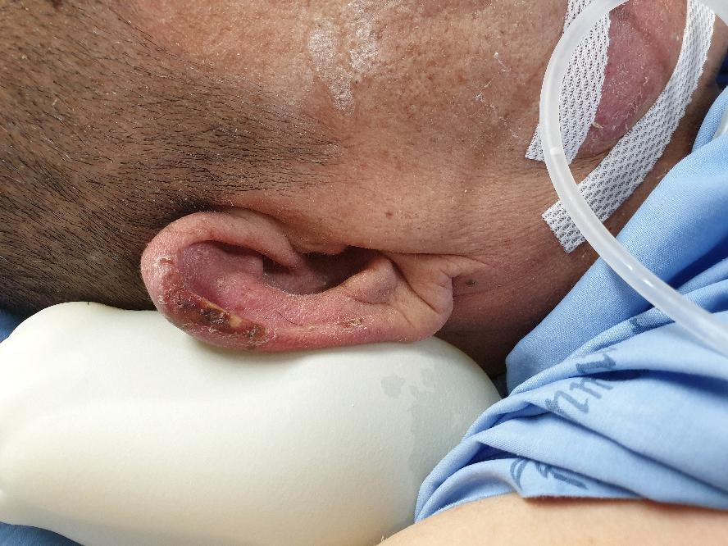
Image © Shutterstock/Rojchana Loonrasri

Image 5:
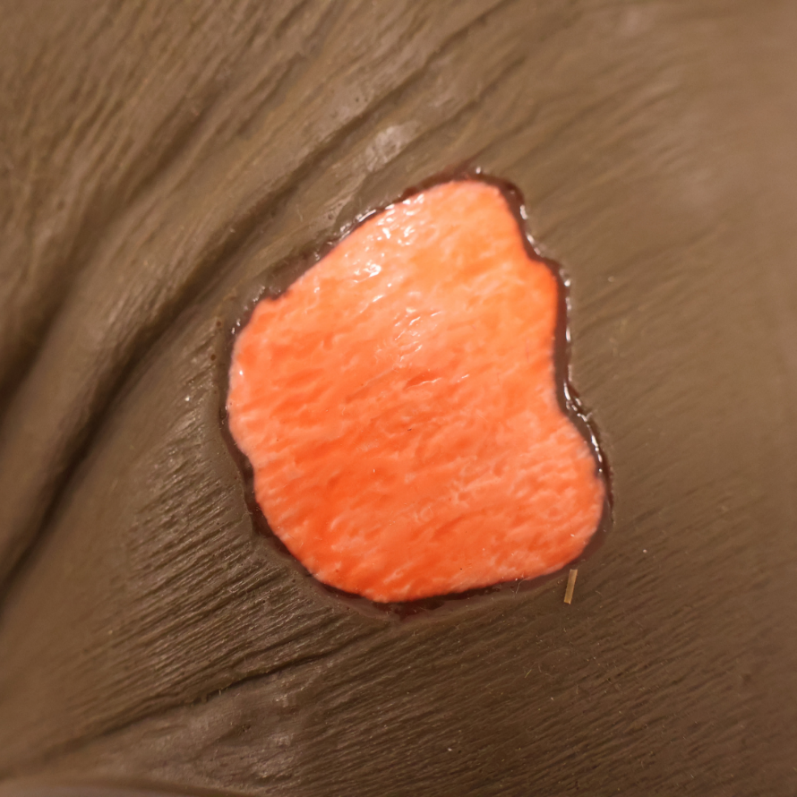
Image © Sims & Skills Ltd

Image 6:
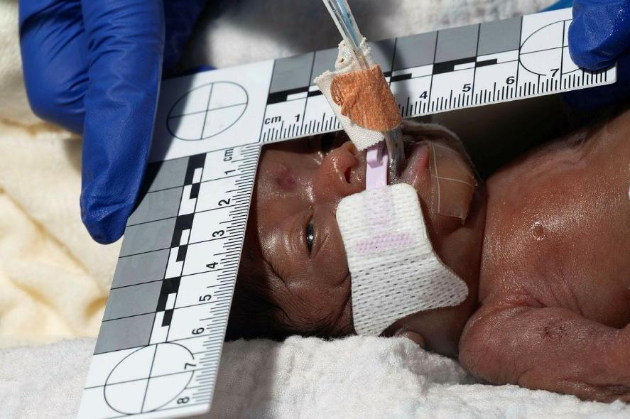
Image © University Hospitals Bristol and Weston NHS Foundation Trust, Reframe Image Library

Image 7:
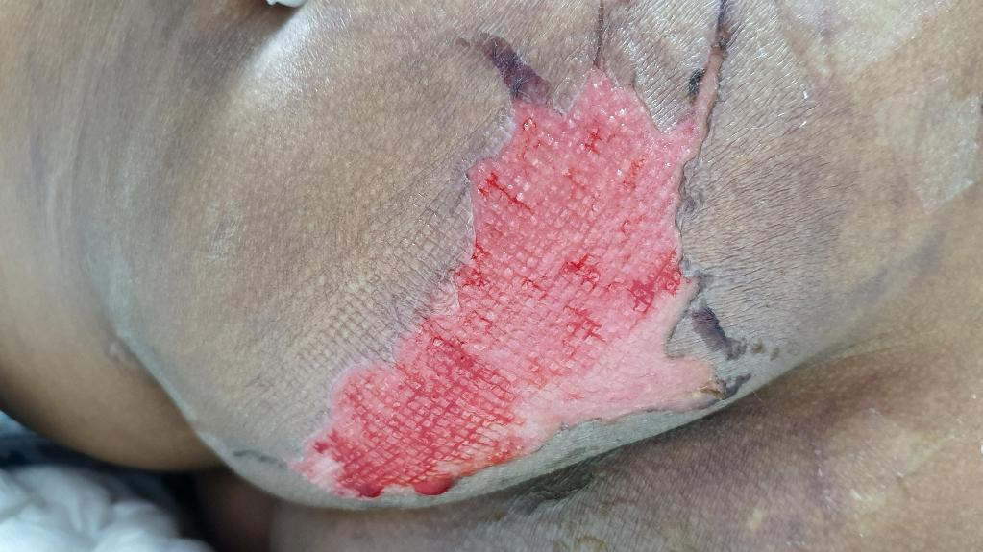
Image © Shutterstock/RJ22

Image 8:
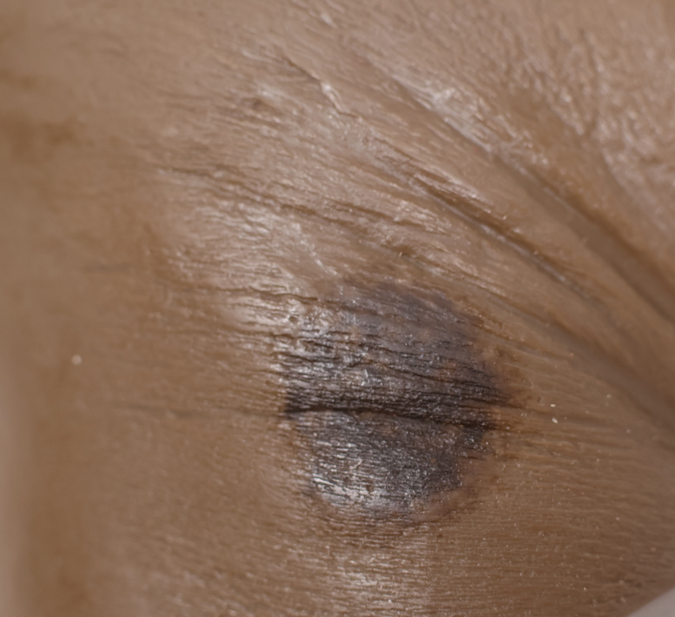
Image © Sims & Skills Ltd

