Consolidation: answers

Practice question 1
Step 1: Define the variables.
Let $x$ represent the horizontal side and y represent the vertical side of the compound diagram.
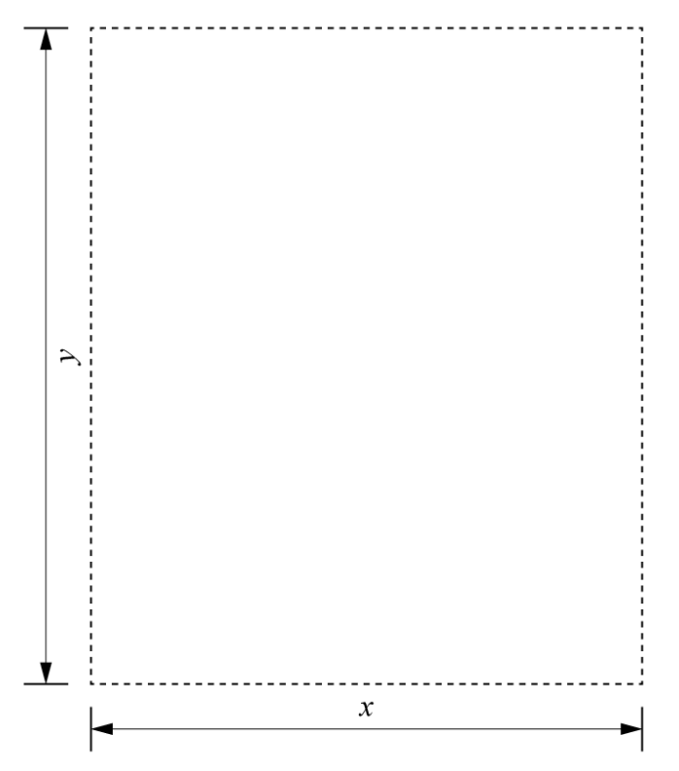
The total area of the site is 8000 m², so:
$$xy=8000$$
Express $y$ in terms of $x$:
$$y= \frac{8000}{x}$$

Step 2: Write an equation for the cost of fencing in terms of $x$.
The vertical sides (length $y$) cost £20 per metre. The horizontal sides (length $x$) cost £30 per metre. So, the total cost of fencing is:
$$C=\left(2 ×30x\right)+\left(2 × 20y\right)=60x+40y$$
Substitute the formula for $y$ into the cost equation:
$$C=60x+40 \left(\frac{8000}{x}\right)$$
$$C=60x+ \frac{320,000}{x}$$

Step 3: Differentiate to minimise $C$.
Differentiate C with respect to $x$:
$$C=60x+ \frac{320,000}{x}$$
$$\frac{dC}{dx}= 60- \frac{320,000}{x^{2}}$$
Now we need to find $x$. Set the derivative equal to 0:
$$60- \frac{320,000}{x^{2}}=0$$
$$\frac{320,000}{x^{2}}=60$$
$$x^{2}= \frac{320,000}{60}$$
$x^{2}= 5333.33$3
$x = \sqrt{5333.333}=73.03$ m

Step 4: Check it’s a minimum.
Find the second derivative:
$$\frac{dC}{dx}= 60- \frac{320,000}{x^{2}}$$
$$\frac{d^{2}C}{dx^{2}}= \frac{640,000}{x^{3}}$$
Substitute $x=73.03:$
$$\frac{d^{2}C}{dx^{2}}= \frac{640,000}{{(73.03)}^{3}}=1.643…$$
The second derivative is greater than 0, so this is a minimum.

Step 5: Find the dimensions and the total cost.
$$x = 73.03 m$$
Substitute $x$ into the formula for $y$:
$y= \frac{8000}{73.03}=109.54 m$
Calculate the total cost:
Substitute $x=73.03$ and $y=109.54 m$ into the cost equation:
$$C=60x+40 y$$
$$C=60(73.03)+40 (109.54)$$
$$C=4381.80+4381.60=£8763.20$$
The minimised cost of the fencing is £8763.20.
The dimensions of the compound are length 73.03 metres and width 109.54 metres.

Practice question 2
Let $y$ represent the vertical side and x represent the horizontal side of the compound.
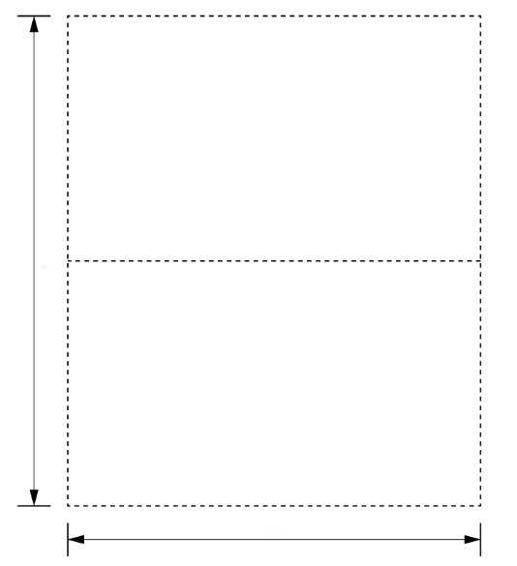

y
x
Step 1: Define the variables.
The total area of the site is 9000 m², so:
$$xy=9000$$
Express $x$ in terms of $y$:
$$x= \frac{9000}{y}$$

Step 2: Write an equation for the total length of fencing in terms of $x$.
There are 2 sides of length $y$, 2 sides of width $x$ and 1 dividing fence along $x$.
The total length of fencing for the site is:
$$L=2y+3x$$
Substitute $x$ into the length equation:
$$L =2y+3\left(\frac{9000}{y}\right)$$
$$L =2y+ \frac{27000}{y}$$
Step 3: Differentiate to minimise $L$.
Differentiate $L$ with respect to $y$.
$$L =2y+ \frac{27,000}{y}$$
$$\frac{dL}{dy}= 2- \frac{27,000}{y^{2}}$$
Now we need to find $x$. Set the derivative equal to 0:
$$2- \frac{27,000}{y^{2}}=0$$
$$\frac{27,000}{y^{2}}=2$$
$$y= \frac{27,000}{2}$$
$$y^{2}= 13,500$$
$y = \sqrt{13,500}=116.19$ m
Step 4: Check it’s a minimum.
Find the second derivative:
$$\frac{dL}{dy}= 2- \frac{27,000}{y^{2}}$$
$$\frac{d^{2}C}{dy^{2}}= \frac{54,000}{y^{3}}$$
Substitute $y=116.19:$
$$\frac{d^{2}C}{dy^{2}}= \frac{27,000}{{(116.19)}^{3}}=0.017…$$
The second derivative is greater than 0, so this is a minimum.
Step 5: Find the final dimensions:
$$y = 116.19 m$$
Substitute $y$ into the formula for $x$:
$x= \frac{9000}{116.19}=77.46$ m
Calculate the total fencing length:
$$L=2(116.19)+3(77.46)$$
$$L=232.38+232.38$$
$L=464.76$ m
The dimensions of the compound to minimise the total fencing length are height 116.19 metres and width 464.76 metres.

