Consolidation 2: Using differentiation to calculate the quantity of building supplies required

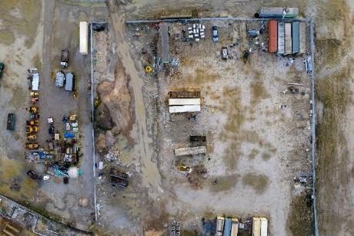
Worked example
Image © Shutterstock/Bilanol
You are working as an assistant construction site manager for a construction contractor.
Your company is about to start work on a new project and has asked for your help to set up a new site compound. It will be similar to the compound shown in the photo, and will be used to store construction material and equipment.
The area of the site compound must be
5600 m² and will be fenced on three sides, with an existing wall on the remaining side.
Image © Shutterstock/Bilanol
The diagram below shows a plan of the extent of the proposed site compound. The site will be fenced using Heras fencing panels that are 3.5 metres wide and 2 metres high.
Use your knowledge of calculus to calculate the minimum number of Heras fencing panels to enclose the compound.
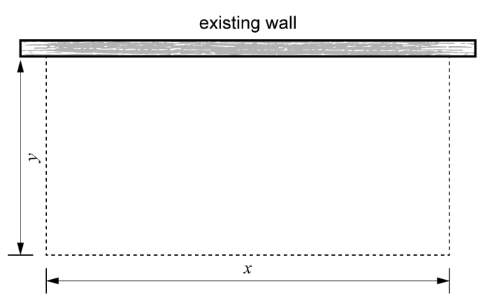
Extent of the proposed site compound

Step 1: Define the variables.
The area, $A$, of the site is:
$$A=xy$$
Therefore:
$$y= \frac{A}{x}$$

Step 2: Write an equation for the length in terms of $x$ and $A$.
The total length, $L$, of the required site fence is:
$$L=x+2y$$
Substitute in the formula for $y$ to see that:
$$L=x+2\left(\frac{A}{x}\right)$$

Step 3: Differentiate to find the minimise $L$.
We can differentiate $L$ with respect to $x$.
First, rewrite using a negative power:
$$L=x+2Ax^{-1}$$
Now differentiate.
Remember, to differentiate, multiply by the power and then reduce the power by 1.
$x$ is the same as $x^{1}$ so it differentiates to 1:
$$\frac{dL}{dx}=1+\left(-1\right)×2Ax^{-2}$$
$$\frac{dL}{dx}=1+-2Ax^{-2}$$
$$\frac{dL}{dx}=1-\frac{2A}{x^{2}}$$
Set the derivative equal to 0, to find $x$:
$$0 =1- \frac{2A}{x^{2}}$$
Isolate the fraction:
$$\frac{2A}{x^{2}}=1$$
Rearrange to make $x^{2}$ the subject:
$$x^{2}=2A$$
Substitute $A=5600$ m²:
$$x^{2}=2 × 5600=11,200$$
Solve for $x$
$x= \sqrt{11,200}=105.83$ m

Step 4: Find the total number of panels required.
The Heras fencing panels are available in 3.5-metre lengths. Divide the amount of fence required by the length of a panel, to find out how many panels are needed.
$\frac{105.83}{3.5} = 30.24$
So 31 panels are required for length $x$.
Now find the number of panels required for length $y$.
$$y=\frac{A}{x}= \frac{5600}{105.83}=52.92 m$$
$$\frac{52.92}{3.5}=15.12 m$$
So 16 panels are required for length $y$.
Total number of panels required $= 31 + 16 + 16 = 63$ panels

Practice question 1
You are working as an assistant construction site manager for a construction contractor. Your company is about to start work on a new project and has asked for your help to set up a rectangular storage compound to store construction materials and equipment.
The total area of the storage compound must be 8000 m², and it will be fully enclosed with fencing on all four sides.
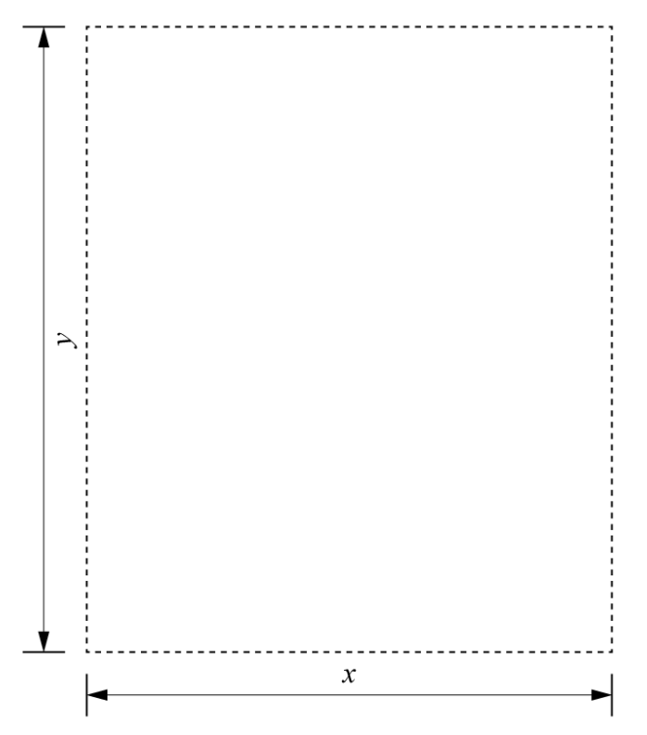

The fencing costs differ based on their location: fencing along the two vertical sides in the diagram costs £20 per metre, while fencing along the two horizontal sides costs £30 per metre.
Your task is to calculate the dimensions of the compound that minimise the total fencing cost. Use calculus to find the dimensions and the minimum cost.

Practice question 2
You are working as an assistant construction site manager for a construction contractor. Your company is about to start work on a new project and has asked for your help to set up a rectangular storage compound to store construction materials and equipment.
The total area of the storage compound must be 9000 m², and it will be divided into two equal sections by a fence running parallel to the horizontal side.
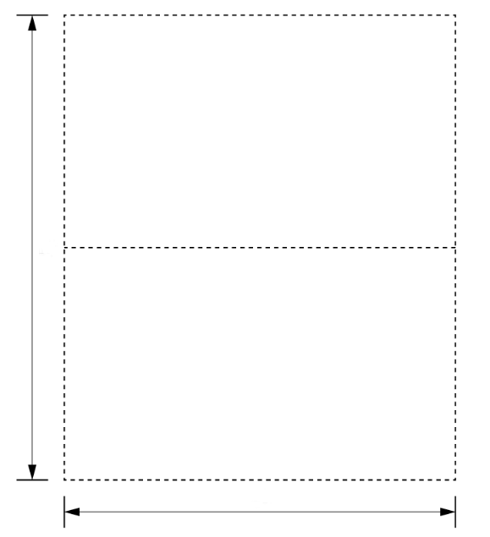

y
x

The compound will require fencing along all four sides and an additional fence to divide the yard into sections, as shown in the diagram.
Your task is to minimise the total length of fencing required. Use calculus to determine the dimensions of the yard that minimise the total fencing length.

