Kanban interactive – user instructions
Link to interactive: https://www.technicaleducationnetworks.org.uk/interactive/kanban
Link to video walkthrough: https://vimeo.com/1118131685/4406764c1a

Overview
The Kanban interactive is intended to show how kanbans are used as visual markers to facilitate Just-in-Time (JIT) stock control. The purpose of the simulation is to place the kanban in the correct place in the stock so that new stock arrives just in time to continue production. If the kanban is placed too early in the stock queue, it triggers new stock to arrive too soon and the production facility becomes overstocked. This ties up cash in unnecessary stock and in the worst case, might mean there is more stock than space to store it. If the kanban is placed too late in the stock queue, the production facility runs out of stock and production stops, leading to the production facility losing income.
The interactive has two modes: set up and play. In the first mode, the scenario is set up to define the component batch size, the lead time for new batches and the number of items used per day. Once the scenario is defined, the user can place the kanban within the stock queue for each of the components.

Set up mode
This mode is the default when the interactive is launched.
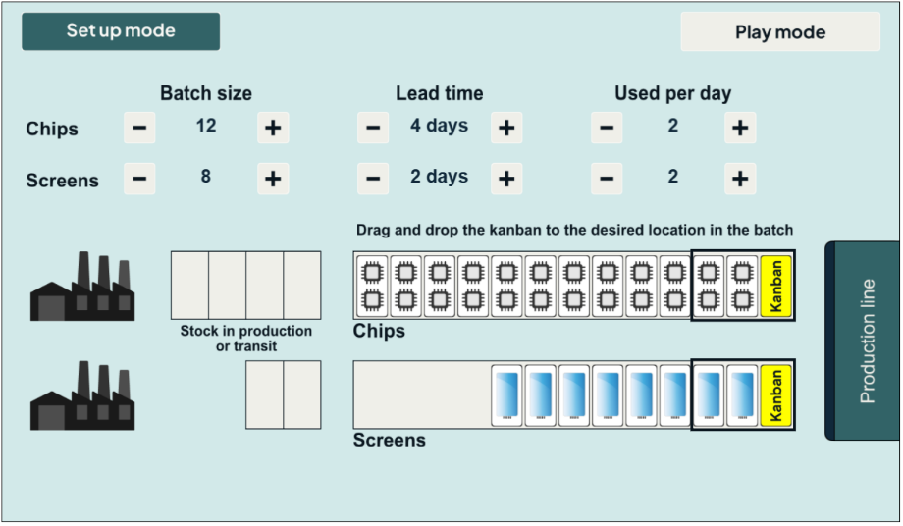

Step 1 – Set up the scenario values
Using the ‘+’ and ‘– ’ buttons next to each item, set up scenario values for batch size, lead time and number of items used per day. A number of starting positions should be provided in the teacher guide. The batch size will be shown in the production queue area with the kanban initially placed at the head of the queue.

Step 2 – Place the kanbans
This is achieved by clicking and dragging the kanban left or right within the starting batch. It is expected that this stage will require some trial and error to get right. Note, if the scenario is changed, the kanban locations will reset.
The rectangles drawn around items at the right of the production queues show which items will be considered for action on the production run for that day.
The example used in this guide is shown below. It is noted that in this set up, two chip items will be used and a chip kanban will be dispatched on the first day of production. Note, when two items are used per day, the kanban can be placed to the right of the two items or between them and the effect will be the same. In the example below, the kanban has been placed between the two items that will be used on day 1. It would be equally valid to have it to the right of the two items. If it were moved one further place to the left, then it would be considered on the next day when the second two items were used. One screen item will be used each day and the kanban has been dragged to sit to the immediate right of the third screen item. This means it will be dispatched on day 3 when the third item is used.
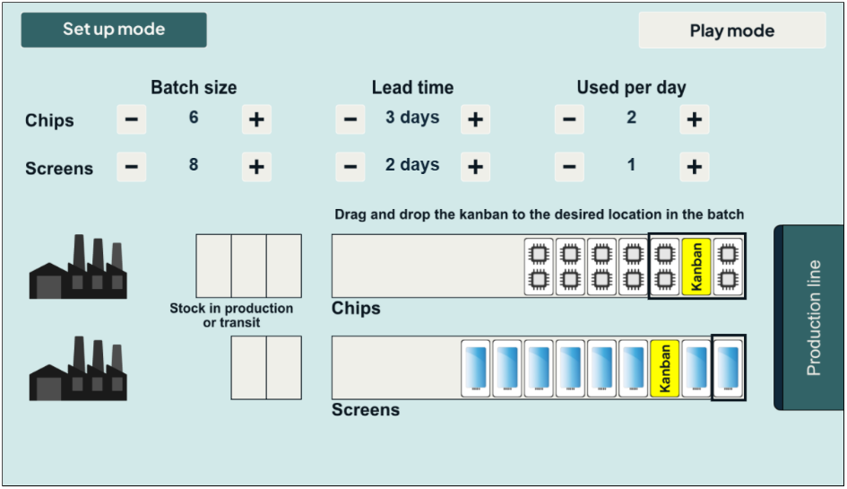

Play mode
When play mode is selected, the user can no longer change scenario values or move the kanbans. Production is stepped through on a day-by-day basis by pressing the “Run production” button. (The “Run production” button appears after Play has been pressed.)
When the day’s production is run, the following happens:
- The number of items used per day is consumed by production.
- If there is a kanban in the day’s items, it will be dispatched and an order raised for external supply. The kanban will result in stock entering the first box in the production/transit area.
At the end of day 1, the simulation will show:
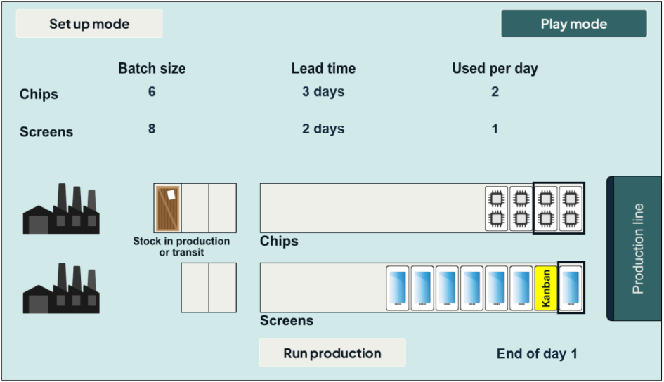

At the end of day 2, the simulation will show:
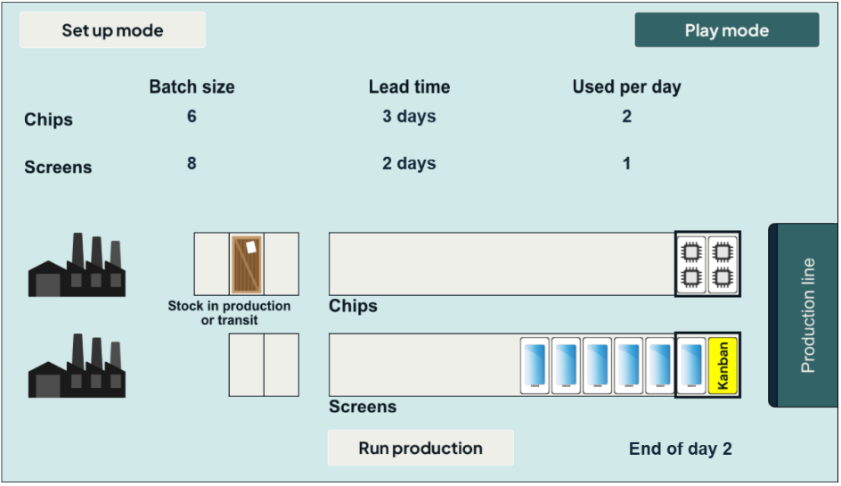
At the end of day 3, the simulation will show:
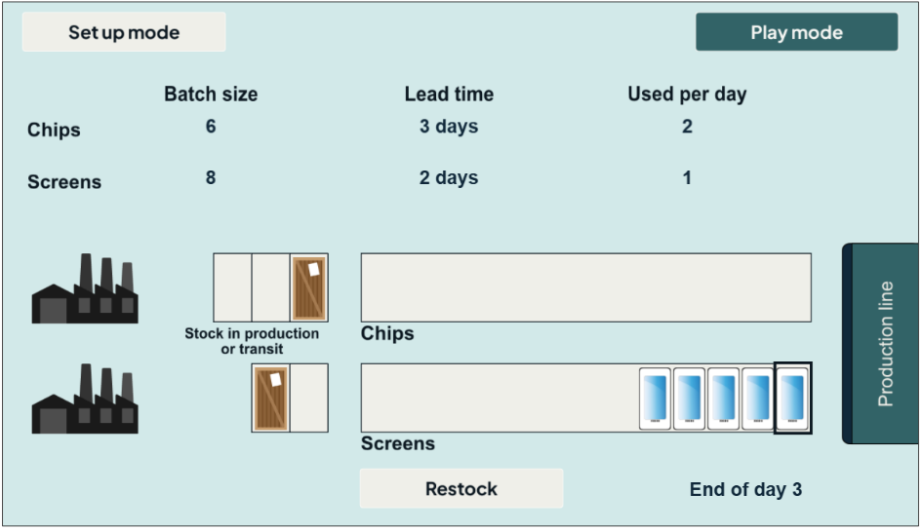
At the end of day 3, the chips stock has reached the final box and so is ready for restocking. This is an important definition of the lead time in this simulation:
If a kanban is dispatched on day x and has a lead time of L days, it will be restocked ready for use on day x + L. For example, the chips kanban was dispatched on day 1 with a lead time of 3 days and so will be ready for production use at the start of day 4.
Pressing the “Restock” button gives:
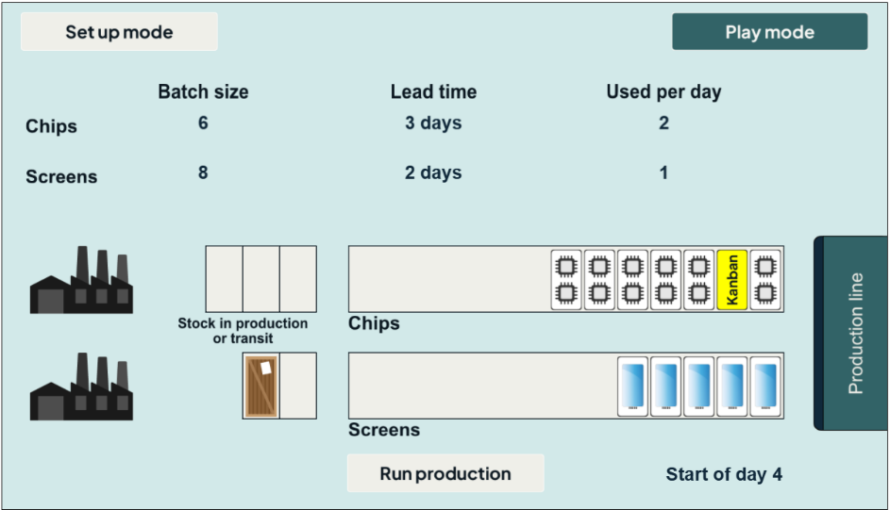
No problems so far! The key point to notice is that when the restocking has taken place, the chips production queue looks identical to the starting position – six chips and one kanban in the same location.
Continue the next two steps by pressing “Run production”, which gives the figure shown below. It is noted that eventually the “Run production” button does not reappear; instead, a “Restock” button appears. This indicates that new parts are available for restocking for the day’s production.
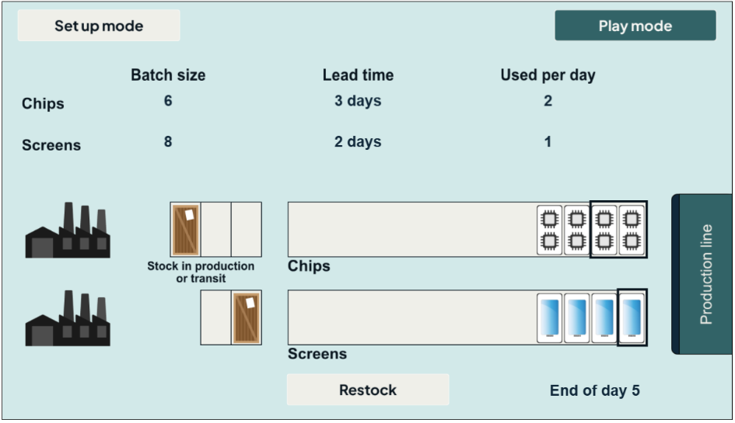
Pressing the “Restock” button moves items from the packing area to the stock area. In the figure below, the restocking of the screens has resulted in a production stock of 12 screens. This is higher than the starting stock of 8 and your production director has stepped in to have a word with you!
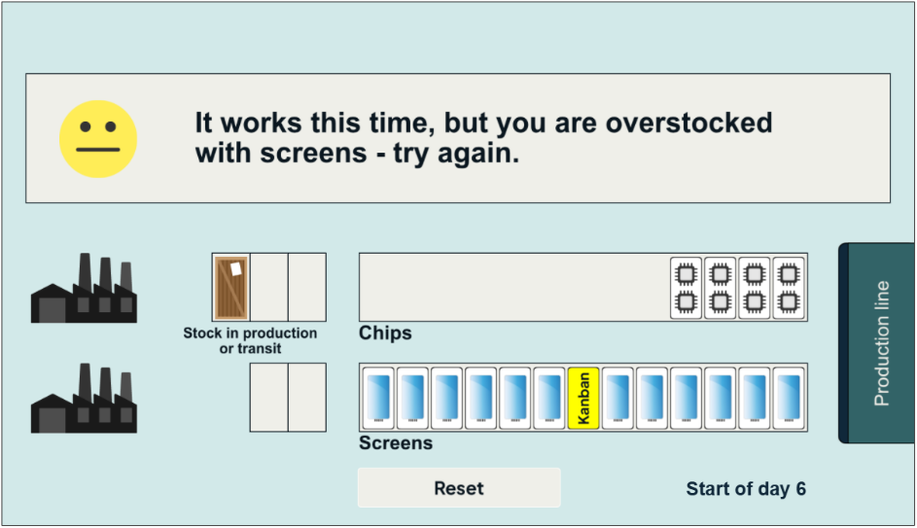
Press the “Reset” button to go back to set up mode. Leave the scenario as is but change the positions of the kanbans as shown below (deliberately worse for screens), and try again.
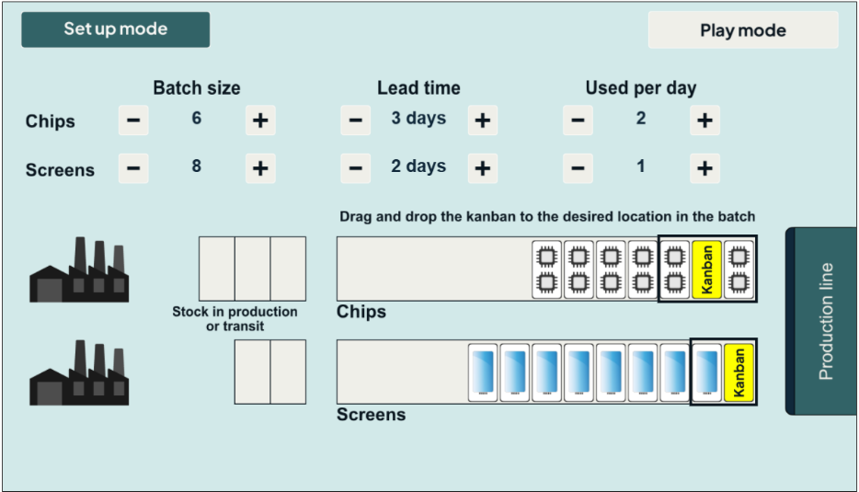
Running the simulation for several steps eventually leads to:
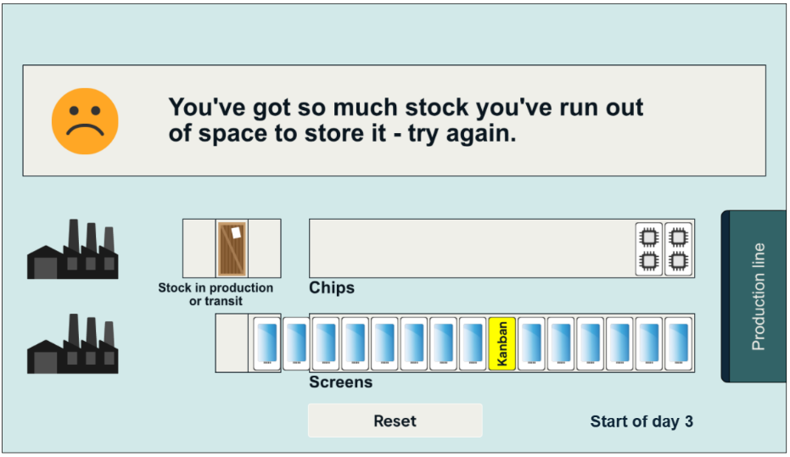
In this scenario, you’ve overstocked so much that you’ve run out of stock space. Your production director is less than impressed with you!
Press the “Reset” button and try again with this as a starting configuration:
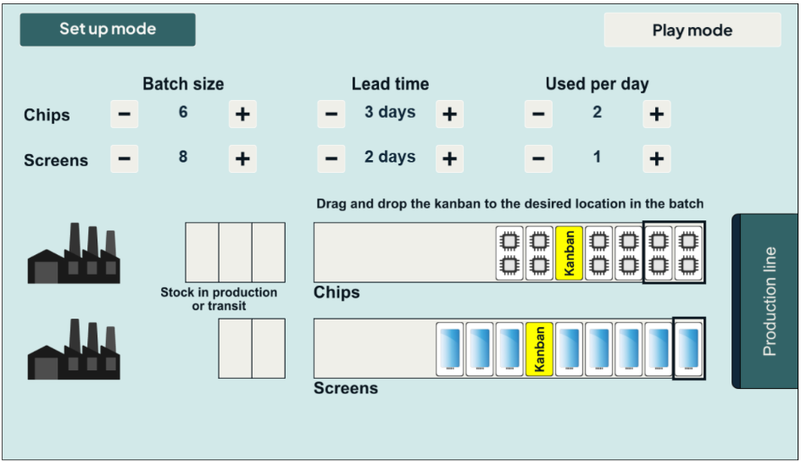
Running this one leads to:
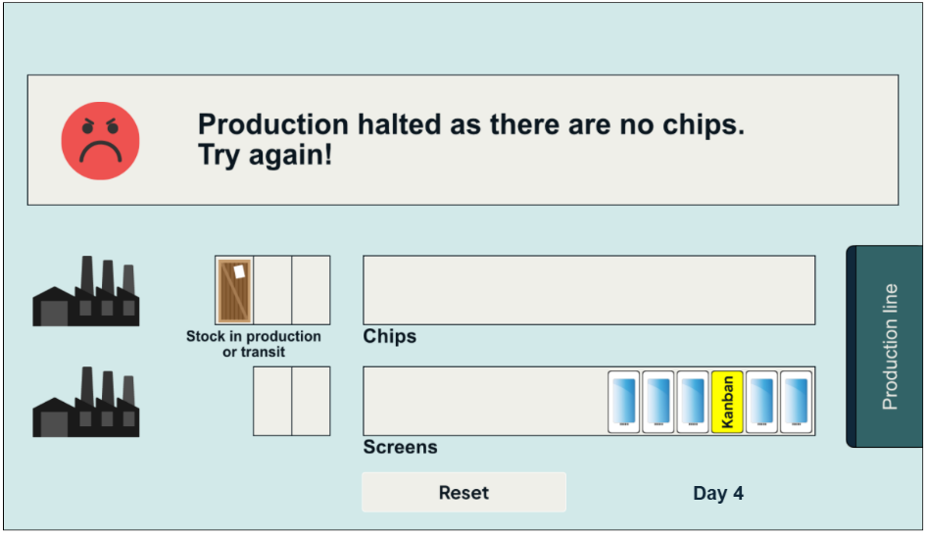
This time, you’ve run out of chips and production has stopped. Your production director is looking for you!

Eventually, you try the following set up:
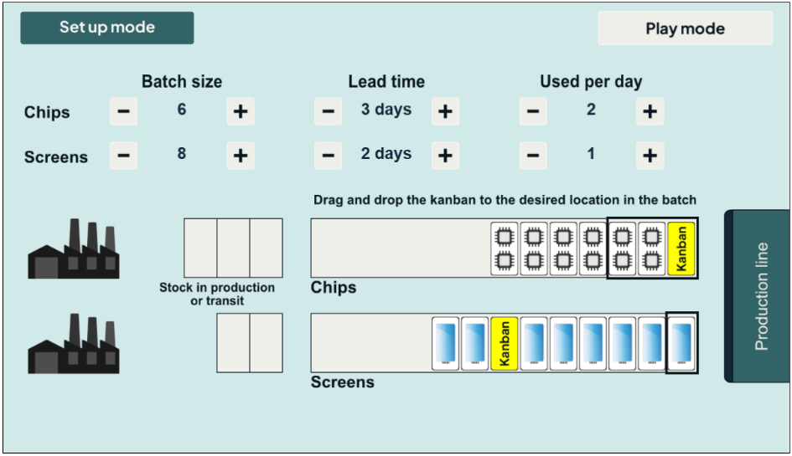
After running until both stock items have been through at least one restocking, you end up with the following:
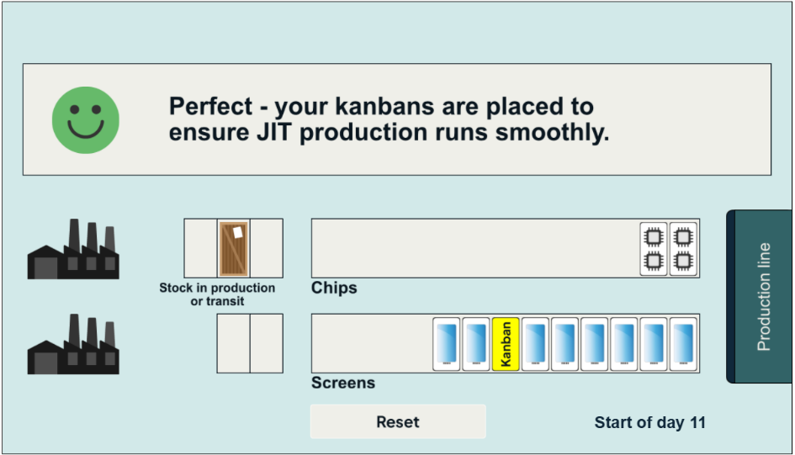
Both kanbans have been placed correctly to ensure JIT production.

Scenarios
A number of scenarios should be constructed so that different groups can work on different problems.
It is also possible to construct scenarios that can never work. For example, when a batch size is 6 items, the lead time is 4 days and the number used per day is 2, you will always run out of chip components no matter where the kanban is placed. The learning point here is that the batch size agreed with the producer should be appropriate for the lead time. If there is a long lead time, the batch size has to be big enough to not run out before new stock is delivered.
