Activity 2: Impact of the forecast

There are three stock management systems in the stock management interactive:
- Made-to-stock (MTS);
- Made-to-order (MTO);
- Just-in-time (JIT).
The stock management interactive runs three different profiles, each running over 28 days:
- nominal demand profile – total demand is 56 items;
- low demand profile – 50 items;
- high demand profile of 62 items.
Using the interactive, complete the table on the next page.
Link to the interactive: https://www.technicaleducationnetworks.org.uk/interactive/stock
You will find the information you need when you run each management system and demand profile:
- Boards in stock;
- Chips in stock;
- Screens in stock;
- Cases in stock;
- Finished items in stock;
- Cash in stock.
Comparing stock management practices
 | Made-to-stock (MTS) |  |  | Made-to-order (MTO) |  |  | Just-in-time (JIT)
 | Nominal | Low | High | Nominal | Low | High | Nominal | Low | High
Maximum cash in Combined stock
Max board stock
Max chip stock
Max screen stock
Max case stock
Finished items
Maximum production utilisation
Production days
Shipping delay days

Review questions
Referring to the data values in the interactive (Figure 1) and using your knowledge about the stock management processes, consider the following questions.
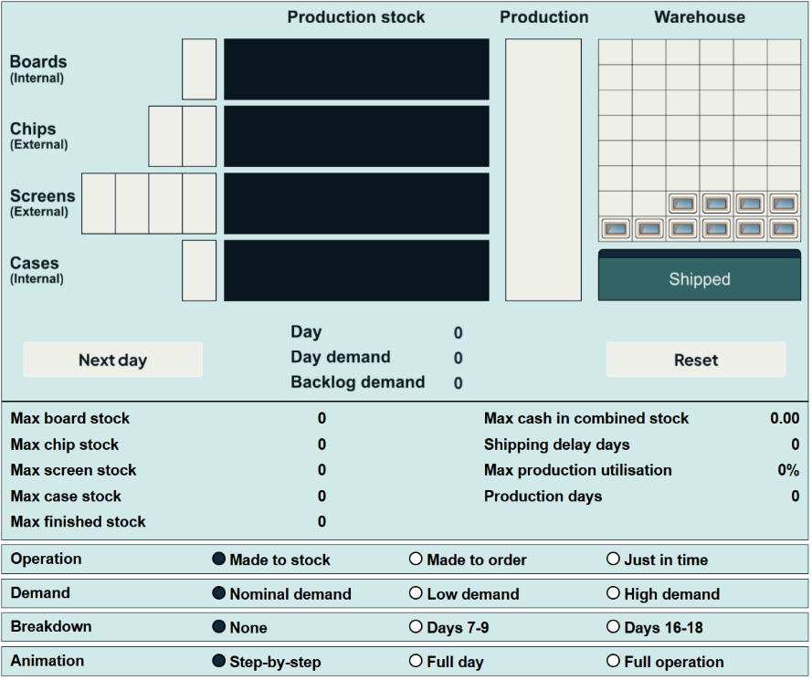
Stock management
The approach to how stock is managed can vary based upon the business and the type of stock that is used in the manufacturing process.
Considering each of the stock management processes:
- Which stock management approach can be linked to the business having the highest financial implication when considering stock volume?
- How could this have an impact on the business overall if not managed effectively?
- Which stock management approach would typically result in there being an increased volume of work in progress?
- Are there any inherent risks in each stock management approach that could be relevant and how can these be monitored and measured?
Demand estimation
Within the manufacturing process and stock management, there is an element of forecasting and estimation to determine what may be required in the future. Typically, these estimations are based upon historical data and trends within the sector (historical and predicted) and make the assumption that the process will be without issue.
Considering the manufacturing processes and each of the stock management processes:
- How does the demand estimation impact the business overall?
- What is the impact of a disruption such as a machine breakdown in each of the processes?
- How does an inaccurate estimate impact on the business? Think about lead time of stock items considering variable costs and the costs associated with transport and storage.

