Rolling average interactive – user instructions
Link to interactive: https://www.technicaleducationnetworks.org.uk/interactive/rolling-average
Link to video walkthrough: https://vimeo.com/1118129817/d46b8ceec0

Overview
The rolling average interactive is intended to provide a brief background to estimating future demand based on historical data and provides an introductory starting point for later stock control interactives. A rolling average, sometimes referred to as a moving average, is a mathematical approach that smooths out short-term fluctuations in data that changes over time to highlight longer-term trends.
The interactive is set up to show four sets of historical product demand data:
Constant 28 days | The constant here refers to the fact that the demand on average is constant even though there are significant random fluctuations on a day-by-day basis. The dataset consists of 28 points, and the average overall points will ultimately be used as the demand estimate in the later stock control interactive.
Constant 84 days | This is as above but with a larger dataset of 84 days.
Growth 84 days | This is an 84-day dataset that has an underlying demand growth trend.
Decline 84 days | This is an 84-day dataset that has an underlying demand decline trend.

Constant 28 days
This mode is the default when the interactive is launched.
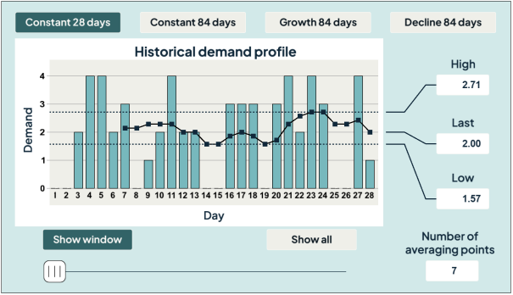
The screen shows the day-by-day demand over the period of 28 days as a series of bars, where the demand varies between 0 and 4. The black plot shows a connected set of points whose value is determined by averaging the demand values on several days up to that point. For example, in the above, the left-most black square marker represents the mean average of the seven demand values up to and including that day.
The default setting on the interactive shows a window of 28 days of data, as indicated by the “Show window” selection. For the case shown above, there are only 28 data points so they all fit in the window. In later cases, there will be 84 data points, of which 28 will be visible when “Show window” is selected. The actual 28 shown in the window can be changed by dragging the display in the required direction. The alternative display mode is “Show all”. This scales the display to show all data points on screen. Note, these two display modes are equivalent when 28 data points are used and the plot will look the same whatever “show” mode is used.
The data points used in the averaging of any particular point can be seen by hovering the mouse pointer over the point of interest. For example, the screens below show the mouse hovering over the first and tenth points respectively (that is the rolling 7 day average on days 7 and 16). In each case, the grey highlighting covers the 7 data bars used to calculate the rolling average at the right-most point.
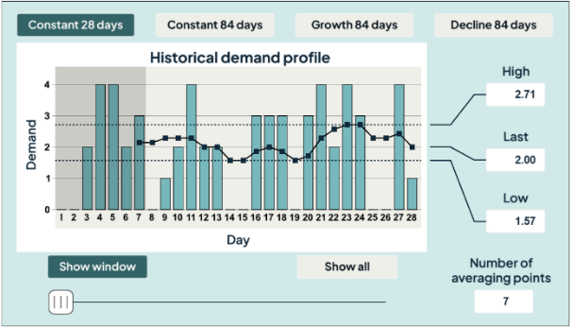

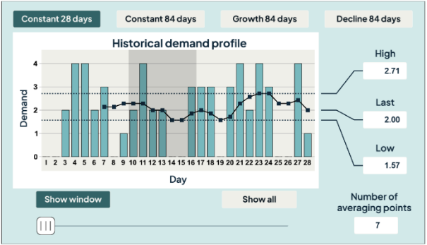
The dotted lines on the display show the upper and lower values of the averaged points. It is noted that the variation in the set of averaged points is less than the variation in the underlying data, ranging between 1.57 and 2.71 compared with 0 to 4. Additionally, the rolling average or the last (most recent) value is shown in the “Last” box.
The number of averaging points can be increased by moving the slider at the bottom of the screen – when this is done, the value changes in the “Number of averaging points” box. The example below shows the screen when 14 days are used to construct the average.
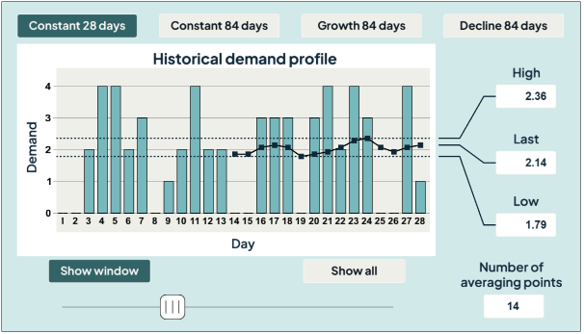
There are two things to note when the number of averaging points is increased from 7 to 14:
- The range of the averaged points narrows to 1.79 to 2.36 giving a better estimate of the actual mean.
- The time range of available points is reduced from 22 values when 7 data points are used to 15 values when 14 data points are used.
In other words, there is a trade-off between estimating the mean average and how many data points you can use to identify a trend.
It should also be noted that the “Last” value changes when the number of averaging points is changed. The screens below show the data points used to construct the last average value when 7 and 14 averaging points are used respectively. The average of the last 7 data points will, in general, not be the same as the average of the last 14 data points (or any other N points).
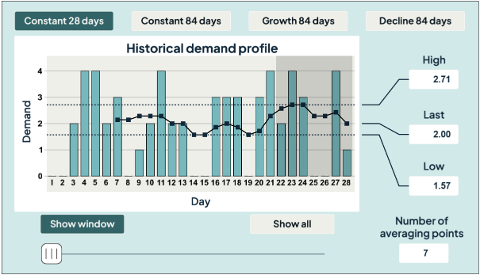
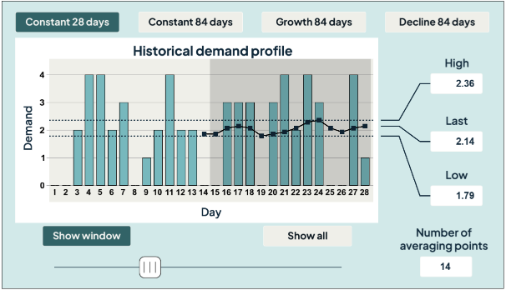
In the limit (that is, when you move the slider fully to the right), the full set of 28 points can be used to get a 28-day mean average estimate of 2.00 per day but, because there is only one data point presented, nothing can be said about whether there is any underlying trend in the data.
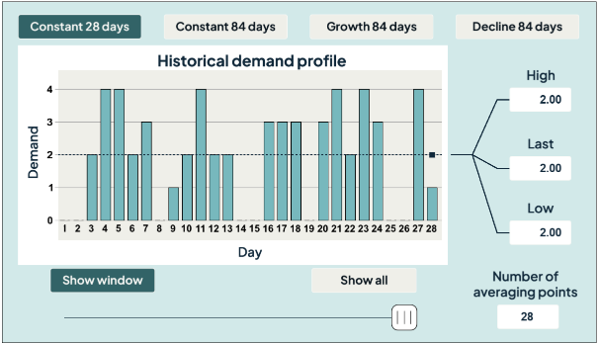
The demand mean average of 2.00 per day will be used as the daily average demand estimate in later interactives.

Constant 84 days
A larger dataset is required to get a better insight into any underlying trend. This option extends the previous case to provide 84 days of demand data (as opposed to 28). The following screen shows the data and seven averaging points in the default display mode. 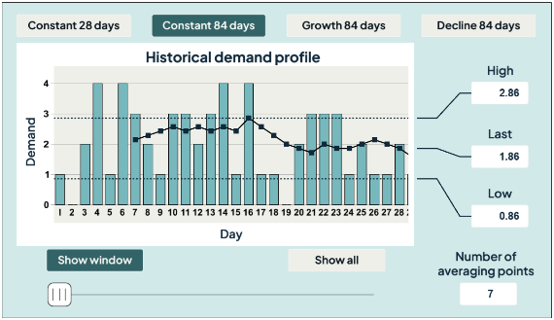
The window only accommodates 28 data points. The contents may be scrolled by click (or touch) dragging the window, see for example below.
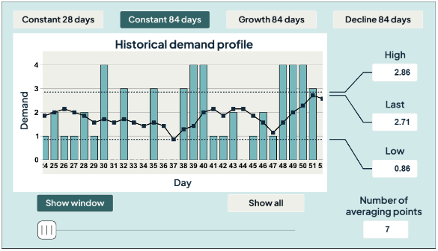
An alternative window view is available by selecting the “Show all” option. This squeezes all the data into the window, as shown below. In this view, the effect of increasing the number of averaging points becomes easier to see. Further, because there are more data points available, it is also easier to see any underlying trends.
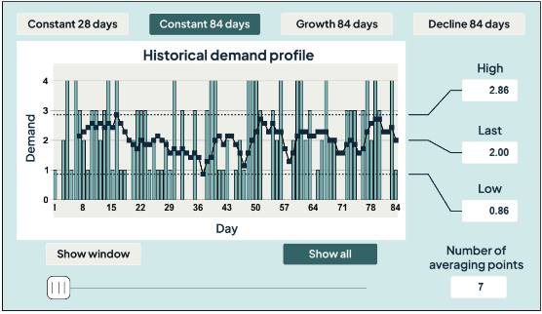
The screen below shows that if a 28-day average is taken (by moving the slider fully across to the right), a mean value of 2.00 per day is recovered as the last-most point (which will be taken as our best estimate as it is based on the most recent data). Further, although the plot wanders up and down between 1.64 and 2.21, it does not visually look as if there is any growth or decline trend.
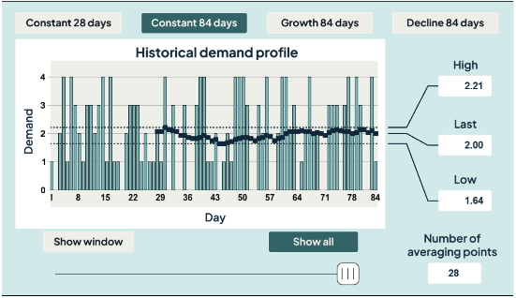

Growth 84 days
This option gives 84 data points in which there is some underlying growth. Initially, when a small number of averaging points is used, 7 in the screen below, the trend is not obvious in the “Show all” view. There is some meandering with a peak near the right but because the mean data has large variation, this could easily be a blip.
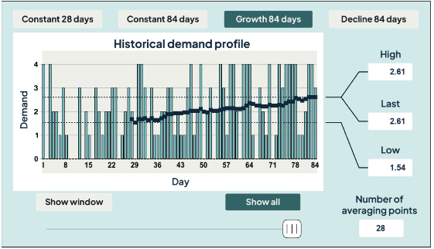
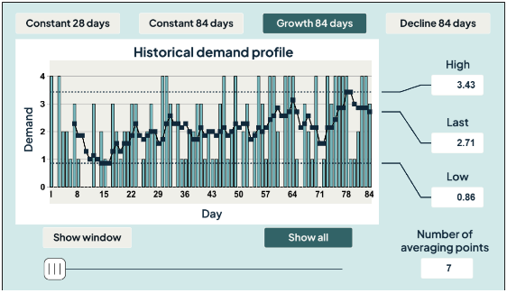
Again, using a larger number of data points (by moving the slider to the right) reduces the variation and, as in the screen below, shows a very definite growth trend in the demand.

Decline 84 days
This option is as above except there is an underlying decline in demand.
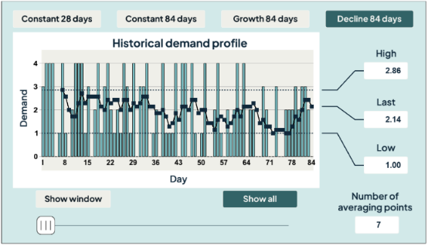
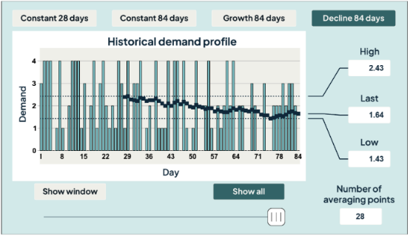

Other comments
The above datasets show a reasonably narrow range of data, much less than 1 year. Collecting more data over several years will allow some subtle growth or decline trends to be shown. Additionally, demand may change over a year in a cyclical manner. For example, high-value items such as mobile phones will probably see an increase in demand in the run-up months to Christmas every year.

