Stock management interactive – user instructions
Link to interactive: https://www.technicaleducationnetworks.org.uk/interactive/stock
Link to video walkthrough: https://vimeo.com/1119123407/7990708158

Overview
The stock management interactive is intended to demonstrate the principles of three stock management methods: made-to-stock, made-to-order and just in time. The interactive simulates an idealised four-component manufacturing process where two of the components are produced internally and will be available the day after they are requested, while the other two are sourced externally and take two and four days to be available respectively. The production line can only run when there is at least one of each component available in the production stock area.
An estimate has been made regarding the expected demand over the 28-day period the simulation runs (see the rolling average interactive). The value used is 56 items, or an average of two per day based on a fictitious history (note, the interactive shows individual boards, completed phones in the warehouse, etc. but in reality these must be thought of as batches of many items). In operation, the actual demand varies; some days the demand will be higher than two, some days it will be lower and could even be zero. As the actual demand can only be estimated, the interactive gives three scenarios to show the user what happens when the demand meets expectation (the nominal demand) is lower than expected or higher than expected.
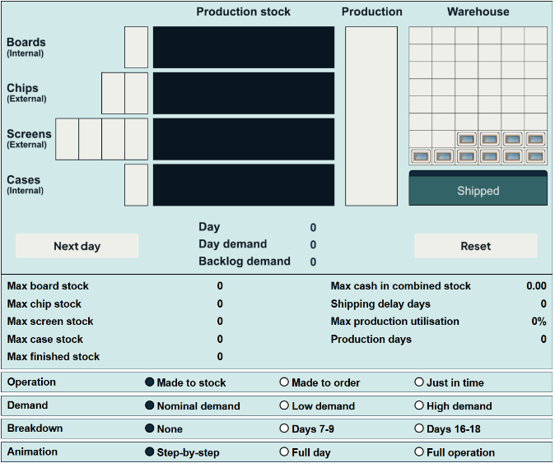
The stock control method and product demand are selected using the radio buttons immediately below the interactive. These can only be changed when the “Day” is showing zero, i.e. a “reset” has just been performed, or the interactive has just been loaded. During operation, these items will be locked.
The third line below the interactive area is a selector for production line breakdown. The default is no breakdown and the two other options are for breakdowns either fairly early (days 7–9) in the 28-day production cycle or fairly late in it (days 16–18). During operation, this item will be locked.
The last line below these choices selects how the animation in the interactive works. The general steps after the desired radio button selections have been made are:
- Click the “Next day” button midway down the left side of the screen to start the cycle for the next day of production. If there are items ready to be moved into stock, these will be added.
- The “Next day” button will change to “Run production”. If there are sufficient parts, this will assemble them into finished items and move them to the warehouse.
- The “Run production” button will change to “Ship items”. If there is demand and sufficient items in the warehouse, finished stock will be shipped to fulfil orders.
- The “Ship items” button will change to “End of day”. Pressing this will update any stock that has been ordered or in transit. This gives the status of all items at the end of a production and shipping day.
- The “End of day” button returns to “Next day” and the cycle repeats.
The above steps are carried out separately when the animation radio button has the selection “Step-by-step”. When the selection is “Full day”, all the steps between one “Next day” click and the next are run automatically without user intervention. When the selection is “Full operation”, all 28 days are run automatically.
The above is repeated until the full 28-day simulation has completed, at which point a set of options to view results graphs is presented.
Note, the “Reset” button can be pressed at any time to start again.

Made-to-stock
In this scenario, stock items are ordered or produced at the start of the period to produce the required finished stock over a short period of time. Once all the items have been manufactured, the stock in the warehouse is reduced in line with the demand on each day. In order to cover the initial production period, the warehouse contains a holding stock, in this case of ten items.
The in-house production of circuit boards and cases has a capacity of 28 items per day for each item. It will therefore take two days to fully stock the items for manufacture. The externally supplied items (chips and screens) are ordered as a full batch of 56 items but take longer to be available.
The button labelled “Next day” halfway down on the left side () initiates the simulation. There are four stages:
- Next day | When clicked, this moves the simulation to the next day, starting at day 1, and runs through for 28 days. Any produced or delivered stock item in the right-hand location of the stock production/delivery area will be moved to the production stock area and made available for production.  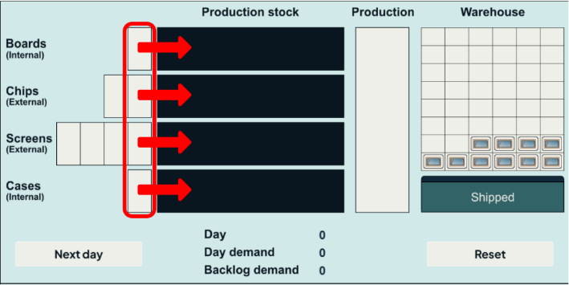
- Run production | If there are enough stock items in the production stock area, they will be moved into production and new finished items will appear in the warehouse. The maximum production rate of finished items is 8 per day. If there is insufficient stock, there will be no production on that day.
- Ship items | At the end of production, any items in the warehouse will be shipped. Ideally, this will be the same number as the daily demand on that day. However, if the demand is higher than the finished stock, a demand backlog will build up. The demand backlog will be reduced if the number of finished items in the warehouse is greater than the daily demand on that day.
- End of day | This updates the position of the stock items at the end of the production day. Newly ordered stock items enter on the left and production stock items move up the queue for production.

1.
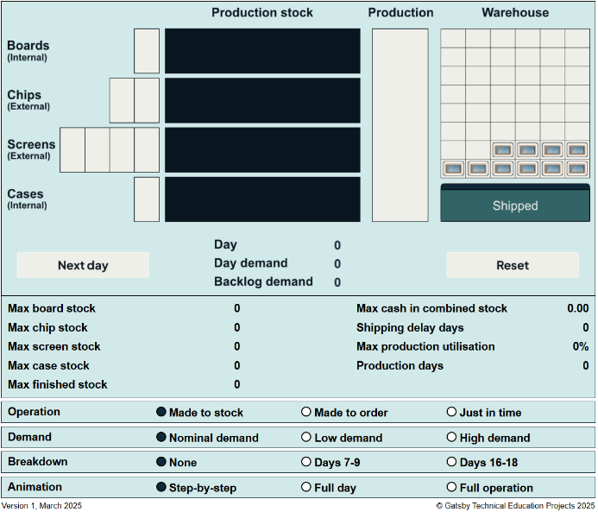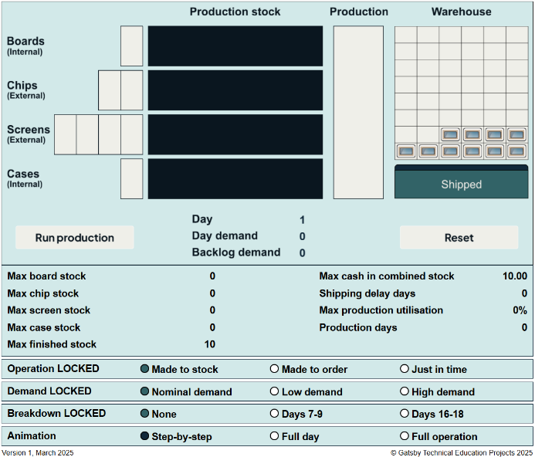

2.
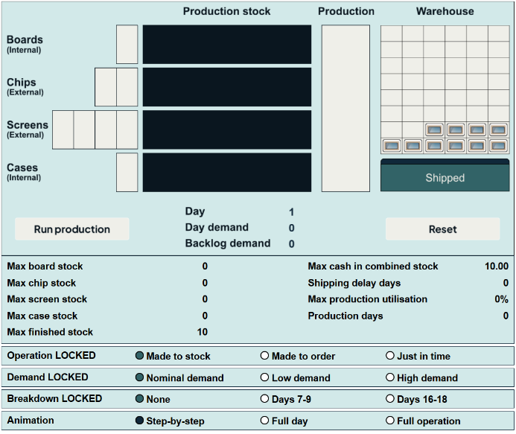

3.
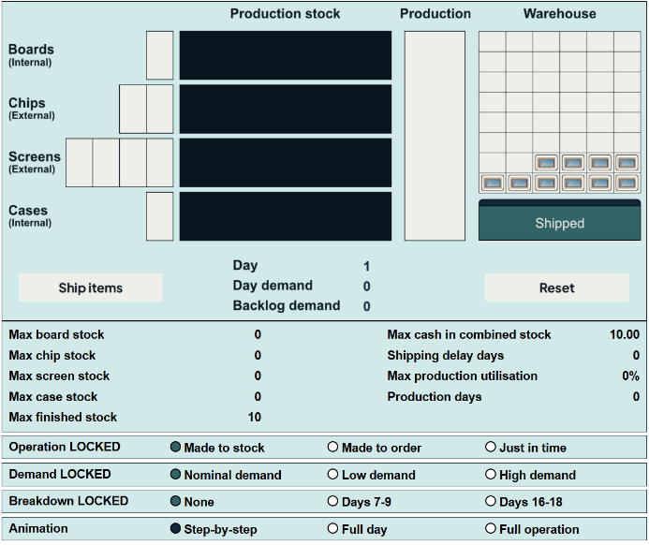

4.
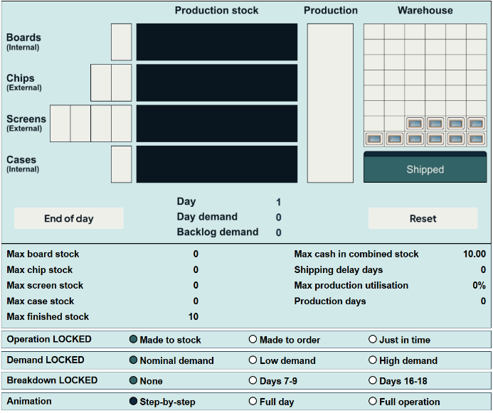

As an example, the state of play after day 2 is shown below.
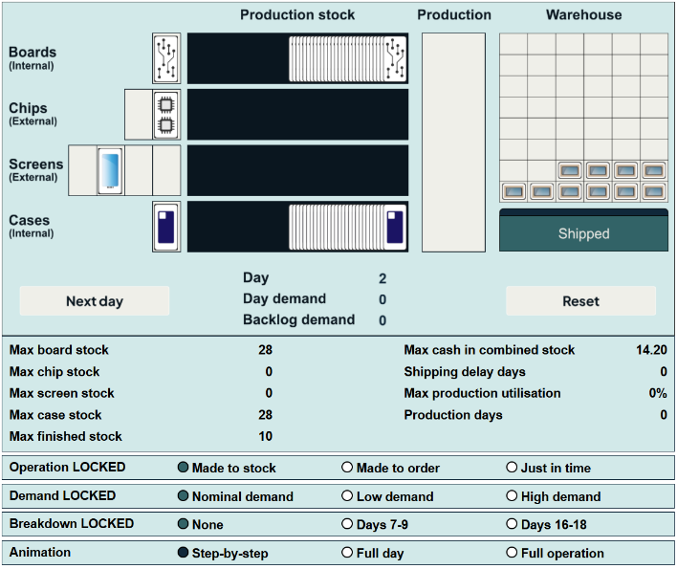
In the first few days, it is instructive to go through each step one at a time in order to see the sequence of events in the four stages. Once familiar with the operation, the “Animation” selection at the bottom of the screen can be changed to “Full day”. When this is selected, the four stages run back-to-back without a break which speeds up the progress. When very familiar, the simulation can be run continuously by selecting “Full operation” which runs each day automatically without the need for the user to click on any buttons. Full operation can be interrupted by selecting another animation option and it will be halted at the end of the day it is currently animating.
At the end of 28 days, there will be no option to continue and the screen will add a section giving the user the option to produce bar plots by clicking on the newly inserted buttons (“Boards in stock”, “Chips in stock”, etc).
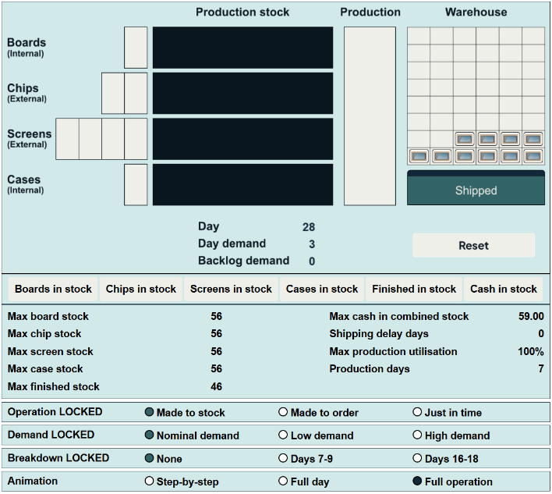

The interactive gives a set of values that characterise the performance of the stock control method used, and which are updated as the simulation progresses.
Max board stock | These are the maximum number of component items held in the production stock area. This value determines how much factory area must be available to hold production stock.
Max chip stock
Max screen stock
Max case stock
Max finished stock | The maximum number of finished stock items held. This value determines how much factory area must be available to hold finished stock.
Max cash in combined stock | This is the maximum total value of stock held as individual stock items plus finished items (see “Value of stock” below). This value determines how much credit or liquid cash the factory must have available to maintain operations.
Shipping delay days | This is the total number of days delayed from demand on a day to shipping. The larger the value, the longer it takes a customer to receive goods after an order has been made. Large values may increase the length of time it takes for payment to be received and may damage reputation (see “Shipping delay days” below).
Max production utilisation | This measure gives the maximum percentage of production capacity used over the period, where the capacity is up to 8 finished items per day. Values of less than 100% may indicate that there is too much production capacity installed and that some could be removed to save money by reducing financing, operating and maintenance cost.
Production days | This is the number of days the production line is operating over the period. Low values indicate that machinery is standing idle. The spare capacity could be used for other projects or hired out. A low value may also indicate that renting external production may be advantageous.
The various stock management and demand scenarios will give different results in the above metrics. Values should be compared at the end of 28 days along with a discussion of the implications.

Value of stock
Stock is valued in arbitrary units rather than trying to use actual values. The total value of the stock items to make a finished product is as below.
Boards | 0.10
Chips | 0.60
Screens | 0.25
Cases | 0.05
Finished product | 1.00

It is noted that the finished product is valued as the sum of the component parts. There is an argument that this undervalues the finished product as value has been added by manufacturing the parts into a product. However, this is ignored in this simulation.

Shipping delay days
If an item cannot be shipped on the day it is requested then the product adds a shipping delay. The value of shipping delay days is the cumulative sum of all delays, as illustrated below.
Day | Demand | In warehouse after production | State | Cumulative delay days
1 | 4 | 0 | 4 x 0 day late | - (none shipped yet)
2 | 3 | 2 | Start with (4 x 1 day + 3 x 0 day)  2 shipped (2 x 1 day) – ship from oldest  End with (2 x 1 day + 3 x 0 day) | 2 (2 x 1 day)
3 | 0 | 4 | Start with (2 x 2 day + 3 x 1 day + 0 x 0 day)  4 shipped (2 x 2 day + 2 x 1 day)  End with (1 x 2 day) | 2 (above) + 4 + 2 = 8
4 | 1 | 4 | start with (1 x 3 day + 1 x 0 day)  2 shipped (1 x 3 day + 1 x 0 day)  End with 0 | 8 (above) + 3 + 0 = 11

Plotting results
The previous numerical results only show “high-water” values, and can be compared between the various demand and stock control methods. The six plot buttons that are visible when the simulation reaches day 28 allow the change in values over time to be shown, for example, the four images below show the evolution of stock levels for the four individual components.
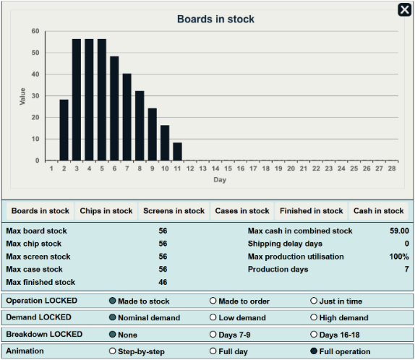
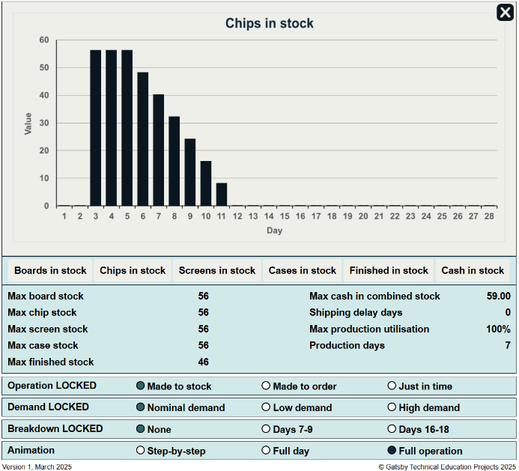
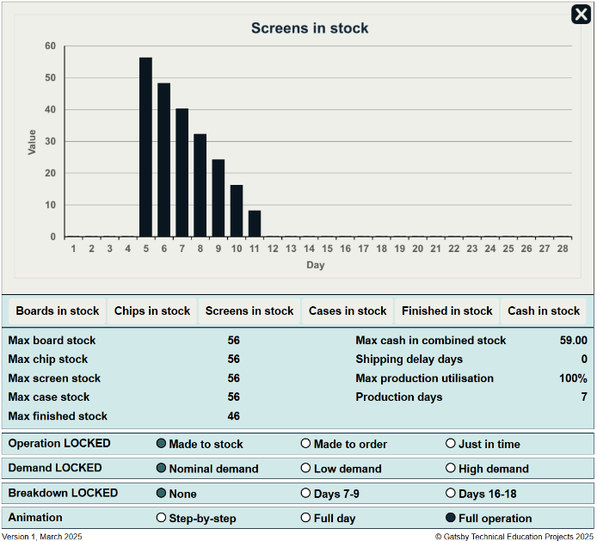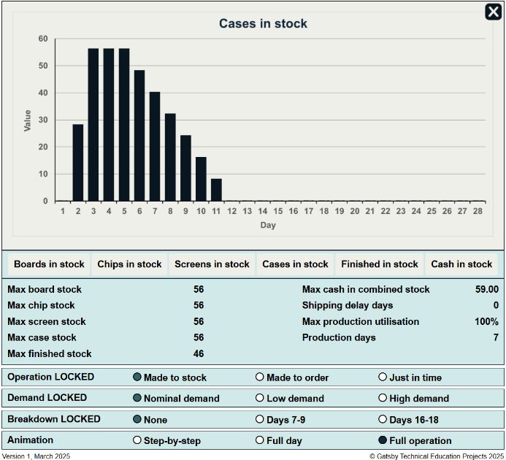
Individual plots can be dismissed by clicking on the cross in the upper-right of the screen. The plot contents can be changed by just selecting a different plot button. The images above show that maximum stock is held for three of the items while waiting for screens to be delivered, sometimes for several days. Of course, the ordering or production could be changed to prevent this but this does not materially affect any of the metrics being used.
The stock of finished items and cash tied up in component and finished items stock plots are shown below. Note that this stock management process results in high finished item stock in addition to high component stock and that a lot of cash is tied up for many days.
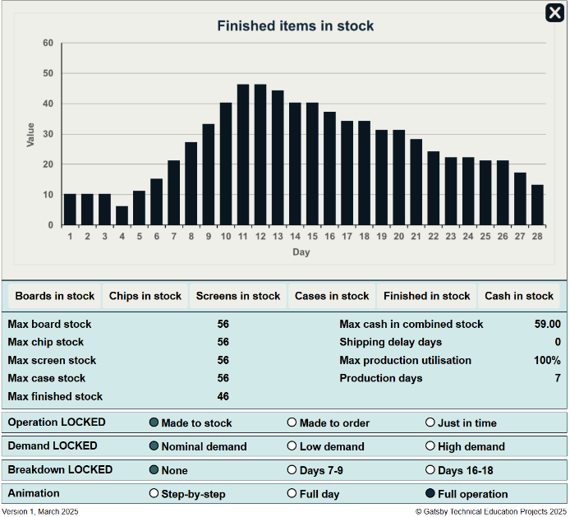
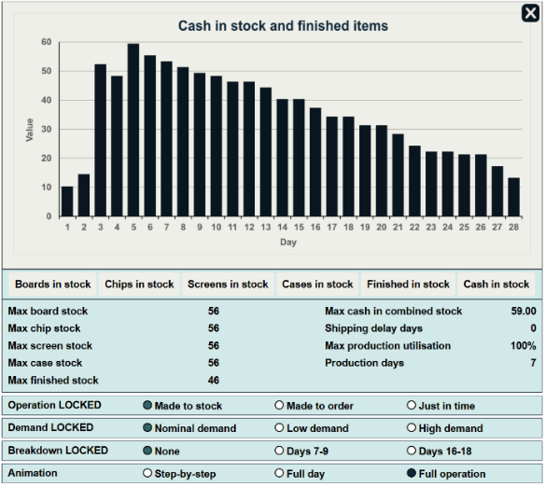
To consider other scenarios, the graph must be dismissed and the “Reset” button pressed.

Other demand scenarios
The previous case used the nominal demand scenario, i.e. the estimate of 56 items over 28 days was correct. There are two other demand scenarios that can be selected:
- Low demand: the actual demand is less than the estimated 56 items.
- High demand: the actual demand is more than the estimated 56 items.
In each case, the metrics will change.

Other stock management scenarios: made-to-order
In this scenario, stock items are only ordered or produced whenever the demand on a day is not zero (so with the nominal demand, nothing will happen on the first two days). It will then typically take several days for the stock to arrive and be put into production. The manufacturing facility has the same capacity values as the made-to-stock case.
The simulation runs on the same basis as the made-to-stock example. At the end of 28 days, the numerical metrics under the nominal demand scenario are as shown below.
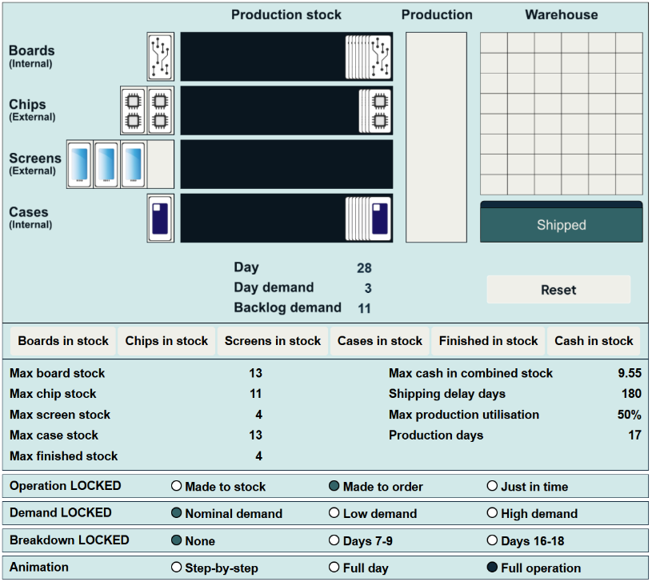
Note the maximum stock values and cash tied up in stock is lower than the made-to-order case. The production line runs for more days, but only at 50% of capacity, and there is a significant number of shipping delay days.
The individual plots are given below.
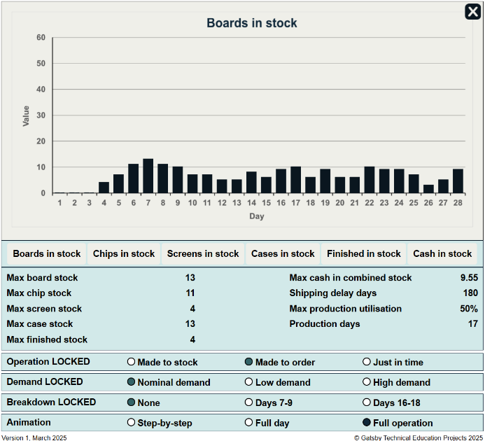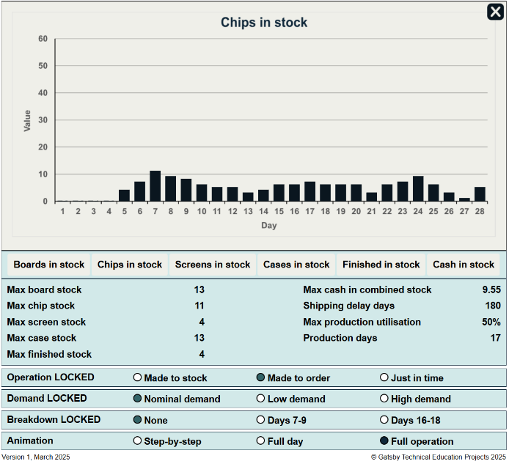
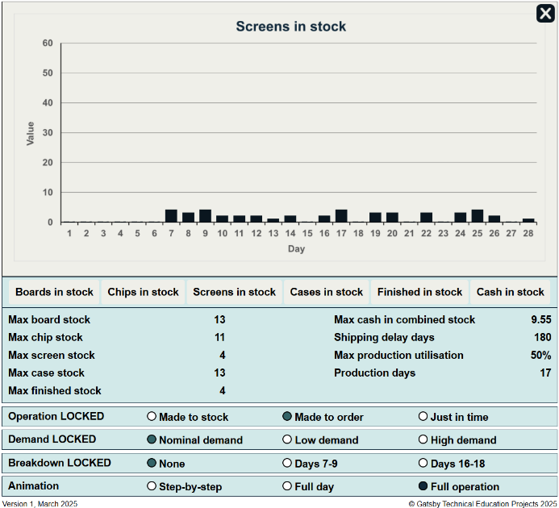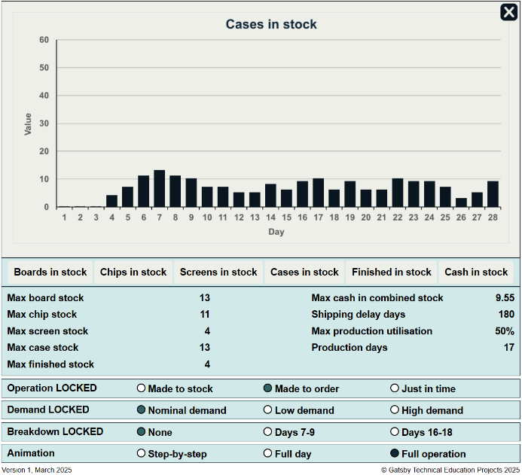
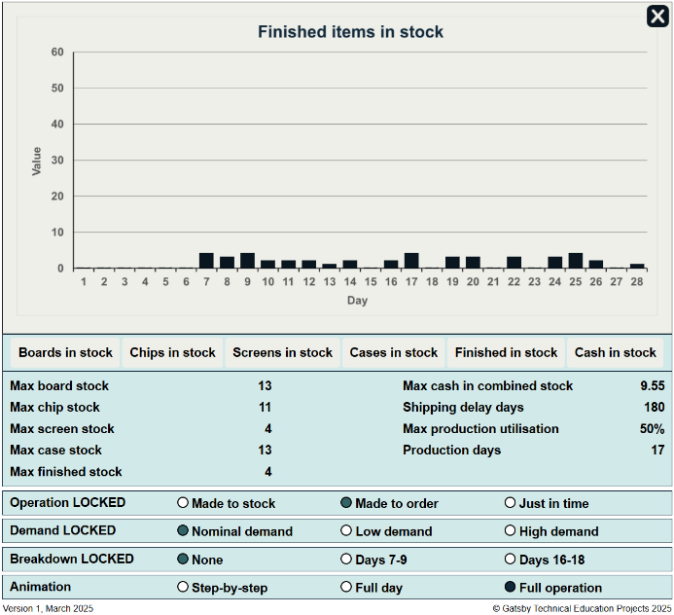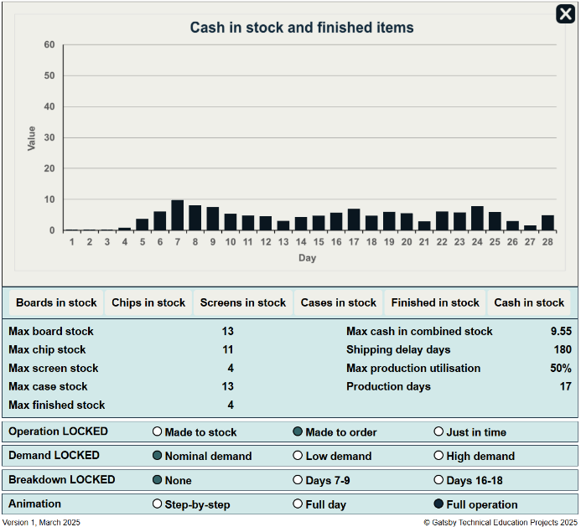
The bars on these graphs are much lower than those on the made-to-order scenario.

Other stock management scenarios: just in time
In this scenario, items are supplied to the facility just in time to be used. However, because the full forward demand is not known, the average demand of two items per day will be assumed. This is imperfect just in time; a better implementation would use a system to trigger new stock orders when working stock falls too low. This is the concept of kanban, which is considered in a separate interactive.
The simulation runs on the same basis as the made-to-stock example. At the end of 28 days, the numerical metrics under the nominal demand scenario are as shown below.
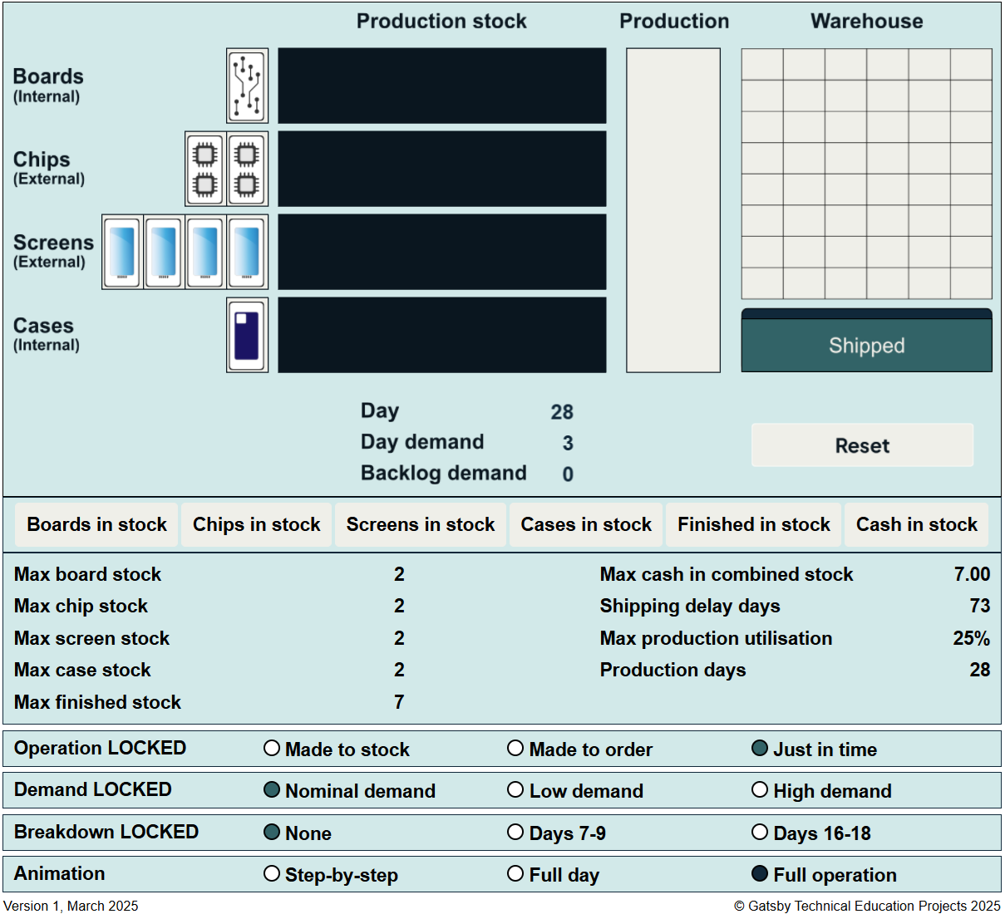
This stock control method has lower maximum stock levels than made-to-order and less cash tied up in stock. The production line runs every day, but only at 25% capacity, and, while there are shipping delay days, the number is much less than the made-to-order value.
The individual plots are given below.
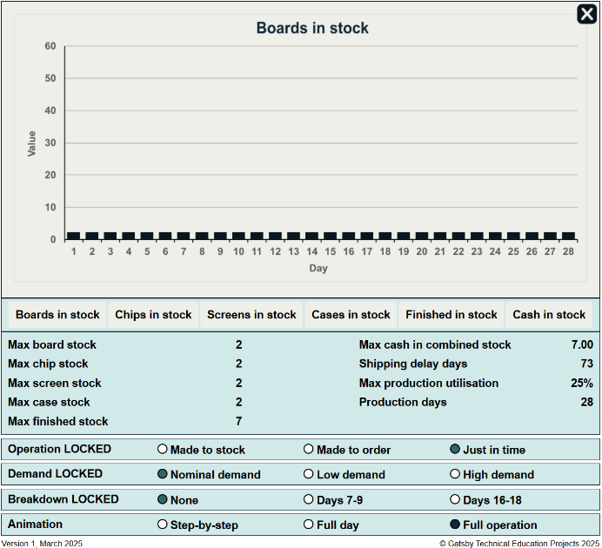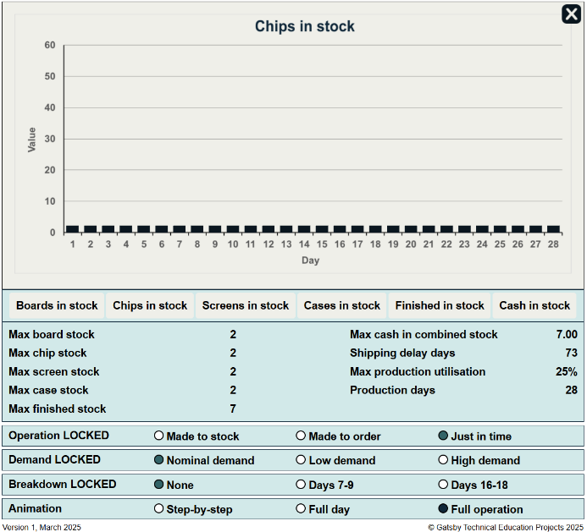
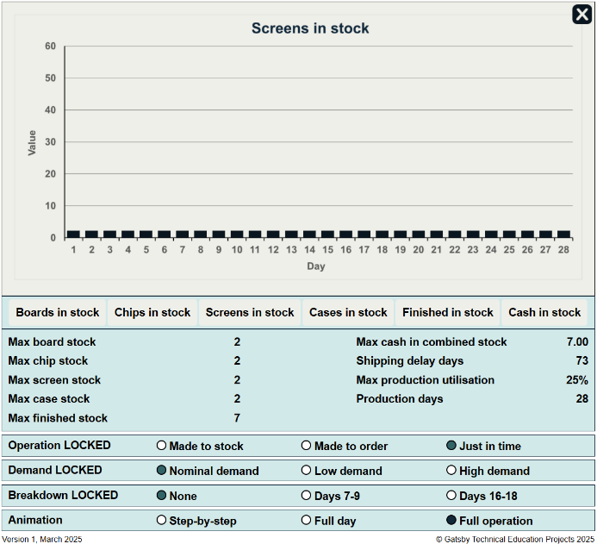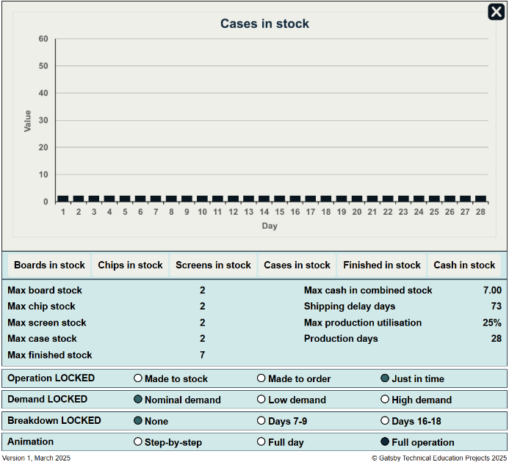
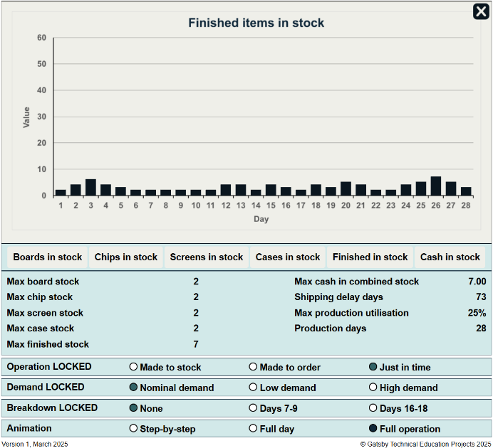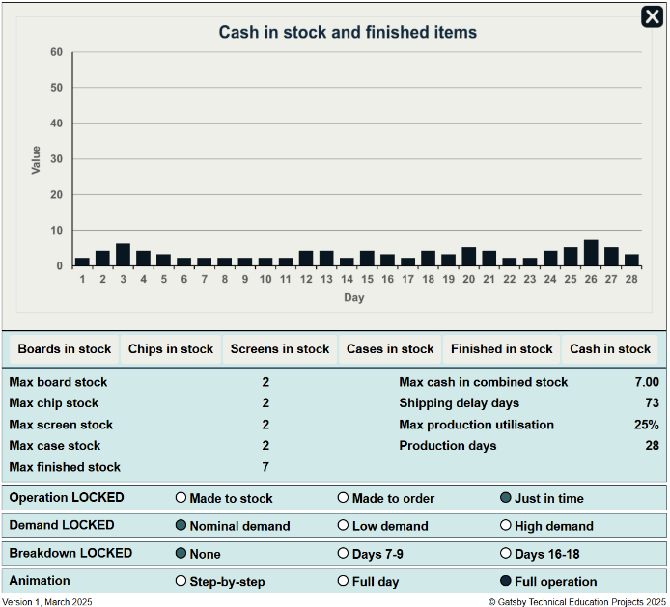
These bars are lower than in the previous two stock management scenarios.

Breakdown
The different scenarios have a different resilience to production breakdown, and this can be investigated by selecting one of the breakdown scenarios. In the image below, an early breakdown has occurred on the made-to-stock scenario. Component stock items are available for manufacture but they cannot be used because the production line has stopped and shipping can only meet demand if there is a sufficient stock of finished items.
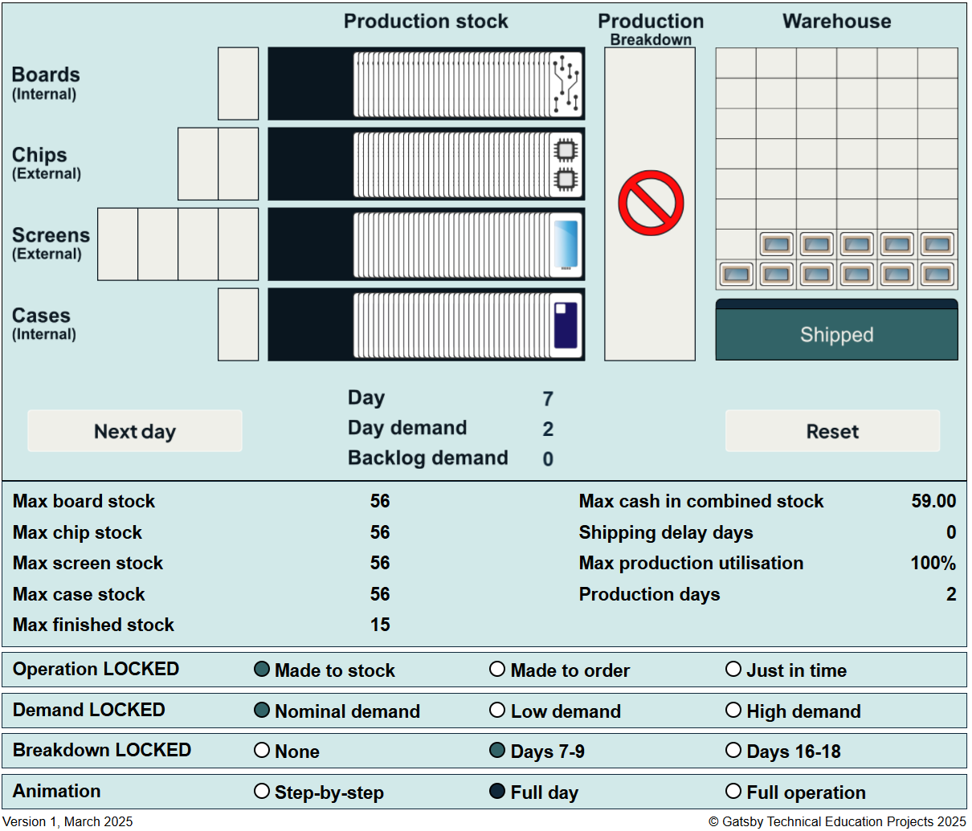
The impact of breakdowns for different stock management and demand scenarios can be compared using the numerical metrics given and the bar plots.

