Activity 2: Planning charts

Gantt chart
A Gantt chart is a tool used in project planning to break down problems into smaller, manageable tasks and to prioritise them. It is important as it helps provide a roadmap for the complete project.
Label these key features on the chart:
- list of tasks
- task bars indicating task duration
- project timeline
- staff assigned to task
- hours assigned to task

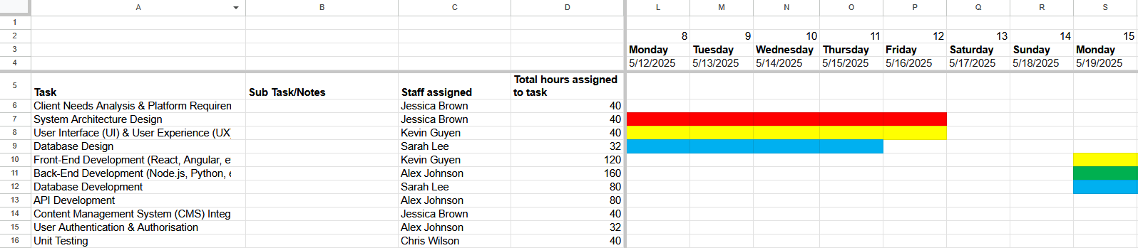

Resource and cost plan
A resource and cost plan is used to help calculate the costs and manage the budget for a project.
Label these key features on the plan:
- list of staff working on the project
- hours worked and rate of pay
- total cost for each staff member
