Activity 2: Planning charts

Gantt chart
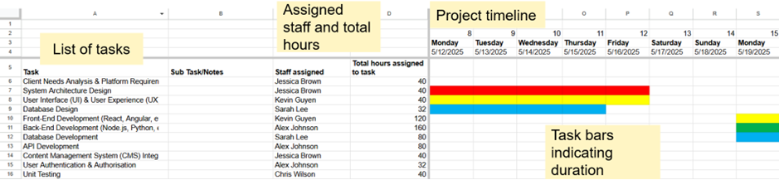

Resource and cost plan
