Activity 2: Computational thinking scenarios sample answers
Scenario 1: Abstraction
Brief: Develop a personalised video recommendation engine
A popular video streaming platform wants to design a new personalised video recommendation system. The system must suggest videos that the user is highly likely to watch next, based on their viewing habits.
The recommendation system should perform the following steps for every user on every visit:
- Input data collection: Gather data on the user’s last 50 viewed videos including video ID, category, watch time and the creator ID.
- Filtering process: Remove any videos of which the user has already watched more than 95%.
- Scoring process: Calculate a potential recommendation score for unwatched videos based on similarity to the user’s top three favourite categories and the average watch time.
- Output: Display the top 20 highest-scoring videos on the user’s homepage. Videos should load instantly and display correctly on mobile, tablet and desktop.
Your task is to use abstraction to identify the most important details from the above brief so that you can identify the core functionality.

- List at least six abstractions that are necessary for the recommendation engine to function:
These could include high-level concepts, objects or essential features e.g. user profile or recommendation score. Categorise each feature into one or more of the following:
- things that vary
- things that will remain constant
- key actions the solution must perform
- repeated process the solution will perform.
Things to consider:
- Which information in the brief is vital for the recommendation engine to work effectively?
- Which information in the brief can be ignored at this stage?

Feature | Category
User profile  Provides information about the user’s tastes | Things that remain constant  Things that vary
Video data  E.g. ID, category, watch time, creator ID | Things that vary  Repeated process the solution will perform
Viewing habit  Past video data e.g. last 50 viewed | Repeated process
Video/content  The item being viewed | Things that remain constant
Recommendation score  A calculated value indicating the video’s suitability | Things that vary  Key actions the solution must perform
Recommendation list  The final output of top 20 videos to be displayed to the user | Key actions to perform  Things that will remain constant

- Explain why you chose these abstractions:
For each abstraction, write an explanation to justify your choice. Use the PEE (Point, Evidence, Explain) method:
- Point: State the abstraction and category.
- Evidence: How does it achieve the requirements in the brief?
- Explain: Why is it essential to the functionality? What complexity does this abstraction hide? Why did you categorise them in this way?
Point: Video data (things that vary)
Evidence: The brief states “Gather data on the user’s last 50 viewed videos including video ID, category, watch time and the creator ID”.
Explain: This data is essential for the filtering and scoring processes as it will need to compare the video data of new videos to rate their suitability for the user. The abstraction hides the complexity of how the data is stored and allows the system designer to focus on the variables needed for the core logic. Video data is categorised as ‘things that vary’ because the specific ID, category and watch time change for every video in the system. The collection of this data would be a repeated process as, while the data itself is variable, the act of pulling it into the system is a consistent, recurring task. While the data itself is variable, the act of pulling it into the system is a consistent, recurring task.

Scenario 2: Decomposition
Brief: Designing a new social media feature
Your favourite social media platform wants to add a major new feature: Collaborative Group Playlists. This feature must allow groups of users to simultaneously suggest, vote on and reorder songs in a shared queue for a virtual party.
The development team has already used abstraction to define six essential functionalities:
- User management | Handling user roles and managing the list of users
- Song suggestion/ search | Providing an interface to search a music library
- Playlist interaction | Managing the playlist by adding, removing and reordering
- Voting system | Allowing users to up-vote a song in the queue; songs with more votes are automatically moved up the queue
- Real-time updates | Ensuring that any change is immediately visible to all connected users without them needing to refresh the page
- Party setup | The ability for a user to create a new private party, invite friends via link and define host privileges

Your task is to decompose the development of this new feature into the main components and the sub-tasks required to build it.

- Choose three key functionalities that you think are the most important and break each one down into at least three sub-tasks. Consider:
- What are the specific steps involved in each task?
- How can you ensure these tasks are manageable and achievable?
- Do any of the sub-tasks need breaking down further?
Example:
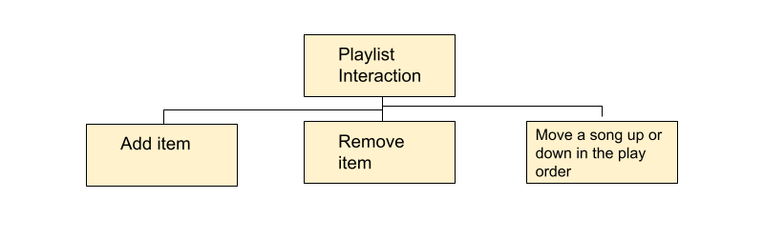
Here, the high-level component ‘Playlist Interaction’ has been broken down into three smaller, more manageable tasks.
The add item feature would need to be built first, as you cannot remove or reorder an item until after something has been added.

Now choose two more high-level components from your list and decompose these in the same way. Present your decompositions as a structure diagram.
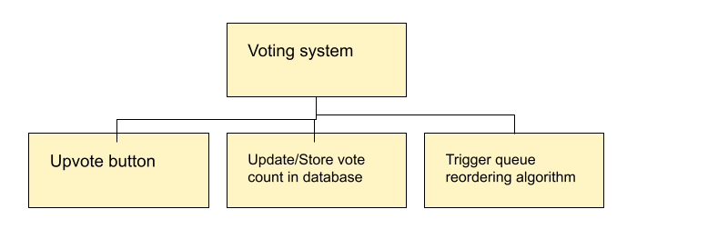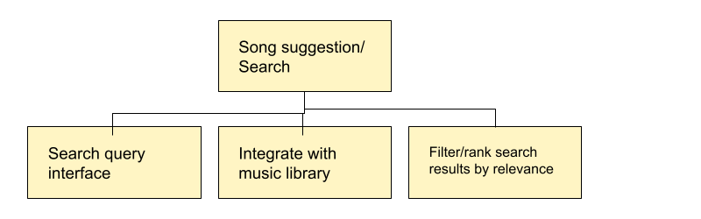
- Write an explanation for why you broke each task down in this way:
Use the PEE (Point, Evidence, Explain) method to ensure your explanations are well-justified.
- Point: State the high-level functionality and the sub-tasks that you divided it into.
- Evidence: How does each sub-task help you solve the original problem? Are there any dependencies between the sub-tasks?
- Explain: How does your breakdown ensure that each task is manageable? Explain the order that the sub-task will need to be developed in? Why must they be developed in this order?
Point:
The song suggestion/ search functionality was broken down into:
- Search query interface
- Integrate with music library
- Filter/rank search results by relevance

Evidence:

The overall task requires an interface that allows users to search the music library. The sub-tasks address the three main parts of this: what the user sees, how the system finds the data and how the system makes these results useful. The feature must be integrated with the music library before it is able to filter or rank the results and the interface must be in place before you can send a search query, therefore these items must be developed in the following order:

Search query interface → Integrate with music library → Filter/rank search results by relevance
Explain:
This breakdown makes each task manageable by isolating the work.
A front-end developer can build the search interface.
A back-end developer can handle the integration.
A data scientist or back-end developer can design the ranking logic.
The tasks must be developed in order as you need to be able to search the library before you can display the results.

Scenario 3: Pattern Recognition
Brief: Detecting unusual activity in a study app
An educational revision app uses timed quizzes to test student knowledge. The app needs a new system to detect unusual user patterns that suggest a student might be using a bot to complete the quiz, rather than answering the quizzes themselves.
You have been given a small sample of quiz log data from three different subjects. The system needs a robust, generalised rule for when an attempt should be ‘flagged’ as suspicious.
Your task is to analyse the data and use pattern recognition to identify common conditions that lead to an attempt being flagged across all subjects.
Quiz Log Data
Attempt ID | Subject | Correct answers (%) | Time taken (minutes) | Outcome
A101 | Maths | 98 | 0.8 | 🚩 Flagged
A102 | Maths | 85 | 2.5 | Normal
A103 | Maths | 90 | 0.5 | Normal
A104 | Science | 97 | 0.7 | 🚩 Flagged
A105 | Science | 96 | 1.5 | Normal
A106 | Science | 80 | 0.4 | Normal
A107 | History | 99 | 0.9 | 🚩 Flagged
A108 | History | 92 | 1.8 | Normal
A109 | History | 75 | 0.5 | Normal

- Identify the pattern and the conditions
Based on the data above, identify the specific conditions that must both be true for an attempt to be flagged.
- Score: Correct answers > 97%
AND
- Time: Time taken < 0.9 minutes
Now state the rule that your program should follow to flag suspicious quiz attempts across all subjects:
IF
The user’s score is > 97%
AND
The total completion time is < 0.9 minutes
THEN
Mark attempt as 🚩 Flagged

- Justify the rule that you have written
Use the PEE method to justify how you reached your conclusion:
- Point: State the rule.
- Evidence: How does the sample data support your conclusion? What was similar in each flagged case?
- Explain: What is the benefit of having one rule that applies across all subjects?
Point: The rule states that an attempt is flagged if the correct answers is > 97% AND the time taken is < 0.9 minutes.
Evidence: This two-part condition is consistent across all three flagged attempts in the data:
A101 | Maths | 98 | 0.8 | 🚩 Flagged
A104 | Science | 97 | 0.7 | 🚩 Flagged
A107 | History | 99 | 0.9 | 🚩 Flagged

The other attempts which are normal all fail at least one of these conditions but are not flagged.
Explain: The benefit of one generalised rule is that it is robust, efficient, and easy to apply across all subjects without needing separate, complex rules for maths, science or history. It identifies a clear pattern of suspiciously high accuracy achieved in an unrealistically short amount of time, which suggests automation or cheating, regardless of the subject content.
Scenario 4: Algorithm Design
Brief: Design an automated library fine calculator
A local library needs an automated system to calculate fines for overdue books. The system must follow three rules to calculate the correct fine amount:
- If the book is 7 days or less overdue, the fine is 50p per day.
- If the book is more than 7 days overdue, the fine is £1.00 per day for every day.
- The total fine must not exceed £10.00.
Your task is to design an algorithm to calculate the fine amount.

- Design the algorithm
Using either written instructions or a flowchart, design a step-by-step algorithm to solve this problem. Consider:
- What is the input, process and output?
- What decisions need to be made?

Flowchart symbols you may need:
Terminators indicate the start and end of a program
Used for processes
Used for decisions. E.g. IF, ELSE

Used for inputs and outputs
Shows the flow of the program.

Sample answer:
- START
- INPUT Number of Days Overdue (Days)
- PROCESS Calculate Fine
- IF Days <= 7 THEN
  - Fine = Days * £0.50
- ELSE IF Days > 7 THEN
  - Fine = Days * £1.00
- DECISION Fine > £10.00 ?
- IF Fine > £10.00 THEN
  - Fine = £10.00
- OUTPUT Fine
- END

- Justify your algorithm design.
Use the PEE method to justify why you have designed your algorithm in this way.
- Point: Describe your algorithm e.g. the flowchart shapes or keywords you used for each step.
- Evidence: Have you tested your algorithm with sample data? Does it work?
- Explain: Why is this approach suitable for the task?
Point: The algorithm uses sequential steps, IF/ELSE statement for the different rates and a final conditional check to enforce the maximum fine. It also defines the input (days overdue), process (calculation) and output (final fine).
Evidence: The algorithm correctly handles the three rules:
- If Days = 7, FIne = 7 * £0.50 = £3.50
- If Days = 8, Fine = 8 *£1.00 = £8.00
- If Days = 20, Fone = 20 * £1.00 = £20.00. Here, the final IF statement checks whether Fine > £10.00 and caps the final fine at £10.00

Explain: This approach is suitable because the problem is a decision-based calculator. The algorithm is clear, logically ordered and ensures that the most restrictive rule (maximum fine = £10.00) is applied after the initial fine has been calculated. This guarantees that no fine ever exceeds the limit.

