Activity 2: Applying problem solving approaches sample answers
Introduction
In this activity, you will work in groups to apply problem solving approaches in a digital scenario.
First, you will choose one of the following problems to solve:
A. School room booking system  Design a system for school staff to manage room bookings. The system must allow users to view a real-time calendar of room availability, submit a booking request for a specific time/date, receive email confirmation and prevent double-booking for the same room and time slot. | B. Sports tournament scheduler  Design a system to organise a sport tournament for 8 to 16 teams. The system must allow the admin to input team names, automatically generate a match list for all pairings, record scores during matches, calculate points and display a real-time leaderboard to rank the teams. | C. Event ticket validator  Design a system for event staff using handheld scanners to validate digital tickets. The system must scan the unique Ticket ID, verify it is valid for the current date/time and prevent reuse by permanently marking the ticket as 'USED'. The system must alert staff with error messages for invalid, expired or previously used tickets.

Part 1: Top-down design
The top-down approach begins by decomposing the problem into smaller, manageable sub-problems (modules). This method is usually used when planning a solution.
Step 1: Input–Process–Output
Identify:
- Input: The fundamental information needed for your selected system
- Process: The core high-level functions the system must perform
- Output: The results it must produce
This step uses abstraction to define essential characteristics.
Stage | Data/Information required | Your system
INPUT | Data required to start the system | Staff ID/Email, Room ID/Name, Date, Start Time, End Time
PROCESS | The main high-level functions/checks the system performs | User authentication  Check room availability  Record booking  Generate confirmation email
OUTPUT | The final results shown to the user or stored in the database | Real time availability calendar, Booking confirmation status, Updated booking database record, Confirmation email

Step 2: Decomposition and modularisation
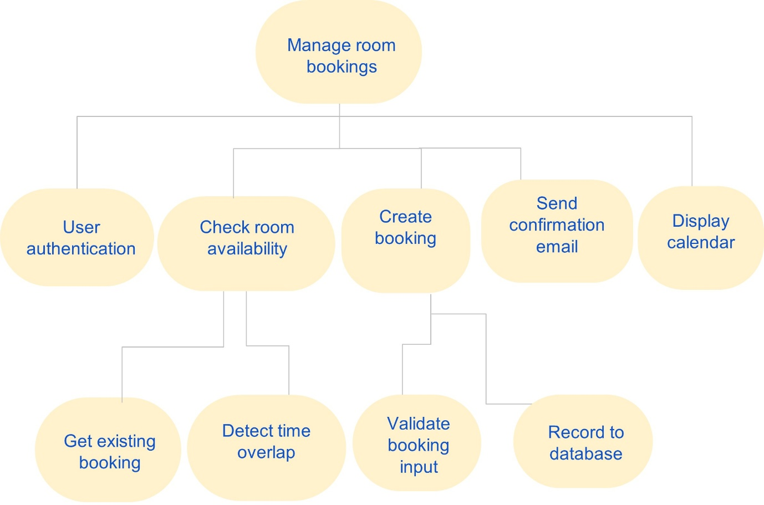
Decompose the main process function into smaller parts, moving in the downward direction. The goal is to create sub-tasks that are manageable and can be easily developed.

Part 2: Bottom-up development
The bottom-up approach focuses on building the smallest, essential modules first, thoroughly testing them in isolation and then merging them into a larger system.
Step 3: Select and design one core feature module
Choose one single, most critical function from your decomposition that needs to be built and tested first to ensure the entire system works.
- Chosen core feature module: Validate booking input
Give three reasons that you chose this feature:
- Validating booking input is a small, essential module that can be easily built before integrating into the larger system.
- Validating booking input is essential for other modules, such as checking room availability and recording to the database.
- This module is fundamental. Building it first provides a robust foundation, making later integration simpler.
Algorithm design: Outline the precise steps for this feature and create two test cases to prove it works. You can either use a flowchart or pseudocode to design your algorithm.
FUNCTION validate_input(room_id, date, start_time, end_time):
// Check for missing data (basic validation)
IF room_id IS NULL OR room_id IS EMPTY:
RETURN "ERROR: Room ID is required."
IF date IS NULL OR date IS EMPTY:
RETURN "ERROR: Date is required."

// Check time constraints (simplified logic)
IF start_time >= end_time:
RETURN "ERROR: Start time must be before end time."

// If all basic checks pass
RETURN "VALID"
END FUNCTION
Step 4: Coding the solution
Write a short section of Python code that implements the core logic described in your algorithm above.
Your code must:
- be modular: Use at least one function or procedure to encapsulate the core logic
- include an input and output: Use input() and print() functions
- apply programming techniques: Use appropriate logic and programming structures (e.g. if/else or loops).
def validate_input(room_id, date_str, start_time, end_time):
"""
Checks if the essential booking inputs are provided and logically sound.
"""
# 1. Check for missing or blank data (strip() catches whitespace-only entries)
if not room_id or not room_id.strip():
return "ERROR: Room ID is required."
if not date_str or not date_str.strip():
return "ERROR: Date is required."

# 2. Check time constraints (start must be before end)
# Times should be entered as whole numbers e.g. 930 for 9:30am
try:
if int(start_time) >= int(end_time):
return "ERROR: Start time must be before end time."
except ValueError:
return "ERROR: Time must be entered as a whole number (e.g. 930 for 9:30am)."

# 3. If all checks pass
return "VALID"

# --- INPUT AND OUTPUT SECTION ---

# Use input() for simulation
print("--- Input Validation Module Test ---")
room_id_input = input("Enter Room ID: ")
date_input = input("Enter Date: ")
start_time_input = input("Enter Start Time (e.g., 900): ")
end_time_input = input("Enter End Time (e.g., 1000): ")

# Call the core function
validation_status = validate_input(
room_id_input,
date_input,
start_time_input,
end_time_input
)

# Use print() to display the result
print(f"\nRESULT: {validation_status}")

Step 5: Testing the code
Create two test cases to prove your code works, focusing on the inputs and outputs of your function.
Test case | Input value | Expected output (what the function should return) | Actual output (result of running the code)
1 | R101, 2025-12-15, 1000, 1100 | VALID (All fields present and start < end) | RESULT: VALID
2 | R101, 2025-12-15, 1100, 1000 | ERROR: Start time must be before end time. (Start time is greater than end time) | RESULT: ERROR: Start time must be before end time.

Part 3: Merging modules
Step 6: System integration and finalisation
Select a second, related function from your Step 2 Decomposition and complete the following:
- Plan, code and test the second feature: Write a second, separate Python function that implements the logic for this new feature and test that it works as expected.
- Integrate/Merge: Integrate your first working function with this new second function and test that they work together.
Use the space below to design your algorithm and record your test cases.
Students should consider the following when merging modules:
- Check data exchange: Test to ensure that any data passed between the modules works correctly e.g. is the output from the first module correctly passed as input to the second module. This is essential for cross-checking that the modules communicate correctly.
- Test for logic errors: Run test data through the newly integrated system to check for logic errors that may have been introduced when the modules were connected. While each segment may work on its own, testing the boundary and erroneous data through the full sequence ensures the combined logic works and that the program is robust.

