Resource 1 Worksheet answers
1 You need to order vinyl flooring for this renovation. Calculate the internal floor area.
Add 10% for cutting waste and state the total area to order.

First, split the shape into two rectangles, for example:
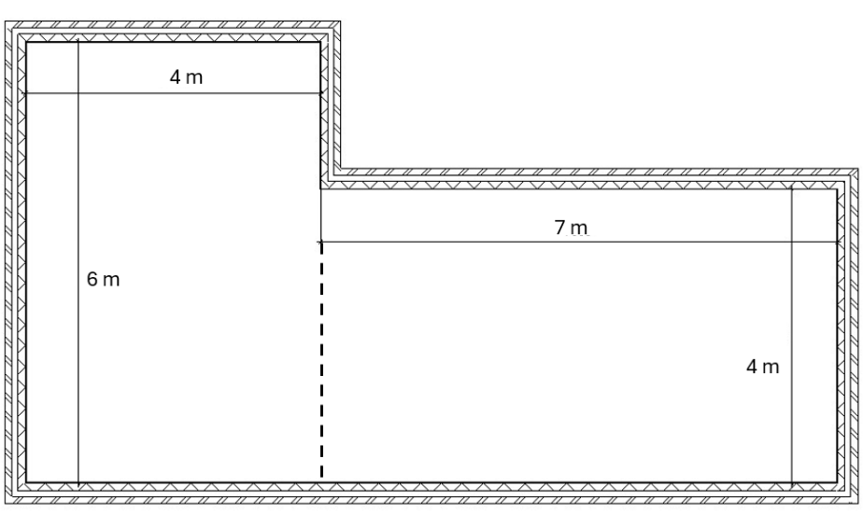
Rectangle 2
Rectangle 1
Now find the area of each rectangle:
Rectangle 1
$$\text{area}$$ | $$=$$ | $$\text{length} ×\text{width}$$
 | $$=$$ | $$6 \text{m}×4 \text{m}$$
 | $$=$$ | $$24 {\text{m}}^{2}$$
Rectangle 2
$$\text{area}$$ | $$=$$ | $$\text{length} ×\text{width}$$
 | $$=$$ | $$7 \text{m} ×4 \text{m}$$
 | $$=$$ | $$28 {\text{m}}^{2}$$
(1 mark)
So, $\text{total area} = 24 {\text{m}}^{2}+ 28 {\text{m}}^{2} = 52 {\text{m}}^{2}$
(1 mark)
10% of 52 is: $\frac{10}{100}×52{\text{ m}}^{2}=5.2 {\text{m}}^{2}$ .
(1 mark)
So, the total amount to order is $52 {\text{m}}^{2}+ 5.2 {\text{m}}^{2} = 57.2 {\text{m}}^{2}$
(In practice, you will probably need to round up to 58 or even 60 for the order.)
(1 mark)
2 Steel I-Beams each have a mass of 250 kg.
A hydraulic platform can safely support a load of 50 kN.
- What is the maximum number of beams that the platform can safely support?
First, convert kN to N:
$50 × 1000 = 50 000 N$
(1 mark)
Second, work out the weight of each beam:
$$W$$ | $$=$$ | $$\text{mg}$$
 | $$=$$ | $$250 \text{kg} ×9.8 m/s^{2}$$
 | $$=$$ | $$2450 \text{N}$$
(1 mark)
Finally, divide load by the weight of a beam:
$$\frac{50 000 \text{N}}{2450 \text{N}}=20.41 (2\text{ d.p.)}$$
(1 mark)
Therefore, the platform can safely support 20 beams. There cannot be a fraction of a beam and rounding up to 21 would be unsafe.
(1 mark)
The site safety manager requires a 15% safety margin on the lift capacity.
(b) Calculate the maximum number of beams you can lift while maintaining this safety margin.
Calculate 15% of the maximum load:
$$\frac{15}{100}×50 000 \text{N}=7500 \text{N}$$
So, the safe lift capacity including the safety margin is:
$$50 000 \text{N}-7500 \text{N}=42 500 \text{N}$$
(1 mark)
Divide the safe lift capacity by the beam weight to find the new safe number of beams:
$$\frac{42 500 \text{N}}{2450 \text{N}}=17.35 (2\text{ d.p.)}$$
(1 mark)
There cannot be a fraction of a beam and rounding up to 18 would be unsafe, so round down to 17 beams.
(1 mark)
3 (a) Define luminous efficacy.
Luminous efficacy is the ratio of the luminous flux emitted by a light source to the electrical power it consumes.
OR
$$\text{luminous} \text{efficacy}= \frac{\text{luminous flux}}{\text{power}}$$
(1 mark)
- A lamp is rated at 36 W and emits a total luminous flux of 1800 lumens.
Use this formula to calculate the luminous efficacy of the lamp.
$$\text{luminous} \text{efficacy}= \frac{\text{luminous flux}}{\text{power}}$$
Include units in your answer.

$$\text{luminous} \text{efficacy}= \frac{\text{luminous flux}}{\text{power}}=\frac{1800 \text{lm}}{36 \text{W}}=50 lm/W$$
(1 mark for formula)
(1 mark for substitution)
(1 mark for units)
(c) The building specifications require all lighting to have an efficacy of at least
60 lm/W to meet sustainability targets. Does this lamp meet the specification? (Yes/No)
No, since 50 is less than 60.
(1 mark)
4 You are ordering ready-mix concrete for a foundation pour.
Concrete has a density of 2400 kg/m³. There are 1000 kg in one tonne.
- Calculate the volume of 5 tonnes of concrete.
First convert tonnes to kg: $5 \text{tonnes} = 5 × 1000 = 5000 \text{kg}$
(1 mark)
Rearrange the density equation to solve for volume:
$$\text{density}$$ | $$=$$ | $$\frac{\text{mass}}{\text{volume}}$$
$$\text{volume}$$ | $$=$$ | $$\frac{\text{mass}}{\text{density}}$$
 | $$=$$ | $$\frac{5000 \text{kg}}{2400 kg/m^{3}}$$
 | $$=$$ | $$2.08 {\text{m}}^{3}$$
(1 mark for formula)
(1 mark substitution)
(1 mark for answer with correct units)
The foundation of a house has dimensions 12 m × 8 m × 0.75 m.
A particular pump can pump concrete at the rate of 96 m³ per hour.
- Work out, to the nearest minute, how long it takes to fill the foundations.
$$\text{volume}$$ | $$=$$ | $$\text{length} ×\text{width} ×\text{height}$$
 | $$=$$ | $$12 \text{m} ×\text{8} \text{m}×\text{0.75 m}$$
 | $$=$$ | $$72 {\text{m}}^{3}$$
$$\text{time taken (h)}$$ | $$=$$ | $$\frac{\text{volume (}{\text{m}}^{3})}{\text{rate (}m^{3}\text{/h)}}$$
 | $$=$$ | $$\frac{72 {\text{m}}^{3}}{\text{96} m^{3}\text{/h}}$$
 | $$=$$ | $$0.75 \text{h}$$
 | $$=$$ | $0.75 \text{h}×60 min/h$
 | $$=$$ | $$45 \text{minutes}$$
(1 mark for calculating volume)
(1 mark for time taken)
(1 mark for substitution)
(1 mark for answer in minutes)

(c) Concrete is sold in cubic metres (m³). Based on your volume calculation, how much should you order to the nearest 0.5 m³ to ensure you do not run short?
You require 2.08 m³ of concrete, which rounded to the nearest 0.5 m³ is 2.5 m³.
You cannot round down or you will not have enough concrete.
(1 mark for rounding to nearest 0.5)
(1 mark for rounding up)
5 The thermal expansion of a material is described by the formula:
$$ΔL = α × L × ΔT$$
(a) Explain the meaning of α in this formula and describe what is meant by thermal expansion.
α represents the coefficient of thermal expansion.
(1 mark)
Thermal expansion is the increase in size of a material when its temperature rises.
(1 mark)
(b) A 10 m length of wire increases in length by 15 μm when its temperature rises by 4°C. Calculate the value of α for this wire, giving your answer with units.
Convert 15 μm to SI uits: 15 × 10⁻⁶ m
(1 mark)
Rearrange the given formula and substitute known values:
$$\text{α}$$ | $$=$$ | $$\frac{ΔL}{L ×ΔT}$$
 | $$=$$ | $$\frac{15×{10}^{-6}\text{ m}}{\text{10 m × 4 ℃}}$$
 | $$=$$ | $$3.75 ×{10}^{-7} {°\text{C}}^{-1}$$
(1 mark for rearranging formula)
(1 mark for converting µm to m)
(1 mark for using correct temperature difference)
(1 mark for substitution)
(1 mark for correct answer with units)
(c) Explain why thermal expansion of wire needs to be considered when designing overhead power lines, what is a potential hazard resulting from it, and two ways to mitigate the hazards.
Example explanations:
- Temperature changes cause the metal wire to expand when it gets hotter or shrink when it gets colder.
- Expansion makes the wire sag more between pylons.
- Colder temperatures can cause more tension in the wires.
(1 mark)
Example potential hazards:
- Excessive sagging can be dangerous (for example, wires could get too close to the ground, trees, or people).
- Too much tension could damage supporting structures or wires.
(1 mark)
Example mitigations:
- Engineers allow extra clearance or maintain safe distances for sagging.
- Engineers design supporting structures and tension for the environment to consider temperature fluctuations.
(2 marks)
OR other valid wording for the points above.

