LED dimmer circuit: Worksheet answers

Task
A client needs a lighting solution for a cinema room. Design and build a circuit that dims an LED, for use in this room. It is important that the brightness changes smoothly to maintain visual comfort, enhance ambience, reduce eye fatigue, and achieve energy efficiency.
It should conform to the following safety requirements, work reliably and its components should not become warm.
Resources available
- an LED
- a potentiometer
- two resistors
- a transistor
- a battery (5 V)
- breadboard
Safety requirements
Current control: Limit LED and transistor current to under 20 mA using a correctly calculated series resistor.
Component orientation: Verify LED polarity and transistor pinouts (CBE) before applying power to prevent thermal damage.
Short circuit prevention: Ensure the positive and negative supply rails never come into direct contact on the breadboard.
Voltage limits: Maintain a stable supply voltage between 5–9V to prevent transistor breakdown.

Activity 1: Designing an LED dimmer

Part 1: Simulation
Use simulation software to prototype the LED dimmer circuit.
- Open your chosen simulation software
- Add the following components:
- DC power supply (5–9 V);
- potentiometer (10 kΩ);
- NPN transistor (BC547 or equivalent);
- LED;
- fixed resistor for the LED.
- Wire the circuit so that:
- the potentiometer controls the base of the transistor;
- the LED is connected in the collector circuit.
4. Test the simulation by adjusting the potentiometer.

Part 2: Circuit diagram
- Draw a circuit diagram of the dimmer circuit you simulated using pencil or CAD software Make sure you:
- Use correct electronic symbols
- Label:
- all components;
- voltage supply;
- resistor values;
- transistor terminals (B, C, E).
You should draw a circuit diagram (either neatly with pencil or using CAD software), labelling all components.
Circuit layout using Circuit Wizard
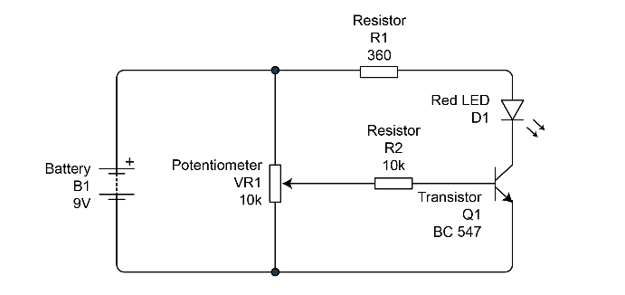
Circuit layout using Tinkercad®
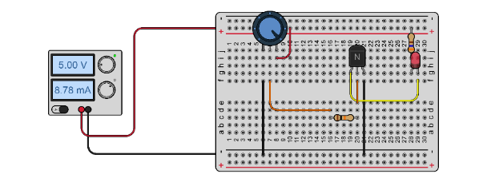
- Write one sentence for each of the terms below to explain their function.
Power supply | Provides electrical energy to drive the circuit.
Potentiometer | Acts as a variable resistor to control the base current of the transistor, allowing the LED brightness to be adjusted.
Base resistor | Limits the current entering the transistor base to prevent damage.
Transistor | Operates as a switch or current amplifier. A small base current controls a larger collector current flowing through the LED.
LED | Transfers electrical energy to light.
LED current-limiting resistor | Limits the current through the LED to a safe operating value.

Activity 2: Calculations and considerations
Before moving to the physical build, you must verify your design. These steps ensure your circuit is safe, efficient, and functions correctly.

1. LED protection
Task: Calculate the series resistor $R_{1}$.
Expected results: Depending on the LED colour chosen from the Data Sheet (1.8 V to
3.4 V) and a 9 V supply, resistors will typically fall between 270 $Ω$and 560 $Ω$.
Example calculation (Blue/White LED): $V_{s}=9 \text{V},V_{f}=3.2 \text{V},I_{f}=0.02 \text{A}$
$R=(9-3.2)÷0.02=290 Ω$. (Nearest standard value $330 Ω$.)
Power safety check: $P=I^{2}×R$. For the example above: ${0.02}^{2}×330=0.132 \text{W}$.
You should conclude this is safe because $0.132 \text{W}<0.25 \text{W}$. If you calculate a value higher than 0.25 W (likely due to using a very low resistance or high voltage), you must stop and re-evaluate.

2. Performance check
Task: Measure $I_{B}$ and $I_{C}$ to find the DC current gain.
Expected results: For a BC547B, the gain should be between 200 and 450.
What to look for: If a student reports a gain of 1 or less, they are likely measuring voltage instead of current, or their multimeter is in the wrong port.
Model explanation: The gain of 310 shows that for every 1 mA of current I put into the Base, the transistor allows 310 mA to flow through the Collector (up to the limit of the power supply). This proves the transistor is successfully amplifying the control signal.

3. Voltage checkpoints
Task: Diagnostic voltage measurements ($V_{B},V_{C},V_{E}$).
Expected results:
- $V_{E}$ (Emitter): Should be 0 V (connected to Ground). If it is not, there is a loose connection.
- $V_{B}$ (Base): Should range from 0 V (LED off) up to approx. 0.7 V (LED fully on). It will ‘clamp’ at 0.7 V due to the silicon P–N junction.
- $V_{C}$ (Collector): Should be High (near supply voltage) when the LED is off, and Low (near 0 V) when the LED is fully bright.

Activity 3: Practical task
Step 1: Assemble the circuit on a prototyping board (breadboard).
Follow your design from Part 1. Use the standard schematic template below as your guide.
- Prepare your bill of materials (BOM): Collect the components listed in the table below.
- Breadboard assembly: Map the schematic symbols to the physical pins on your breadboard.
- Pre-power check: Double-check your ‘Safety critical’ points:
- Transistor orientation: Is the flat side facing the correct way (C–B–E)?
- LED polarity: Is the long leg (Anode) connected to the positive side?
- Resistor placement: Are your calculated values in the correct slots?
Bill of materials (BOM)
Power supply: batteries or low voltage power supply of 5–9 V
Potentiometer: 10 kΩ
Transistor: BC547B or similar
Resistor: 10 kΩ and 360 Ω connected to base of transistor
LED: any colour
Resistor to the correct value given the LED (you calculated this in part 1 of the worksheet)
Step 2: Power up safely
- Set the power supply to 5 V
- Switch on
- Slowly adjust the potentiometer
Step 3: Test the circuit
- Observe LED brightness
- Check for smooth dimming
- Measure LED current using a multimeter ________________
Step 4: Record measurements
- Supply voltage: ____________
- LED current: _______________
- Base current: _______________
- Collector current: ____________
Note: your answers are likely to differ from those of others. For example, due to the accuracy of use of measurement equipment and components incorrectly seated on the breadboard.

Activity 4: Evaluation

1. Performance
Does the LED dim smoothly enough to ensure visual comfort, or is there a noticeable ‘jump’ in brightness that might distract a viewer?
Model answer: The LED dims smoothly across approximately 80% of the potentiometer’s rotation. However, there is a slight 'jump' from off to dim at the start. For a cinema room, this is acceptable but not perfect; a viewer might find the initial jump slightly distracting if they require a true ‘fade from black’.

2. Accuracy
Compare your calculated LED current with your measured current.
Justify any differences. How do real-world factors like resistor tolerance (e.g., ±5%) or the specific gain ($h_{FE}$) of your BC547 transistor impact the result?
Model answer: My calculated current was 20 mA, but I measured 18.2 mA. This difference is likely due to the ±5% tolerance of the resistor and the voltage drop ($V_{CE}$) across the transistor itself, which I did not include in my initial Ohm’s Law calculation. Additionally, the specific gain ($h_{FE}$) of my transistor might be at the lower end of the data sheet range, slightly limiting the collector current.

3. Reliability
The brief specifies that components should not become warm.
Based on your measurements and power calculations ($P=I^{2}R$), explain why your circuit is safe for long-term use in a confined cinema wall-mount.
Model answer: My measurements showed a current of 18 mA and a voltage across the resistor of 6 V. $P=I×V$(or $I^{2}R$) gives a dissipation of roughly 0.11 W. Because this is less than half the rated limit of the components, they do not become warm. This makes the circuit safe for a confined cinema wall-mount as there is no risk of heat build-up or fire over long-term use.

4. Safety and good practice
Explain why a 0.25 W resistor is a safe choice for this installation. (Hint: Compare your calculated value to the 0.25 W limit; is there a sufficient safety margin?) Is polarity correct and clearly identified?
Model answer: A 0.25 W resistor is a safe choice because my maximum calculated power dissipation was 0.14 W. This provides a safety margin of nearly 45%, meaning the component is operating well within its physical limits. Regarding polarity, the LED and transistor are correctly oriented; I have used red and black jumper wires to clearly identify the positive and negative rails to prevent future maintenance errors.

5. Limitations
Identify at least two technical weaknesses. If you were mass-producing this for a high-end cinema, what would you change to make it more professional?
Model answer: Two weaknesses are: 1. The circuit is inefficient as it wastes energy as heat in the transistor. 2. The dimming is linear, but the human eye perceives light logarithmically. If mass-producing, I would use Pulse Width Modulation (PWM) via a microcontroller or a 555 timer for better efficiency and smoother dimming. I would also move the design from a breadboard to a Printed Circuit Board (PCB) to ensure all connections are permanent and vibration-resistant.

6. Reflection
Write a paragraph explaining whether you met the needs of your client. Including any steps you would do differently in the future.
Model answer: Overall, the LED dimmer circuit met the client’s core needs: the light dimmed reliably, and the components remained cool, ensuring safety. However, while the ambience was improved, the 'visual comfort' was limited because the dimming was not perfectly linear – there was a slight flicker at the very bottom of the range.
I could improve my design by incorporating a Pulse Width Modulation (PWM) control circuit using a 555 timer. This would significantly improve energy efficiency by reducing the power wasted as heat in the transistor. Additionally, I would use a logarithmic potentiometer rather than a linear one; this would better match how the human eye perceives changes in light, resulting in a much smoother ‘cinematic’ transition from dark to light.

