Activity 3: Source 2 (fictional)

How we boosted our strawberry yields with stacked bed technology
Published on the Finzen Agriculture website
25 June, 2024

At Finzen Agriculture, we’re always looking for ways to produce higher quantities of better-quality British strawberries without using more land or water. Our latest trial has done exactly that – and the results have exceeded what we expected.
Rethinking how we grow
Rather than growing directly in soil or relying on rotating structures, as some other UK growers do, we’ve developed our own approach: vertically stacked growing beds using coir substrate, fed by precision drip irrigation and supplemented with LED lighting.
Each plant sits in a fixed trough filled with coir (coconut fibre), arranged in stacked rows within our glasshouse near Ludlow, Shropshire. Water and a carefully measured nutrient feed are delivered straight to each plant’s roots through drip irrigation, with any excess collected and reused rather than lost to drainage. On darker winter days, LED grow lights positioned above each row of troughs supplement natural daylight, helping to maintain steady growth and fruit quality even when sunlight hours are low.
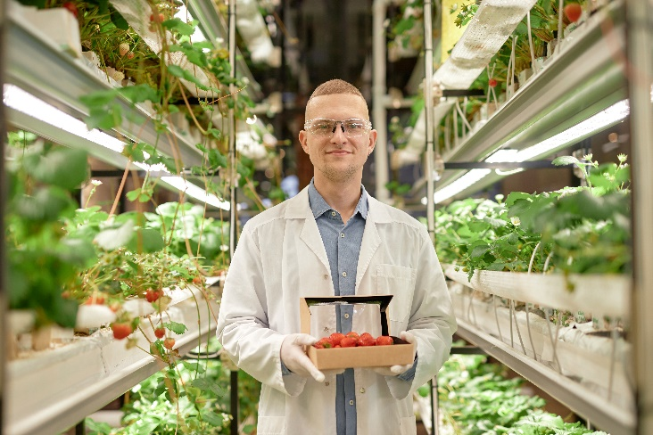
“Stacking our troughs vertically lets us multiply our growing area within the same glasshouse footprint, without needing moving parts or rotating machinery,” says our Head of Horticulture, Rhys Bevan. “Coir gives the roots a clean, consistent growing medium, our drip system means every plant gets exactly the water and nutrients it needs, and the LEDs mean the lower rows in each stack aren’t left short of light just because they’re not at the top.”
Image © Shutterstock/SeventyFour

What we found
We ran a year-long trial comparing our new stacked coir-substrate beds against our previous, conventional glasshouse growing. Here's what we discovered:
- Our yields were roughly 4.5 times higher per square metre than our original soil-based glasshouse beds.
- We used 40% less water overall, since drainage from our drip system is collected and recirculated.
- We estimate a 75% reduction in the carbon footprint per tonne of fruit we produce, largely thanks to reduced water pumping and treatment.
- Fruit ripened roughly 15% faster during the darker winter months, which we put down to the supplemental LED lighting keeping light levels consistent across all rows.
- We saw no loss in fruit sweetness or shelf life compared with our previous growing method.
Powered by our own renewable energy
Our glasshouse sits right next to our anaerobic digester, which converts our crop waste and farm residues into biogas. We use this to generate electricity – enough to power the equivalent of 6,000 homes, including running our LED lighting system – and heat, which we pipe into the glasshouse to maintain growing temperatures throughout the winter. The digestate left over goes back onto our surrounding fields as fertiliser.
“We wanted a system that solved our space problem without adding complexity or maintenance risk,” says our Sustainability Lead, Ama Osei. “Static stacked beds are simpler for us to build and run than moving structures, and pairing them with LEDs has meant every plant in the stack gets a fair share of light, not just the ones on top.”

