Resource 1 Worksheet
1 You need to order vinyl flooring for this renovation. Calculate the internal floor area.
Add 10% for cutting waste and state the total area to order.
(6 marks)
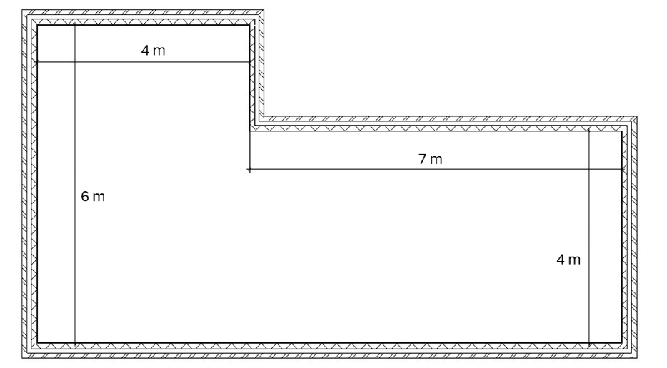

2 Steel I-Beams (Universal Beams) each have a mass of 250 kg.
A hydraulic platform can safely support a load of 50 kN.
(a) What is the maximum number of beams that the platform can safely support?
(4 marks)
The site safety manager requires a 15% safety margin on the lift capacity.
(b) Calculate the maximum number of beams you can lift while maintaining this safety margin.
(3 marks)

3 (a) Define luminous efficacy.
(1 mark)
(b) A lamp is rated at 36 W and emits a total luminous flux of 1800 lumens.
Use this formula to calculate the luminous efficacy of the lamp.
$$\text{luminous} \text{efficacy}= \frac{\text{luminous flux}}{\text{power}}$$
Include units in your answer.
(3 marks)
(c) The building specifications require all lighting to have an efficacy of at least
60 lm/W to meet sustainability targets. Does this lamp meet the specification? (Yes/No)
(1 mark)

4 You are ordering ready-mix concrete for a foundation pour.
Concrete has a density of 2400 kg/m³. There are 1000 kg in one tonne.
(a) Calculate the volume of 5 tonnes of concrete.
(4 marks)
The foundation of a house has dimensions 12 m × 8 m × 0.75 m.
A particular pump can pump concrete at the rate of 96 m³ per hour.
(b) Work out, to the nearest minute, how long it takes to fill the foundations.
(4 marks)
(c) Concrete is sold in cubic metres (m³). Based on your volume calculation, how much should you order to the nearest 0.5 m³ to ensure you do not run short?
(2 marks)

5 The thermal expansion of a material is described by the formula:
$$ΔL = α × L × ΔT$$
(a) Explain the meaning of α in this formula and describe what is meant by thermal expansion.
(b) A 10 m length of wire increases in length by 15 μm when its temperature rises by 4°C. Calculate the value of α for this wire, giving your answer with units.
(c) Explain why thermal expansion of wire needs to be considered when designing overhead power lines.
(12 marks)

