Activity 2 Worksheet answers: Engineering diagrams
Diagrams
Braking system diagram
- Observe the AR model: Identify the primary components of the braking system.
- Draft the circuit: Draw BOTH:
  - a simplified physical sketch showing the system components from the AR model;
  - a standardised 2D ISO standard engineering schematic.
Note: You must produce both diagrams to compare the physical layout with the schematic conventions. For example, draw the master cylinder and the corresponding single-acting calliper cylinder symbol.
- Map the flow path: Use solid lines to connect your symbols. Use arrows to indicate the direction the fluid or air travels when the system is actuated.
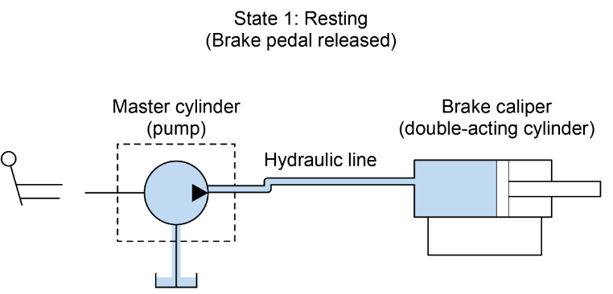

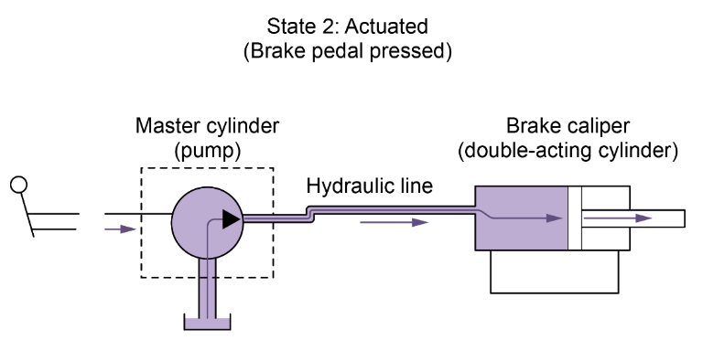
Nail gun diagram
- Observe the AR model: Identify the primary components of the nail gun.
- Draft the circuit: Draw BOTH:
  - a simplified physical sketch of the tool's actuation mechanics from the AR model;
  - a standardised 2D ISO standard engineering schematic.
Note: You must produce both diagrams to compare the physical layout with the schematic conventions. For example, locate the trigger and draw the corresponding
3/2-way directional control valve (DCV) symbol.
- Map the flow path: Use solid lines to connect your symbols. Use arrows to indicate the direction the fluid or air travels when the system is actuated.
- Label port logic: Label the Inlet (P) and Outlet/Exhaust (R/A) ports on your symbols based on where the hoses connect in the AR model.
