Activity 1 Worksheet: Accessible vehicle rear-door opening system
Task design
You are working for a specialist vehicle conversion company. A client requires a standard van to be modified into a Drive from Wheelchair (DFW) vehicle.
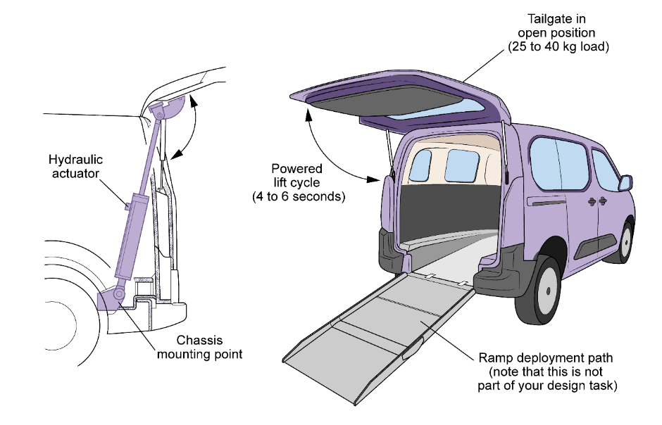
The current manual rear tailgate (upward-opening door) presents a significant accessibility barrier:
- It is too heavy (25–40 kg) for a user to lift from a seated position inside the vehicle.
- Standard gas struts do not provide enough controlled force to ensure the door stays fully open on uneven ground.
Work in teams of 2–3 engineers to design a powered rear-door opening system using either hydraulics or pneumatics. Your system must automatically open, support and close the rear door, allowing the user to safely exit via a ramp without needing to manually push or hold the door. (You are not designing the wheelchair lift or ramp system itself, as this will be completed by another engineering team.)
Note on door configurations: The vehicle conversion company offers modifications for two common van rear door styles:
- Upward-opening tailgate: The door hinges at the roof line and opens upward (like a car boot).
- Dual side-opening doors: Two separate doors hinged at the left and right sides of the vehicle frame, opening outward (90–180 degrees).
Your design team may choose to automate either configuration.
Other considerations include:
- Viscosity and temperature: If you choose hydraulics, how will the weather affect the fluid thickness and opening speed?
- Compressibility: If you choose pneumatics, how will you stop the door from ‘bouncing’ when the wind hits it?
- Maintenance: Based on your calculations, consider how often the seals should be checked to maintain the required design force.
Ensure that your engineering drawings, force vectors and cylinder mounting geometry align precisely with your chosen opening style.
Design requirements
Your design must:
- lift/hold/open a rear door weighing 25–40 kg;
- operate smoothly within 4–6 seconds;
- use one or two actuators (your choice);
- be safe, stable and prevent uncontrolled door movement;
- be maintainable and cost-effective;
- work in common UK weather ranges (–5°C to 30°C).

Task deliverables
a. A labelled engineering drawing of your chosen mechanism. Include dimensions, force arrows and key components.
b. A system diagram (pneumatic or hydraulic). Show actuator, valves, compressor/pump, reservoir, flow direction.
c. A short technical justification for why you have chosen hydraulics or pneumatics.
d. Key calculations (see pages 3–5 for scaffolded calculations)
- Force required to open door
- Cylinder bore size
- Stroke length
- Flow rate estimate (to justify opening speed)
e. A simple thermodynamics/fluid-dynamics explanation of how temperature, viscosity, airflow or pressure drop may affect your design.
f. A short presentation (3–4 minutes) to explain how your system meets the accessibility needs and overcomes the existing barriers. This should include all diagrams, drawings and calculations from your workings. Be prepared to discuss your design and answer questions from the rest of the class.
Scaffolded calculation sheet
In engineering, calculations are not just a check-box exercise; they are the foundations of technical justification. You must prove that your chosen components are physically capable of performing the task safely.
The following calculations will allow you to select the correct actuators and power sources from a manufacturer’s catalogue, ensuring the system is neither under-powered (dangerous) nor over-engineered (too heavy/expensive).
- Force required to open the door
This calculation ensures the system can overcome gravity. If the force is too low, the door will not lift; if the safety factor is ignored, the system may fail as the seals age or in high winds.
Assume door mass (m): ______ kg
Calculate weight:
W = m × g
Take g = 9.81 m/s²
W = ___________________
As the actuator is not pushing vertically, you must account for the mounting angle (θ).
Required actuator force:
F = W ÷ sin θ
θ = ______
F = ___________________
Safety factor: In industry, mechanisms are over-engineered, so they do not operate at their absolute limit.
Multiply your calculated force by a safety factor of 2 to find your final design force (and round to the nearest 100 N).
Design force = __________________N
- Cylinder bore size
This step determines the physical size of your components. A larger bore provides more ‘push’ but takes up more space inside the vehicle’s trim.
Use: 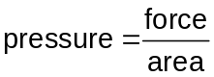, rearranged to make are the subject: 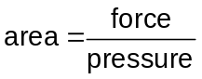
If using hydraulics (typical system pressure ~ 4–8 MPa):
pressure chosen: ______ MPa
calculate area: ___________________
Then bore diameter: 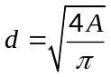
d = ___________________
If using pneumatics (typical ~ 0.4–0.7 MPa):
pressure chosen: ______ MPa
calculate area: ___________________
Then bore diameter:
d = ___________________
- Stroke length
This ensures the door opens wide enough for the user to pass through. If the stroke is too short, the door will not clear the user’s head/wheelchair.
door required travel: ______ mm
actuator mounting geometry multiplier: × ______ (1.0–2.5 range)
required stroke length = ___________________
- Flow rate estimate (to justify opening speed)
To meet the accessibility need, the door must open within 4–6 seconds. Too slow, and the user is stuck in the rain; too fast, and it becomes a safety hazard.
opening time target = ___________ seconds
cylinder bore = _______mm
cylinder radius = ________________ m
cylinder area = _____________________m²
stroke length = __________ m
cylinder volume = area × stroke = ____________________ m³
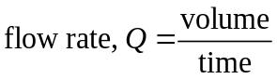 = ___________________ m³/s = _____________ L/min

