Activity 2 Worksheet suggested answers: Accessible vehicle rear-door opening system
Task design
You are working for a specialist vehicle conversion company. A client requires a standard van to be modified into a Drive from Wheelchair (DFW) vehicle.
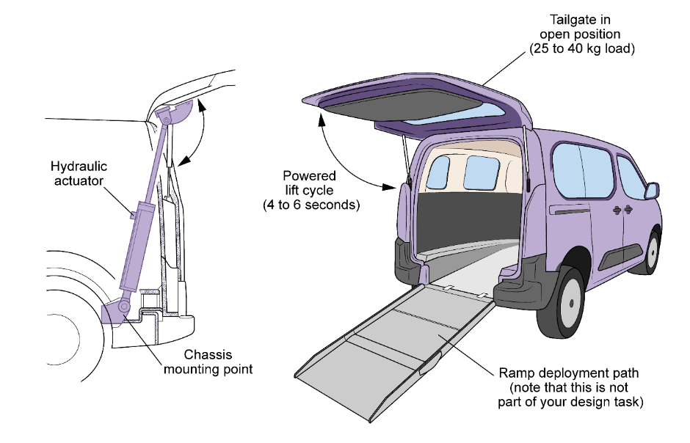
The current manual rear tailgate (upward-opening door) presents a significant accessibility barrier:
- It is too heavy (25–40 kg) for a user to lift from a seated position inside the vehicle.
- Standard gas struts do not provide enough controlled force to ensure the door stays fully open on uneven ground.
Work in teams of 2–3 engineers to design a powered rear-door opening system using either hydraulics or pneumatics. Your system must automatically open, support and close the rear door, allowing the user to safely exit via a ramp without needing to manually push or hold the door. (You are not designing the wheelchair lift or ramp system itself, as this will be completed by another engineering team.)
Note on door configurations: The vehicle conversion company offers modifications for two common van rear door styles:
- Upward-opening tailgate: The door hinges at the roof line and opens upward (like a car boot).
- Dual side-opening doors: Two separate doors hinged at the left and right sides of the vehicle frame, opening outward (90–180 degrees).
Your design team may choose to automate either configuration.
Other considerations include:
- Viscosity and temperature: If you choose hydraulics, how will the weather affect the fluid thickness and opening speed?
- Compressibility: If you choose pneumatics, how will you stop the door from ‘bouncing’ when the wind hits it?
- Maintenance: Based on your calculations, consider how often the seals should be checked to maintain the required design force.
Ensure that your engineering drawings, force vectors and cylinder mounting geometry align precisely with your chosen opening style.
Design requirements
Your design must:
- lift/hold/open a rear door weighing 25–40 kg;
- operate smoothly within 4–6 seconds;
- use one or two actuators (your choice);
- be safe, stable and prevent uncontrolled door movement;
- be maintainable and cost-effective;
- work in common UK weather ranges (–5°C to 30°C).
Hydraulics or pneumatics model chosen
Both systems are a valid choice if the student can technically justify their choice based on load, precision and environmental factors. An example answer is shown below.
Chosen solution overview
A single-acting hydraulic cylinder was selected to open and hold the rear door. This choice prioritises high force density and smooth, synchronised movement. By using controlled oil flow, the system eliminates the ‘spongy’ motion often associated with compressed air, ensuring the door remains stable, even in high winds. The seals should be checked every 3 to 6 months: this is based on harsh environments, e.g. heavy dust, extreme heat/cold, frequent use of the door.
Task deliverables
- A labelled engineering drawing of your chosen mechanism. Include dimensions, force arrows, and key components.
Engineering drawing requirements
The technical drawing must include:
- hydraulic cylinder and piston rod assembly;
- door hinge and chassis mounting brackets;
- force vectors (arrows) showing lift and gravity;
- key dimensions: stroke length, cylinder bore, and pivot distances (using results of students’ calculations).
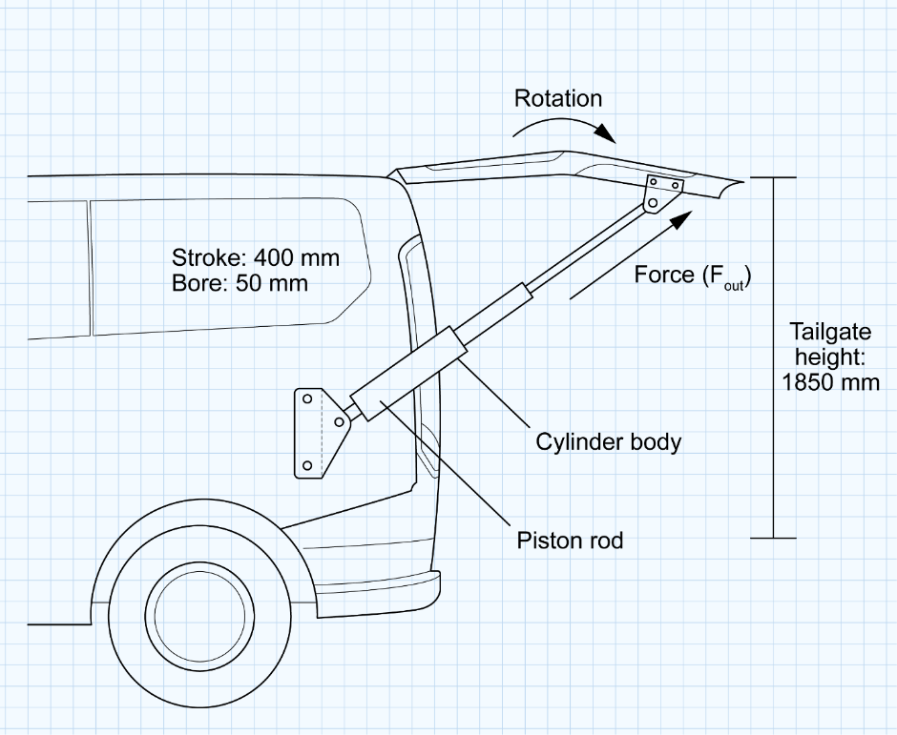
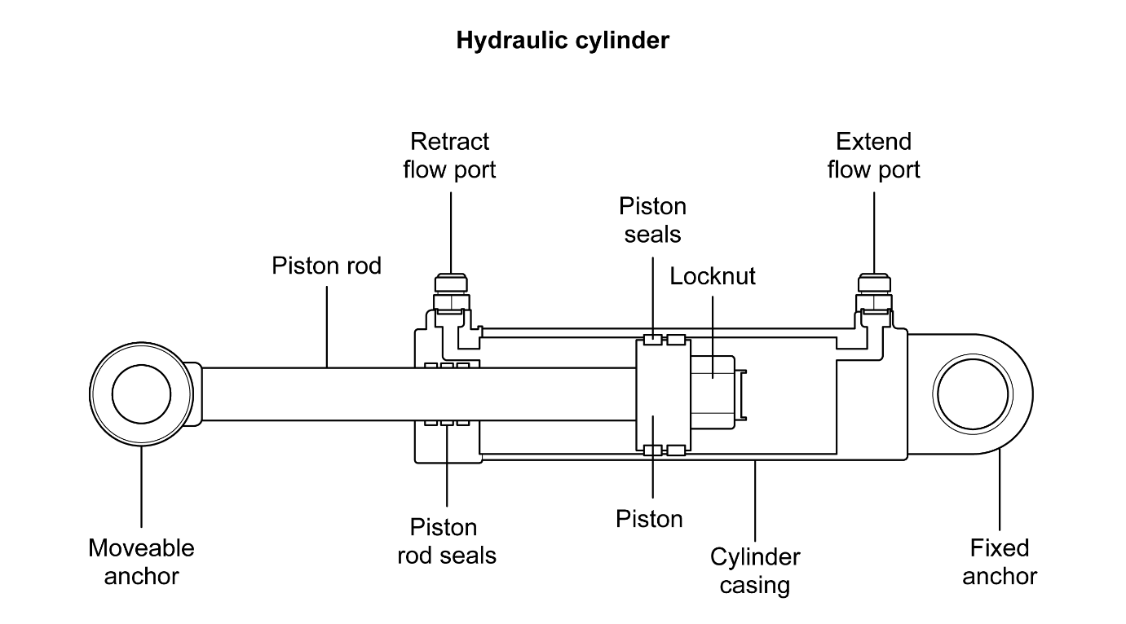
- A system diagram (pneumatic or hydraulic). Show actuator, valves, compressor/pump, reservoir, flow direction.
Hydraulic system diagram
The schematic must illustrate a complete circuit including:
- Reservoir and Electric Pump: For fluid storage and pressure generation;
- Pressure Relief Valve: For system safety;
- Flow Control Valve: To regulate the 4–6 second opening speed;
- Directional Control Valve: To manage the lift/lower cycles;
- Single-acting Cylinder: With return line and flow direction arrows.
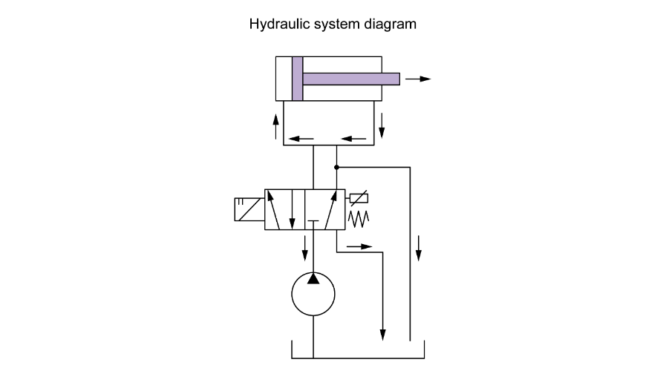
c. A short technical justification for why you have chosen hydraulics or pneumatics.
Technical justification
Hydraulics are chosen due to their ability to generate high force with compact components, smooth controlled motion and safe load holding due to incompressible fluid properties
d. Key calculations
- Force required to open door (see example calculation in part 1 of the Scaffolded calculation sheet)
- Cylinder bore size (see example calculation in part 2 of the Scaffolded calculation sheet)
- Stroke length (see example calculation in part 3 of the Scaffolded calculation sheet)
- Flow rate estimate (to justify opening speed) (see example calculation in part 4 of the Scaffolded calculation sheet)
e. A simple thermodynamics/fluid-dynamics explanation of how temperature, viscosity, airflow or pressure drop may affect your design.
Thermodynamics and fluid behaviour:
- Cold temperatures increase oil viscosity and slow movement.
- Higher temperatures reduce viscosity and increase speed.
- Flow restrictors ensure smooth, controlled motion.
- Friction and pressure losses occur in hoses and valves (this will determine the material used for the hoses, depending on the environment in which they are used).
f. A short presentation (3–4 minutes) to explain how your system meets the accessibility needs and overcomes the existing barriers. This should include:
- the accessibility problem your design solves;
- whether you chose hydraulics or pneumatics and why;
- how the mechanism works using your drawings and system diagram;
- the purpose of the main components;
- key calculations used in the design;
- how the system operates safely and reliably;
- one strength of the design and one possible improvement.
Be prepared to discuss your design and answer questions from the rest of the class.

Scaffolded calculation sheet
In engineering, calculations are not just a check-box exercise; they are the foundations of technical justification. You must prove that your chosen components are physically capable of performing the task safely.
The following calculations will allow you to select the correct actuators and power sources from a manufacturer’s catalogue, ensuring the system is neither under-powered (dangerous) nor over-engineered (too heavy/expensive).
- Force required to open the door
This calculation ensures the system can overcome gravity. If the force is too low, the door will not lift; if the safety factor is ignored, the system may fail as the seals age or in high winds.
Assume door mass (m): 30 kg
Calculate weight:
W = m × g
Take g = 9.81 m/s²
W = 30 × 9.81 = 294 N
As the actuator is not pushing vertically, you must account for the mounting angle (θ).
Required actuator force:
F = W ÷ sin θ
θ = 45º
F = 294 ÷ sin 45 = 294 ÷ 0.707 ≈ 416 N
Safety factor: In industry, mechanisms are over-engineered, so they do not operate at their absolute limit.
Multiply your calculated force by a safety factor of 2 to find your final design force (and round to the nearest 100 N).
Design force = 416 × 2 = 832 ≈ 800 N (to the nearest 100 N)
- Cylinder bore size
This step determines the physical size of your components. A larger bore provides more ‘push’ but takes up more space inside the vehicle’s trim.
Use: $pressure= \frac{force}{area}$, rearranged to make are the subject: $area= \frac{force}{pressure}$
If using hydraulics (typical system pressure ~ 4–8 MPa):
Pressure chosen: 6 MPa
Calculate area: $area= \frac{800}{6000000}=1.33 ×{10}^{-4}m^{2}$
Then bore diameter:
$$d=\sqrt{\frac{4A}{π}}$$
$$d=\sqrt{\frac{4(1.33×{10}^{-4})}{π}}=0.013m =13mm$$
- Stroke length
This ensures the door opens wide enough for the user to pass through. If the stroke is too short, the door will not clear the user's head/wheelchair.
door required travel: 400 mm
actuator mounting geometry multiplier: × 1.5
required stroke length = 600 mm

- Flow rate estimate (to justify opening speed)
To meet the accessibility need, the door must open within 4–6 seconds. Too slow, and the user is stuck in the rain; too fast, and it becomes a safety hazard.
opening time target = 5 seconds
cylinder bore = 16 mm
cylinder radius = 8 mm = 0.008 m
cylinder area = πr² = π(0.008)² = 2.01 × 10⁻⁴ m²
stroke length = 0.6 m
cylinder volume = area × stroke length = 2.01 × 10⁻⁴ m² × 0.6 = 1.21 × 10⁻⁴ m³
$$flow rate, Q=\frac{volume}{time}$$
$$=\frac{1.21×{10}^{-4}}{5}$$
$$=2.41×{10}^{-5}m^{3}/s$$
$$=2.41×{10}^{-5}×1000=0.0241 L/s$$
$$=0.0241×60=1.45L/min$$

