Activity 1 Worksheet: Analysing trends
- The graph below shows type 1 and type 2 diabetes registrations (diagnosis) for individuals aged between 0–25 years old (shown as bars). The percentage change in registration numbers from 2016/17 to 2023/24 is represented with trend lines.
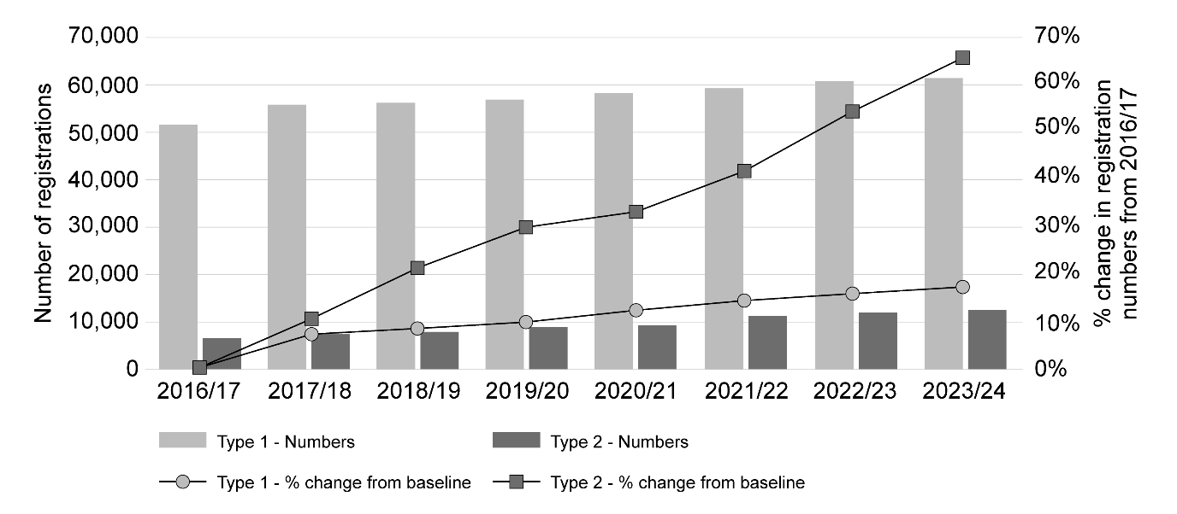
Source: National Diabetes Audit annual reports for 2016/17 to 2023/24. Data provided from GP practices and specialist services. www.england.nhs.uk/long-read/children-and-young-people-diabetes-toolkit/

- Describe the main trends shown by the graph.
- Use data to back up your findings.
- Suggest any limitations to this data which should be taken into account.
- Think about how the data was collected.
- What other information would be useful?
- Suggest public health approaches that will benefit the population through prevention and improvement initiatives.
- How can these be achieved?
Useful websites
Department of health and social care: fingertips.phe.org.uk/static-reports/health-trends-in-england/england/overview.html
Office for health improvement and disparities www.gov.uk/government/statistics/cardiovascular-disease-and-diabetes-profiles-march-2024-update/cardiovascular-disease-and-diabetes-profiles-statistical-commentary
Public health England: www.gov.uk/government/publications/health-matters-preventing-type-2-diabetes/health-matters-preventing-type-2-diabetes
- Cardiovascular disease (CVD) is a broad term that encompasses various conditions affecting the heart and blood vessels. Coronary heart disease (CHD) is a specific type of CVD and refers to the narrowing or blockage of the coronary arteries that supply blood to the heart muscle.
The graph below shows the number of preventable deaths from CVD considered for people aged under 75.
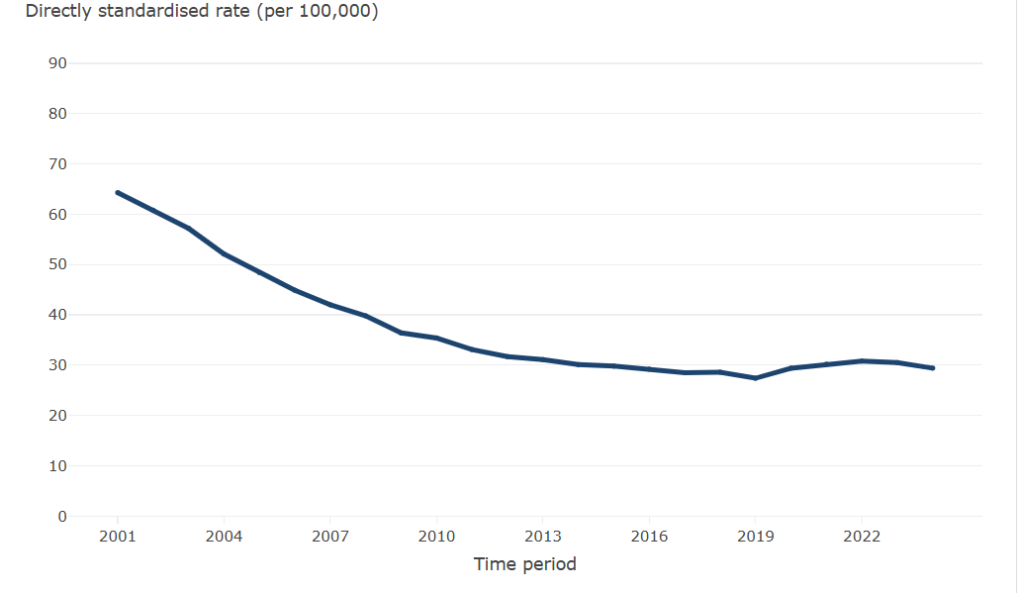
Source: OHID, based on Office for National Statistics data fingertips.phe.org.uk/static-reports/health-trends-in-england/england/cardiovascular_disease.html
- Describe the main trends shown by the graph. Use data to back up your findings.
- Suggest reasons for the changes in the number of preventable deaths between 2001–2010. Suggest a range of public health approaches that would benefit the population through prevention and improvement initiatives.
- How can these be achieved?
Useful websites
Department of health and social care fingertips.phe.org.uk/static-reports/health-trends-in-england/england/overview.html
British heart foundation: www.bhf.org.uk/for-professionals/healthcare-professionals/data-and-statistics/the-cvd-challenge/the-cvd-challenge-in-england and www.bhf.org.uk/what-we-do/policy-and-public-affairs/hearts-need-more/heart-disease-action-plan-report
Public health England: www.gov.uk/government/publications/health-matters-preventing-cardiovascular-disease/health-matters-preventing-cardiovascular-disease
Office for health improvement and disparities: www.gov.uk/government/statistics/cardiovascular-disease-and-diabetes-profiles-march-2024-update/cardiovascular-disease-and-diabetes-profiles-statistical-commentary
NHS: www.nhs.uk/conditions/coronary-heart-disease/prevention/

- In the UK, it is currently estimated that there are around 3 million people living with chronic obstructive pulmonary disease (COPD) and 2 million of these cases are undiagnosed. (Source: cks.nice.org.uk/topics/chronic-obstructive-pulmonary-disease/background-information/prevalence-incidence/). However, exact estimates for COPD vary widely due to differences in study design and diagnostic criteria.
Data shows that there is a large geographical variation in COPD prevalence and hospital admission rates across England.
- Carry out some research to identify trends in the data.
Remember to:
- use data to back up your findings;
- ensure you use reliable sources of data.
- Suggest public health approaches that will benefit the population through prevention and improvement initiatives. How can these be achieved?

- In the UK, over 1.9 million adults have been diagnosed with chronic kidney disease (CKD), although it is estimated that many more remain undiagnosed. The number of cases is expected to continue to increase because of an ageing population and increasing incidences of disorders such as type 2 diabetes. (Source: cks.nice.org.uk/topics/chronic-kidney-disease/background-information/prevalence/)
- Carry out some research to identify any trends in CKD data, such as incidence of disease with age or against a lifestyle factor.
Remember to:
- use data to back up your findings;
- ensure you use reliable sources of data.
- Suggest public health approaches that will benefit the population through prevention. and improvement initiatives. How can these be achieved?
Useful websites
Department of health and social care fingertips.phe.org.uk/static-reports/health-trends-in-england/england/overview.html
NHS www.nhs.uk/conditions/kidney-disease/prevention/ and digital.nhs.uk/data-and-information/publications/statistical/health-survey-for-england/2022-part-2/kidney-disease
Kidney care UK: kidneycareuk.org/kidney-disease-information/about-kidney-health/10-healthy-habits-for-happy-kidneys/
UK parliament: commonslibrary.parliament.uk/what-is-chronic-obstructive-pulmonary-disease-and-who-does-it-affect/
Office for health improvement and disparities: www.gov.uk/government/statistics/update-of-indicators-in-the-respiratory-disease-profile-june-2025/respiratory-disease-profile-statistical-commentary-june-2025

