Activity 1 Worksheet 2: ED report

Your task:
Read through the ED reports and answer the questions at the end of the sheet.

ED Report 6 weeks after diagnosis of COPD
Name: Jarvis Roberts
Presenting complaint: Increase in breathlessness over past 48 hours, green sputum with increased cough, chest tightness, fever 38.2°C, fatigue and poor sleep
Arrival mode: Brought in by ambulance
Diagnosis: Infective exacerbation of COPD

Examination notes:
- Patient unable to speak in full sentences
- Moderate respiratory distress
- Sat in tripod position (elbows on knees)
- Chest auscultation: wheeze heard bilaterally (both sides), reduced air entry at bases of lungs
- Productive cough during assessment
- Skin warm and clammy
- Accessory muscle use present

Investigations ordered:
- Chest X-ray
- Full blood count (FBC)
- C-reactive protein (CRP)
- Arterial blood gas (ABG)
- Sputum sample for culture
- ECG

Treatment plan:
- As patient has a confirmed diagnosis of COPD, SpO2 target range is 88-92% pending arterial blood gas results
- Administer prescribed oxygen
- Administer prescribed bronchodilator medication

Observations whilst in the department:
Time | SpO₂ (%) | Prescribed Supplemental oxygen | RR | HR (bpm) | Temp (°C) | BP | Peak Flow (L/min)
14:32 (Arrival) | 83 | 28% (6L/m) via Venturi mask | 26 | 118 | 38.2 | 156/84 | 210
15:00 (After treatment) | 91 | 24% (4L/m) via Venturi mask | 24 | 102 | 38.0 | 148/82 | 225
16:00 (Re-check) | 92 | 2L/m via nasal cannula | 22 | 98 | 37.8 | 142/80 | 240
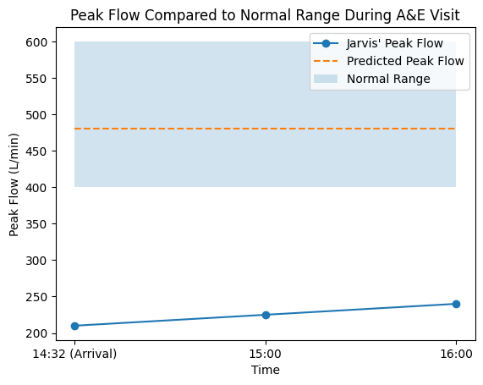
ED consultant documentation: Overall good response to treatment noted, however 2L/min of oxygen through nasal cannula required to maintain a target oxygen saturation of 88 – 92% Plan therefore to admit to Emergency Assessment Unit and continue treatment.
Peak flow was plotted on a chart to monitor improvement. As Jarvis has had no prior attendance to ED and had limited assessment before contacting his GP, he has not yet been provided with a personal peak flow target. An estimate has been made which will need to be reviewed by the community respiratory rehab team alongside his own 10-day peak flow monitoring.
Answer the following questions based on the above ED report.
- Describe one reason why Jarvis’ oxygen saturation was low when he first presented at ED.

- Suggest why Jarvis’ predicted peak flow might be too high.

- Describe how the peak flow graph could support a decision to admit Jarvis rather than discharge him.

- Describe what the graph suggests about long-term lung damage in COPD.

At discharge, Jarvis was issued with a PEAK flow monitor and instructed to record his own PEAK flow across 10 days. His results were plotted on the following chart.
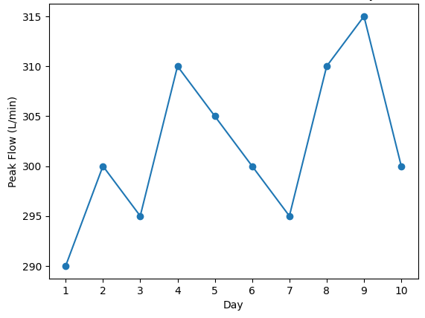

5. Analyse the 10-day PEAK flow monitoring and discuss key points.

