Project Brief: Design a sustainable youth community hub

Introduction
You are working as a junior member of a multidisciplinary design team appointed by Woodmarket City Council. Your team has been asked to develop a proposal for a sustainable, single-storey youth community hub on a brownfield site.
You must interpret the client brief and supporting project information, identify the factors that will influence the development, and produce a clear, coherent and industry-informed proposal in which your decisions are justified.
Your proposal must show that your design is:
- safe;
- sustainable;
- functional;
- buildable.
You will complete four linked tasks using the Project Workbook. The tasks require you to apply your existing knowledge and skills in construction, design, materials, sustainability, health and safety, project planning and costing.
This Project Brief provides the information and evidence you will need:
- Client brief
- Site details
- Site layout drawings and site images
- Site images
- Contamination report
- Geotechnical report
- Stakeholder letter – End user
- Stakeholder letter – Contractor
- Stakeholder letter – Residents

The four tasks

Task 1: Response to the client brief, site analysis and initial project planning
Analyse the client brief and all supporting site information. Identify the client requirements, success criteria, stakeholder needs, functional requirements, site constraints, planning and access considerations, ground conditions, risks and opportunities. Use your findings to produce a structured response to the brief, a stakeholder analysis and an annotated site analysis.

Task 2: Design proposal and design justification
Develop a concept design proposal that responds directly to the client brief, stakeholder needs and your Task 1 analysis. Your proposal must consider layout, orientation, internal and external spaces, accessibility, sustainability, health and safety, basic regulatory compliance, construction methods and material choices. Produce clear sketches and/or CAD drawings, including a developed layout, together with a justified design presentation.

Task 3: Project planning and costing documentation
Produce project planning and costing evidence for your proposed youth hub. Create a logical construction sequence, identify key dependencies, show realistic durations and suitable overlaps, and prepare a simple programme. Use the supplied project information and unit rates to calculate an early cost estimate, showing your working and explaining how your design decisions affect time, cost and feasibility.

Task 4: Team response to a project problem
Work as part of a team to respond to an additional client problem introduced after the individual proposals have been completed. Draw on evidence from the individual proposals and project information to identify opportunities that could be applied across the project. Investigate credible response options and agree a justified team recommendation. Explain how the proposed response affects design, cost, programme, sustainability, accessibility, health and safety, site logistics, buildability and the client requirements. Present the team recommendation as a client presentation and complete an individual reflection.

Client brief
Client: Woodmarket City Council
Woodmarket City Council is commissioning the design of a sustainable, single-storey youth community hub on a brownfield site in the local area. The development forms part of a wider regeneration initiative intended to improve opportunities, wellbeing and social engagement for young people.
The Council requires a high-quality facility that provides safe, inclusive and flexible spaces for a range of activities. The design must respond to the needs of young people and other users while also considering the surrounding community, nearby heritage assets and the practical requirements of delivery.

Project requirements
The proposed facility should provide an appropriate range of spaces for a community-focused youth hub:
- Reception/welcome area
- Multi-functional community rooms
- Activity or recreation spaces
- Quiet/study space
- Staff office or supervision space
- Toilet facilities (including accessible provision)
- Changing areas (where appropriate)
- Storage areas
- Safe circulation routes

External works and infrastructure
The concept proposal should also consider the external works required to support the youth community hub:
- Pedestrian and vehicle access
- Drop-off and pick-up arrangements
- Limited car parking, including accessible parking and electric vehicle charging where appropriate
- Service and delivery access, including any necessary gate or barrier arrangements
- Landscaping, planting and usable external space
- Indicative approach to surface-water drainage
- External lighting
- Security and access-control arrangements where appropriate
At this stage, you are not required to produce detailed engineering designs or specifications for these external systems. You should show how they have been considered within the overall site layout, and explain any important implications for access, safety, sustainability, programme and buildability.

Site considerations
The brownfield site presents a number of constraints and uncertainties:
- Potential ground contamination
- Variable soil conditions
- Proximity to existing roads, residential properties, infrastructure and listed buildings
These factors must be investigated and evaluated when deciding the location, form, access, construction method, foundations, programme and cost of the proposed development.

Client expectations
The Council expects the design to demonstrate:
- appropriate selection of construction methods and materials;
- consideration of sustainability and environmental impact;
- compliance with relevant planning policy, Building Regulations (e.g. Part M), and health and safety requirements;
- a practical and buildable solution that represents value for money.

Indicative project budget
- At this early stage, Woodmarket City Council has established a Rough Order of Magnitude (ROM) construction budget for the project. This should be treated as an early affordability guide rather than a fixed tender sum.
- The design team should consider how decisions relating to floor area, materials, construction method, site constraints, programme and buildability may influence the project’s ability to remain within the available budget.
- Indicative ROM construction budget: £1.8 million–£2.5 million.

Your proposal
You must develop and justify a design proposal that responds to the full client brief and the supporting project evidence.
Your final proposal must demonstrate how the facility:
- meets user needs;
- responds to site constraints;
- provides a safe, sustainable, functional and buildable solution.
All significant decisions must be justified using evidence from the client brief, site information, technical reports, stakeholder correspondence and your own project work.

Site details
The proposed development site (see Image 1), known as Paradise Field, is located within an established urban area and is bounded by roads, residential properties and nearby heritage assets.
- Woodmarket Road forms the northern boundary.
- Woodmarket Villas forms the eastern boundary.
- Lumber Lane forms the southern boundary.
- Waterville Avenue forms the western boundary.
Image 1. Existing site (not to scale)
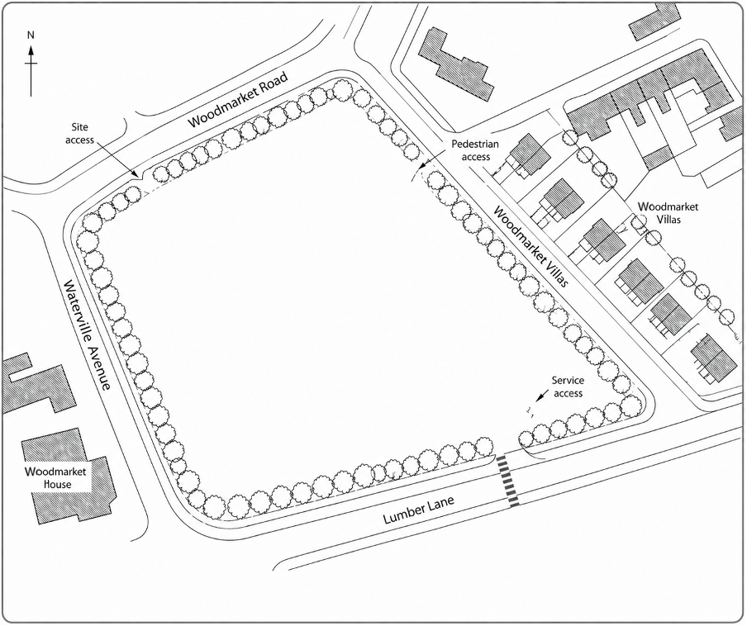
The site is irregular in shape and enclosed by mature trees, hedgerows and other boundary vegetation. The interior is largely open, although evidence of previous development and industrial use remains (see the view across the site in Image 5).

Site dimensions
- 103 metres along Lumber Lane (south boundary).
- 131 metres along Woodmarket Villas (east boundary).
- 97 metres along Waterville Avenue (west boundary).
- 91 metres along Woodmarket Avenue (northern boundary).

Topography and levels
- The site slopes from north to south. The ground level at Woodmarket Road is approximately 10 metres higher than the level at Lumber Lane.
- No formal terracing or engineered level-change infrastructure is visible across the site.
- Previous development may have left areas of made ground, fill and contamination.

Surrounding context
The site is located within a mixed urban environment.
- Woodmarket Road (north) is a main route providing access to the area with a two-lane road and pedestrian footpaths on both sides.
- Woodmarket Villas (east) consists of residential properties arranged in a continuous row. The road is narrow and often congested, with vehicles parked for nearby residents and businesses.
- Waterville Avenue (west) is a residential street with housing and boundary treatments present.
- Lumber Lane (south) carries existing traffic and includes on-street parking.
The surrounding area includes a mix of residential buildings, local routes and existing infrastructure.

Access and movement
- The site is bordered by roads on all sides, providing multiple potential access points. However, each option must be assessed for pedestrian safety, vehicle movement, servicing and impact on neighbouring streets.
- Existing pedestrian routes are present along the surrounding roads.

Heritage
- Woodmarket House (see Image 2), located to the south-west of the site, is a Grade I listed building.
- Woodmarket Villas (see image 3), along the eastern boundary, are Grade II listed buildings.
Image 2: Woodmarket House
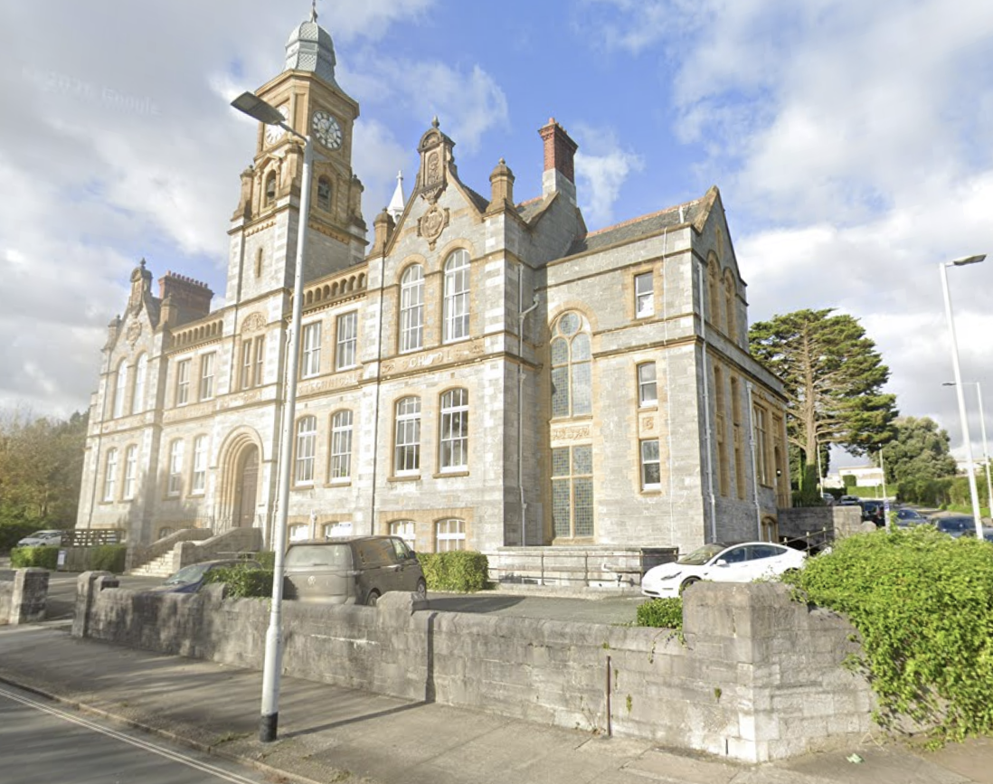
Image 3: Woodmarket Villas
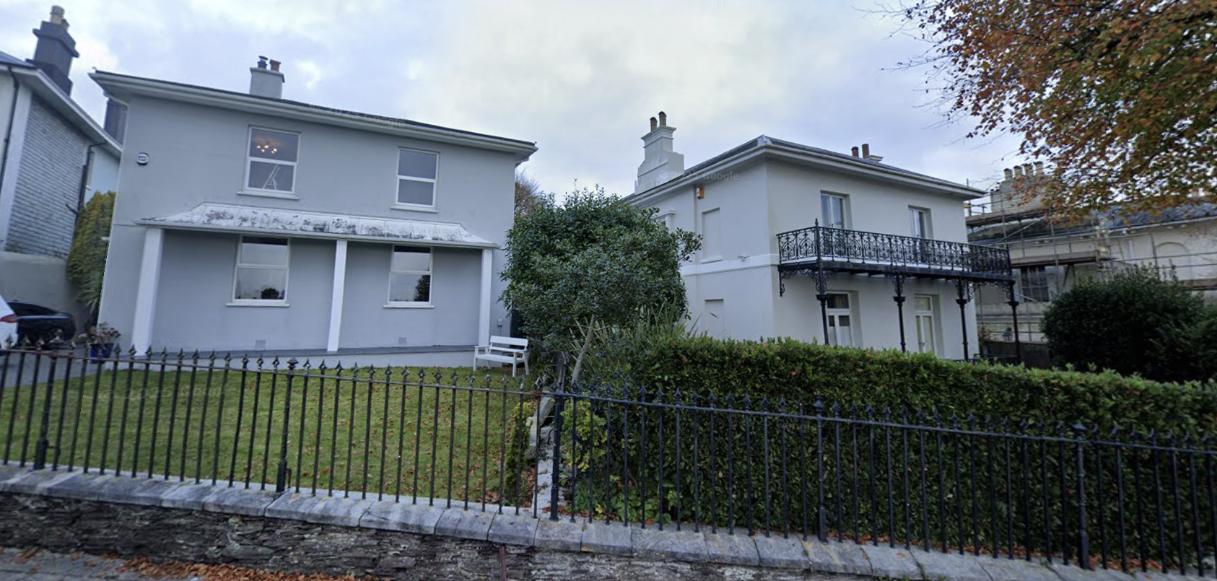

Vegetation and boundaries
The site boundary includes mature trees, hedgerows and other vegetation, particularly around the perimeter (see Image 4). The presence of any tree preservation orders has not yet been confirmed.
Vegetation varies in density and provides differing levels of screening, habitat value and separation from neighbouring properties.
Image 4: View across the site from the north-west corner towards Woodmarket Villas
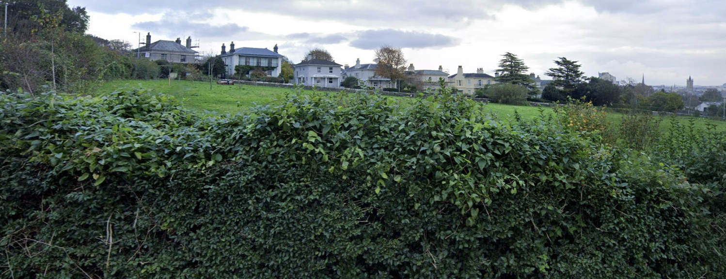
The site is classified as brownfield land and was previously used for light-industrial and vehicle-related activities.
The supporting reports identify variable ground conditions, made ground, shallow groundwater in isolated locations and contamination that will require further assessment and management.
Further details are included within the site investigation reports that follow.

Site layout drawings
Image 5. Previous proposed initial design (not to scale)
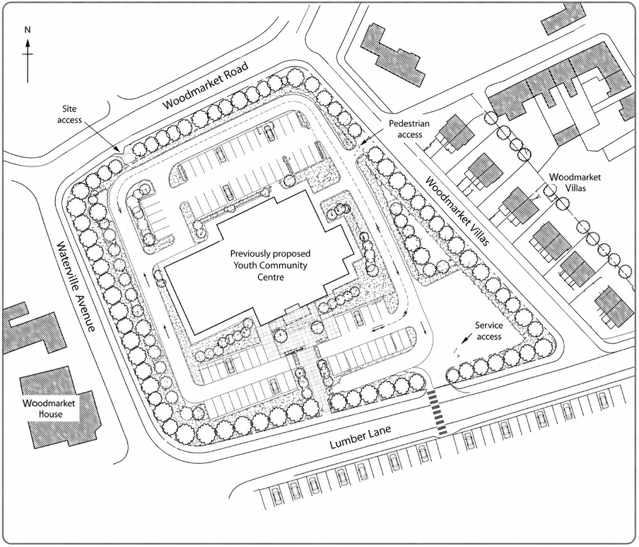

Site contamination letter
LithoCore Environmental Ltd
Environmental and Geotechnical Consultants
Unit 4, Riverside Business Park
Woodmarket, WM1 9AZ
Tel: 0111 456 7890
Email: info@geoenviro.co.uk
Date: 20 April
To: Project Design Team
Subject: Phase 1 & 2 Site Investigation – Contamination Assessment
Site: Proposed Youth Community Hub Development, Paradise Field

Dear Sir/Madam,
Following your instruction, LithoCore Environmental Ltd has undertaken a preliminary Phase 1 desk study and a subsequent Phase 2 intrusive site investigation at the above-mentioned brownfield site. The purpose of the investigation was to assess risks associated with ground conditions and contamination arising from previous site uses.
Historical records indicate that the site was formerly occupied by light industrial units, including vehicle maintenance and storage facilities. As a result, there is potential for residual contamination within made ground and underlying soils.
The intrusive investigation included a series of boreholes and trial pits across the site. Soil samples were collected and analysed in accordance with current environmental and regulatory guidance. The findings have identified the presence of contaminants in several locations, including elevated levels of hydrocarbons, heavy metals (such as lead and zinc), and localised asbestos-containing materials within made ground.
In addition, some areas of the site were found to contain variable and potentially unstable ground conditions, which may have implications for foundation design and construction methodology. Groundwater was encountered at shallow depth in certain locations, which may further influence remediation and construction activities.
Based on the results of the investigation, the site is considered to pose a moderate risk to human health and the environment if left unmanaged. However, these risks can be mitigated through appropriate remediation and design strategies.
We recommend that the following measures are considered as part of the development proposals:
- Further detailed quantitative risk assessment where necessary.
- Development of a remediation strategy to address identified contamination.
- Consideration of appropriate foundation solutions to account for ground conditions.
- Implementation of suitable health and safety controls during construction, particularly in relation to contaminated soils and materials.
- Ongoing liaison with the local authority and environmental regulators.
It is important that these findings are taken into account during the design stage, as they will influence construction methods, programme, cost and overall project feasibility.
Please do not hesitate to contact us should you require further clarification or additional investigation works.

Yours faithfully,
J. Patel
Senior Geo-Environmental Consultant
LithoCore Environmental Ltd

Site geotechnical information
Woodmarket Ground Engineering Ltd
Geotechnical and Environmental Division
Riverside House
Orbit Lane
Woodmarket, WM2 2PL
Tel: 01632 960 550
Email: enquiries@woodmarket-ground.example

Ground conditions survey summary
Project: Proposed Youth Community Hub
Site: Paradise Field
Reference: TFG/GC/202x/118
Date: 15 April

1. Introduction
Woodmarket Ground Engineering Ltd was commissioned to undertake a preliminary ground investigation at the proposed development site. The purpose of the survey was to assess ground conditions, identify constraints to development and provide initial geotechnical guidance to inform design decisions.
The scope of works included a desk-based review of historical land use, a series of trial pits and boreholes, and a visual inspection of the site.

2. Site history and existing conditions
Historical mapping and records indicate that the site was previously used for light industrial purposes, including storage and vehicle-related activities. As such, the site is classified as brownfield land.
The site slopes from north to south and contains evidence of previous hardstanding, disturbed ground and redundant infrastructure. Some areas show signs of made ground associated with earlier development.

3. Summary of ground conditions
The investigation identified the following general ground profile:
- Made ground present across much of the site, consisting of mixed materials including gravel, ash, brick fragments and reworked soils.
- Underlying firm cohesive soils in several locations.
- Localised zones of granular material, likely linked to previous construction activity.
- Groundwater encountered at shallow depth in isolated boreholes.
These findings indicate that ground conditions vary across the site and are not consistent.

4. Contamination considerations
The investigation supports previous environmental findings, identifying areas of contamination within the made ground. Laboratory analysis confirmed the presence of hydrocarbons and elevated concentrations of certain heavy metals, along with isolated asbestos-containing materials.
While these conditions present a constraint, they are typical of brownfield sites and can be addressed through appropriate remediation and safe construction practices.

5. Bearing capacity and foundation considerations
Based on the information obtained, the bearing capacity of the near-surface soils is variable, particularly within areas of made ground. These materials are unlikely to provide reliable support for structural loads without improvement or removal.
In areas where natural, more competent soils were encountered, the ground may be suitable for supporting a low-rise structure, subject to detailed design verification. However, due to variability across the site, it is anticipated that foundation solutions may need to:
- avoid reliance on made ground;
- transfer loads to more stable underlying strata;
- incorporate ground improvement techniques where necessary.
Given the proposed development is a single-storey facility, structural loads are expected to be moderate. However, the variability of ground conditions means that careful consideration will be required to ensure safe and effective foundation design.

6. Key considerations for development
The following factors should be taken into account during the design process:
- Inconsistent ground conditions across the site
- Presence of contamination requiring controlled management
- Potential need for adapted foundation solutions
- Localised shallow groundwater
- Safe handling and disposal of excavated materials

7. Recommendations
Woodmarket Ground Engineering Ltd recommends the following actions:
- Further detailed ground investigation is undertaken where necessary.
- A remediation strategy is developed to address contamination.
- Foundation design considers the variability of the site.
- Appropriate health and safety measures are implemented during construction.
- All works comply with relevant environmental and construction regulations.

8. Conclusion
The site is considered suitable for development, subject to appropriate design, remediation and construction methods. While ground conditions present some challenges, these are typical of previously developed land and can be effectively managed through careful planning and engineering design.
This report should be read in conjunction with other environmental and site assessment documentation.

Prepared by:
A. Morgan
Senior Geotechnical Engineer, Woodmarket Ground Engineering Ltd

Stakeholder letter – End user
Woodmarket Youth Partnership
Community Engagement and Development Programme
Unit 3B, Market Quarter Exchange
Old Timber Way
Woodmarket, WM7 1ZZ
Tel: 01632 960 442
Email: contact@woodmarket-youth.example
Date: 22 April
To: Project Design Team
Subject: User Requirements – Proposed Youth Community Hub
Site: Paradise Field

Dear Sir/Madam,
We are writing on behalf of Woodmarket Youth Partnership and the young people we support across the local area in response to the proposed development of a new youth community hub.
We strongly welcome this investment and the opportunity to create a dedicated space that supports young people’s wellbeing, development and social engagement. Based on our experience working with a wide range of users, it is essential that the facility is designed to be inclusive, flexible and safe, meeting the diverse needs of the community it serves.
We would like to highlight the following key requirements from a user perspective:
- Safe and welcoming environment: The building should feel secure and accessible to all users, including those who may be vulnerable or less confident. Clear visibility, good lighting and appropriate supervision spaces are important.
- Flexible spaces: Young people benefit from spaces that can be adapted for different activities, including social areas, quiet study zones, group workspaces and recreational areas.
- Indoor and outdoor provision: Access to both indoor facilities and safe outdoor spaces is highly valued, particularly for physical activity and informal social interaction.
- Accessibility and inclusion: The design should ensure full accessibility for users with disabilities, as well as creating an environment that is welcoming to people from different backgrounds.
- Technology and digital access: Provision of reliable digital infrastructure, including access to computers and Wi-Fi, is essential to support education, training and social connectivity.
- Durability and maintenance: Materials and finishes should be robust and suitable for high levels of use, ensuring the building remains functional and welcoming over time.
We would also encourage the inclusion of spaces that support mentoring, skills development and community engagement, helping to maximise the long-term impact of the facility.
It is important that young people feel a sense of ownership and connection to the space, and we would welcome opportunities for further engagement and consultation as the design develops.
We look forward to seeing proposals that reflect these priorities and contribute positively to the local community.

Yours faithfully,
L. Thompson
Youth Services Manager
Woodmarket Youth Partnership

Stakeholder letter – Contractor
Woodmarket Construction Services Ltd
General Building and Civil Engineering Services
Block C, Fabrication Yard Alpha
Woodmarket Industrial Estate
Woodmarket, WM4 4XX
Date: 18 April
To: Project Design Team
Subject: Buildability Review – Proposed Youth Community Hub
Site: Paradise Field

Dear Sir/Madam,
Further to our recent discussions, Woodmarket Construction Services Ltd has reviewed the available information relating to the proposed development of a youth community hub on the identified brownfield site. We welcome the opportunity to provide early-stage input regarding construction considerations and buildability.
Based on the preliminary site information and the findings of the site investigation, we note that the presence of contamination and variable ground conditions will require careful management during the construction phase. This is likely to have implications for site preparation, foundation design and overall programme duration.
In particular, we would highlight the following considerations:
- Site access and logistics: The location and surrounding environment may present constraints for the movement of plant, materials and deliveries. Early planning of site access routes and storage areas will be essential.
- Ground conditions: The presence of made ground and potential contaminants may necessitate remediation works and specialist foundation solutions, which could impact both cost and programme.
- Construction method: Selection of an appropriate construction method will be critical. Off-site or modular approaches may offer advantages in terms of reduced programme time and improved quality control, particularly where site constraints are significant.
- Health and safety: Construction activities involving contaminated materials will require robust control measures, including appropriate handling procedures and protection for site operatives.
- Programme and cost: The factors outlined above are likely to influence the overall construction timeline and associated costs. Early consideration of these elements within the design will help to ensure a more efficient and deliverable scheme.
From a contractor’s perspective, we would strongly recommend that buildability is considered at each stage of the design process. Designs that are overly complex or do not take account of site constraints can lead to delays, increased costs and practical difficulties during construction.
We would also encourage ongoing collaboration between the design team, client and contractor to ensure that the proposed solution is both practical and achievable within the project constraints.
We trust that these initial observations are helpful and would be pleased to provide further input as the design develops.

Yours faithfully,
D. Clarke
Construction Director
Woodmarket Construction Services Ltd

Stakeholder letter – Residents
Woodmarket Residents Circle
Local Community Contact Group
The Meeting Room Annex
Canalturn Path
Woodmarket, WM7 0AA
Email: contact@woodmarket-circle.example
Date: 20 April 2026
To: Project Design Team
Subject: Community Response – Proposed Youth Community Hub Development
Site: Paradise Field

Dear Sir/Madam,
We are writing on behalf of local residents and members of the Woodmarket Residents Circle in response to the proposed development of a youth community hub on the identified brownfield site.
As a community group, we recognise the potential benefits of investment in local facilities for young people and are broadly supportive of initiatives that promote positive engagement and development opportunities. However, we would like to raise several concerns that we believe should be carefully considered as part of the design and planning process.
Firstly, the site is near several historically significant listed buildings, which form an important part of the character and identity of the local area. Residents are concerned that any new development should be sympathetic to the surrounding environment in terms of scale, appearance and materials, ensuring that it does not detract from the visual setting of these heritage assets.
In addition, the site is bounded by busy roads with high levels of traffic, particularly during peak hours. This raises concerns regarding safety, access and congestion. Increased activity associated with the development may exacerbate these issues, particularly if adequate provision is not made for safe pedestrian access, drop-off areas and traffic management.
Residents are also concerned about potential impacts, including:
- increased noise levels, particularly during evenings and weekends;
- light pollution affecting nearby properties;
- the safety and supervision of users accessing and leaving the site.
We would therefore strongly encourage the design team to consider the following:
- Appropriate building scale and design to complement nearby listed structures.
- Safe and well-planned access routes for pedestrians and vehicles.
- Measures to manage noise and minimise disruption to neighbouring properties.
- Clear consideration of how the facility will be operated and supervised.
We would welcome ongoing consultation as the project develops and would appreciate the opportunity to provide further input to ensure that the development meets both community needs and local expectations.
We trust that our comments will be taken into account and look forward to seeing how the proposal progresses.

Yours faithfully,
M. Ahmed
Chair
Woodmarket Residents Circle

