Designing a sustainable compaction device

Introduction
This Project Brief is designed to help you to develop the core skills that are fundamental to the T Level Technical Qualification in Engineering and Manufacturing. You will be presented with a real-world scenario, followed by four tasks to complete:
Task 1: Researching and compiling a technical proposal
Task 2: Communicating an initial design
Task 3: Developing a manufacturing plan
Task 4: Presenting a design and plan
This Project Brief is similar to those that you will be expected to follow when working within the engineering industry.

Project scenario
Middlesex Aerospace is a leading manufacturer of aerospace engineering components. Through innovation and investment in new technologies, the company delivers high-quality engineered solutions to the aviation industry worldwide.
The company is highly committed to sustainable manufacturing practices, reducing its environmental footprint, and optimising workshop safety and waste management.

The problem
Middlesex Aerospace carries out a range of machining processes on computer numerical control (CNC) machines (Figure 1). Each year, the process of manufacturing components to create complex structural parts from metal alloys generates millions of tonnes of aluminium swarf byproduct (Figure 2).

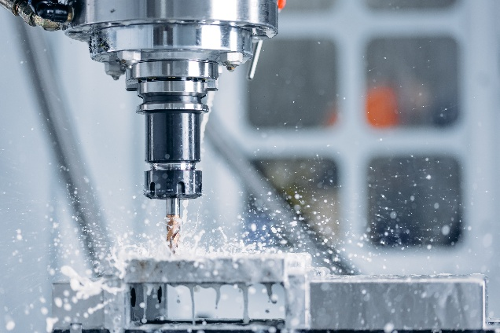
Figure 1: An example of a CNC machine creating a component
(Image © Shutterstock/Parilov)
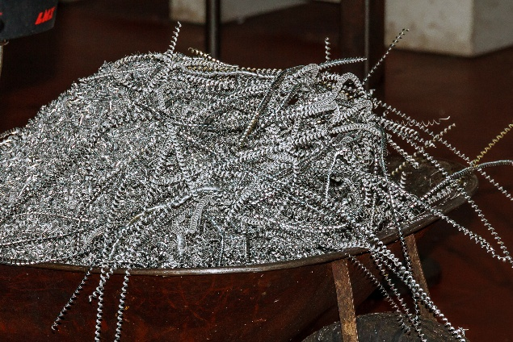
Figure 2: Aluminium swarf from machining (Image © Shutterstock/ZhakYaroslav)

Swarf byproduct is a common problem for any engineering workshop involved in machining processes, creating risks and issues related to:
- contamination
- fire and explosions
- impacts on the environment
- waste management and recycling
- loss of material, leading to cost inefficiencies
- handling and storage.

Finding a solution
You need to create a sustainable, cost-effective solution to manage the high volume of loose aluminium swarf produced by the company’s daily machining operations. The solution must be a purely manual, mechanical workshop device that can compress loose aluminium swarf into dense, rectangular briquettes (Figure 3).
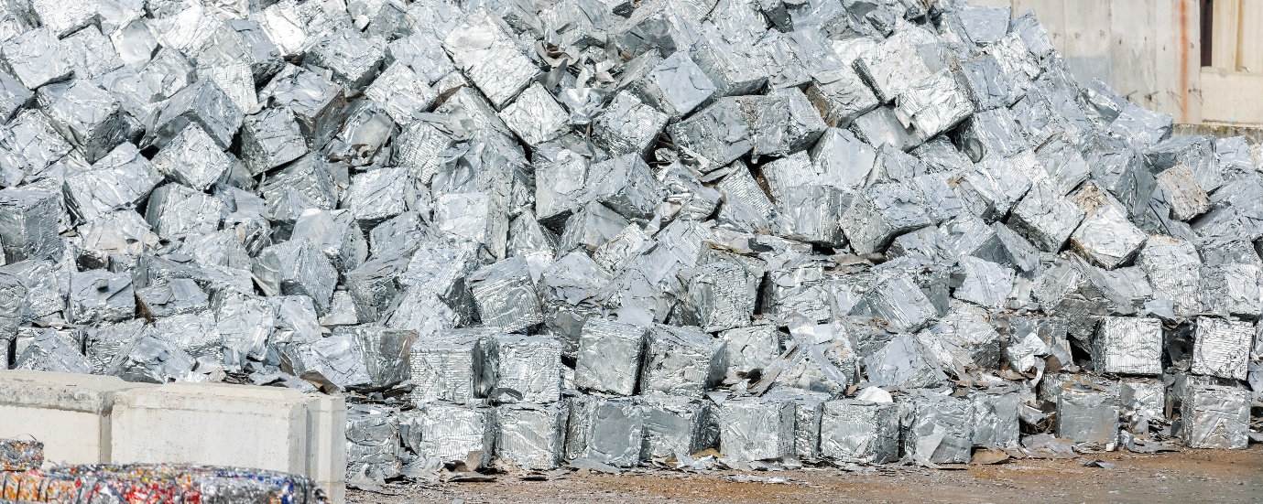
Figure 3: Aluminium briquettes (Image © Shutterstock/K-FK)
An extract of the Product Design Specification relating to your part of the project is provided below. This includes performance requirements, budget constraints and an expected timeframe for completion.

Product Design Specification
Middlesex Aerospace is looking to commission a batch of manual, lever-operated swarf-compaction devices. These must be simple to operate, physically robust and require no external electrical, hydraulic or pneumatic power.

Performance and operational requirements

Mechanism
The device must use a manual lever mechanism to be operated by a single worker pulling a large handle.

Briquette shape and weight
The finished briquettes must be rectangular in shape.
They must not exceed 1 kg to ensure safe manual handling by a workshop operator.

Briquette storage
The finished briquettes must stack inside standard workshop storage containers measuring 1100 × 1100 × 600 mm.

Ease of use
The lever handle must feature a clear visual or physical instruction to indicate how the operator activates the compaction stroke (e.g. an engraved arrow or ‘Pull Here’ label).

Safety and ergonomics

Stability and mounting
The device must include integrated mounting points (e.g. pre-drilled base plates) so that it can be securely bolted or clamped to a standard workshop workbench or floor.

User safety
The design must feature physical guards or shields around moving parts to eliminate the risk of finger pinch hazards during the lever stroke.

Force limitation
The lever must be designed with appropriate length and mechanical advantage so that a standard operator can easily compress the swarf without excessive physical strain.

Materials, manufacture and quality

Durability
The device must be constructed from robust materials capable of withstanding high stresses, structural strain and repetitive daily use (e.g. structural steel or heavy-duty alloys).

Maintenance and security
The mechanism must be tamperproof to prevent unauthorised disassembly, while requiring minimal routine maintenance (e.g. simple pivot lubrication points).

Dimensional accuracy
The device must compact the swarf consistently, achieving a tolerance of ±5 mm on all dimensions of the finished briquettes.

Budget constraints
Middlesex Aerospace has proposed the following purchasing strategy, depending on the final design and manufacturing costs submitted by the engineering team:
- a maximum budget of £1,500 per unit for a total batch of five units.
This gives a total budget of £7,500.

Costing assumption
For all design, fabrication and assembly tasks, assume an average labour and manufacturing cost of £60 per hour.

Project duration and deadlines
The project schedule has been selected by the client. For five units, the entire design, prototyping and manufacturing cycle must be completed within six weeks.

Task 1: Researching and compiling a technical proposal
This task requires you to interpret and respond to the Product Design Specification (PDS). You must research manual lever-operated mechanisms, materials and safety constraints. You must plan and scope the project parameters, including labour resources and costs, and compile a technical proposal confirming how your design will meet the client’s requirements.

Part A: Research
In preparation for writing the technical proposal, you should research and analyse the areas outlined below.

Existing products and mechanisms
- Investigate existing manual compression devices, such as manual can crushers, toggle presses and workshop lever presses.
- Analyse how they achieve mechanical advantage.

Material selection
- Research suitable, cost-effective materials, such as structural steel sections, pivot pins and hardware, that can withstand repetitive daily stresses.
- Consider their cost and ease of maintenance.

Briquette sizing and logistics
- Calculate a suitable rectangular briquette volume and the dimensions to ensure that it remains under the 1 kg weight limit and fits efficiently inside the specified
1100 × 1100 × 600 mm storage container.

Health and safety, and ergonomics
- Research the safety hazards of handling raw, sharp aluminium swarf, including cutting risks and residual cutting fluids.
- Identify physical design features, such as pinch-point guards and stable mounting methods, to protect the operator.
Capture and organise your research notes. These should include your planned research approach, a list of the sources that you have looked at and used, and any mathematical calculations used to determine briquette sizes. The following list may be useful for reference:

- manufacturers’ websites
- materials and their properties
- standard and non-standard parts (if needed)
- sketches/photographs/annotations
- dimensions/tolerances and calculations
- datasheets
- health and safety
- standards (ISO, BS, etc.).

Part B: Compiling a technical proposal

Remember!
- Conduct good-quality research using a range of sources to identify:
- any products that are currently available
- health and safety legislation
- materials to use.
- Whenever you visit a website and use information, reference the site appropriately within your notes. For example:
M.S. Raju, Dr S. Krishna, Dr C.M. Ramesh (2015), ‘A Comparative Study of Aluminium Alloy and Titanium Alloy’ in the International Journal on Recent Technologies in Mechanical and Electrical Engineering (IJRMEE), volume 2, issue 8. Available at: /www.ijrmee.org/download/1442032969_11-09-2015.pdf (accessed: 14/09/2026).
- You must also acknowledge your use of artificial intelligence (AI) and show how you have used it.
Using your research and the constraints in the Product Design Specification, write a structured technical proposal detailing your initial idea for the manual lever-action compaction device.
Your proposal should include:
- Proposed mechanism and rationale: an explanation of your chosen lever configuration (e.g. class of lever) and how it provides sufficient mechanical advantage for an operator.
- Briquette design and dimensions: the rectangular dimensions of your proposed briquette, with calculations showing that it meets the 1-kg weight limit and fits the storage container.
- Material specifications: the chosen materials for the primary frame, the lever arm and the compaction die/chamber, including a justification of their durability and cost.
- Safety and maintenance plan: how your design addresses user safety (e.g. pinch-points, stability) and how the device will be maintained in a busy workshop.
- Initial cost estimation: a top-level estimate of material costs and the estimated manufacturing hours required to fabricate the unit within the £1,500 budget.

Document submissions
At the end of Task 1, you must submit the following documents:
- Research notes and a reference list, showing evidence of your research planning and source validation.
- Technical proposal, presented as a structured, digital report.

Task 2: Communicating an initial design
Your technical proposal from Task 1 has been submitted to Middlesex Aerospace who have accepted it. They have asked you to develop your design ideas. You must prepare sketch designs and calculations for the swarf briquetting machine. You must produce a high-quality CAD drawing of your final lever-action compaction device and use this to communicate your design ideas.

Part A: Initial designs and engineering calculations
You are to prepare a design concept, including fully annotated hand-drawn sketches on paper, of a potential design for the manual lever-operated swarf compactor. Your sketches must clearly illustrate:
- The lever mechanism: how the handle, pivot points and compaction plunger/plate interact to compress the swarf into the die chamber.
- The die chamber: how loose swarf is loaded and contained, and how the compressed rectangular briquette is ejected.
- Materials and construction: clear labels indicating which materials and raw stock shapes (e.g. box section steel, flat plate, steel pins) are used for key parts.
- Safety and ergonomics: features protecting the operator, such as hand grips on the lever, pinch-point guarding and stable workbench mounting holes.
- Key dimensions: the rough dimensions of the machine and the rectangular briquette that it produces.
As part of your design concept, you must perform and document the following calculations, stating any assumptions you make:
- Storage logistics: based on your chosen briquette dimensions, calculate exactly how many of your briquettes will fit inside the 1100 × 1100 × 600 mm container.
- Production costings: estimate the total cost to manufacture a batch of five units. This must include:
  - an estimated Bill of Materials (BOM) – the cost of steel, fixings, pins, etc. per unit
  - the estimated fabrication and assembly hours required to build the units, calculated at the workshop rate of £60 per hour
  - a confirmation that your total cost per unit remains within the £1,500 limit.

Remember!
This task is asking you for ‘annotated sketches’, which are commonly referred to as hand drawings. The CAD drawing will be required in Part B. It is important not to rely on CAD drawings and files for Part A, as this limits how well you can demonstrate your core knowledge and understanding.

Part B: CAD modelling and design justification
Use your design concept from Part A to develop a final, detailed CAD drawing, using a modelling tool.
Your CAD output should follow standard technical drawing conventions and include:
- 2D orthographic drawings (2D views of 3D objects) with dimensions.
- An assembly view showing the overall layout and crucial dimensions.
- Clearly labelled components and annotations explaining key design details, such as pivot points or mounting holes.
You must include a set of reflective notes with your CAD drawing, explaining the evolution of your design and how you have met the brief.
In these notes, you must justify your engineering decisions, including:
- Mechanism choice: explain why you chose your specific lever class and arrangement – e.g. how it maximises mechanical advantage for the operator).
- Material selection: justify why your chosen materials are suitable for high daily stresses, and how they will minimise future maintenance.
- Product Design Specification alignment: explain exactly how your final design satisfies the client’s requirements for safety, budget and physical footprint.

Remember!
- Alongside the hand drawings in Part A and the CAD drawing(s) produced in Part B, the reflective notes must be thorough and cover the mechanisms/features used, and why.
- Create your CAD drawings so that a third party could reproduce the product. Make sure that you include dimensions. Always include a title block, as in industry, providing essential administrative and technical information such as iteration, scale and units, projection, and alignments for an orthographic drawing.

Document submissions
At the end of Task 2, you must submit the following documents:
- Hand-drawn sketches for a potential design with annotations.
- Supporting calculations, covering storage capacity and batch production costs.
- 2D orthographic drawing(s) with dimensions.
- Annotated CAD assembly drawing(s) for your design, dimensioned.
- Reflective notes justifying design decisions and explaining how your final design meets the Product Design Specification requirements.

Task 3: Developing a manufacturing plan
Your CAD drawing from Task 2 has been approved. Middlesex Aerospace now want you to produce a detailed manufacturing plan, including a supporting statement. This will set out how the workshop team will fabricate, assemble, test and deliver the batch of five manual lever-operated swarf compactors within the six-week deadline and £7,500 total budget.

Part A: Programme of Works
Using digital software, such as spreadsheet software or a project planning tool, produce a professional Programme of Works detailing the stages and considerations required to complete the manufacture of your final swarf compactor.
The Programme of Works must include:
- Key project phases. Break up the six-week project into clear, logical phases:
  - Procurement – ordering and receiving raw steel, fixings, pins and safety guards.
  - Fabrication – cutting, drilling, welding or machining the components.
  - Assembly – assembling the frame, lever mechanism and die chamber.
  - Quality control and testing – testing mechanical advantage and dimensional tolerances.
  - Delivery and installation – workbench mounting and operator handover.
- A visual timeline – a Gantt chart – to show the start date, duration and sequence of all activities across the six weeks.
- A critical path analysis to highlight which tasks are critical to meeting the six-week deadline. These are tasks that, if delayed, will delay the entire project, such as waiting for raw material delivery.
- A risk assessment which outlines the risk associated with each task, the likelihood of it happening and the impact should something occur.
- Resource and equipment allocation to identify what workshop machinery and tools are needed for each stage (e.g. bandsaw, pillar drill, welding set, hand tools).

Remember!
- You should ensure that your project planning tool (Gantt chart and critical path analysis) is sufficiently detailed to display the full lifecycle of the project.
- Highlight any assumptions you have made during your planning to show understanding of real-world risk management and project limitations. Assumptions are conditions or factors that you accept as true without direct proof to complete your plan. For example, assuming that workshop machinery is always available, or that raw materials arrive without delivery delays.

Part B: Supporting statement
Alongside your Programme of Works, you need to provide a supporting statement justifying the approaches you have taken during the planning. This document is your technical proposal justifying how you plan to manage the manufacturing process safely and efficiently.
Your supporting statement must cover the areas outlined below.

Manufacturing step by step
Outline the primary physical processes required to construct the main components of your lever-action compaction device. For example, cutting hollow steel sections for the frame, machining the pivot pins and fabricating the rectangular press plate.

Health and safety (risk assessment)
Identify the key risks associated with fabricating this metal device (e.g. welding fumes, sharp metal edges, heavy lifting) and the control measures (PPE, extraction) required to protect the workshop team.

Quality control (QC) plan
Explain how you will inspect the completed units to ensure that they meet the client’s tolerance requirements of ±5 mm on the finished briquettes.

Relevant engineering standards
Identify any relevant workshop safety or manufacturing standards that must be adhered to, such as British/ISO standards for machinery safety or welding quality.

Waste management and the environment
Outline how waste generated during manufacturing, such as offcuts of steel or cutting fluids, will be managed sustainably, mirroring Middlesex Aerospace’s commitment to the environment.

Remember!
The supporting statement needs to be comprehensive and cover each of the points listed – in particular, the manufacturing method you have chosen. This helps to demonstrate how you have met the requirements of the brief.

Document submissions
At the end of Task 3, you must submit the following documents:
- Programme of Works/Gantt chart (created digitally).
- Supporting statement presented as a structured report.

Task 4: Presenting a design and plan
You have completed the designs for the manual lever-operated swarf compactor and are now required to present them in a meeting to senior managers at Middlesex Aerospace. One of the managers has a technical background in workshop supervision; the second does not.
You are to prepare and deliver a presentation covering:
- the final design solution, including an outline of the key features of the machine
- the Programme of Works, budget and materials used in your design
- challenges presented by the brief and how these have been overcome, including future improvements
- how well your design proposal addresses the requirements of the Product Design Specification.
It is expected that you will use digital technology for the presentation.
Your teacher will take the role of a senior manager from Middlesex Aerospace. They will ask questions relating to your presentation from the client’s perspective.

Remember!
- When you give a presentation, digital tools such as PowerPoint are used to help visualise and add value to your presentation. You should not rely too heavily on your slides or read them word for word. It is important to have visuals that are clear and can be seen by your audience, with a consistent design.
- Ensure you use the correct technical language and terminology, drawing on core knowledge from the whole T Level, including English, maths and digital skills.
- Use a consistent font to ensure that your slides look professional.

Timing of presentation
You will have two hours to prepare your presentation.
You will have 30 minutes to present your findings and respond to questions (typically split with 20 minutes for presenting your findings and 10 minutes for responding to questions).

Document submissions
At the end of Task 4, you do not need to submit any documentation. However, you may find it useful to keep copies of your presentation materials (slides, handouts, etc.) and a hard copy of your digital file to review and reflect on at a later date.
Additional evidence of your performance that may be captured:
- Video recording of presentation
- Presentation Q&A record.

