Designing a sustainable compaction device
If you have never worked in, or visited, a computer numerical control (CNC) machine shop, you may not have heard the terms ‘swarf’ and ‘briquetting’.
This guide will explain what these materials are, why we should compress them, and what your manual lever-operated design is expected to look like.

What is swarf?
When industrial machines carve complex components out of solid blocks of aluminium, they also produce a mountain of waste.
This waste is called swarf, or sometimes metal chips or turnings (Figure 1).
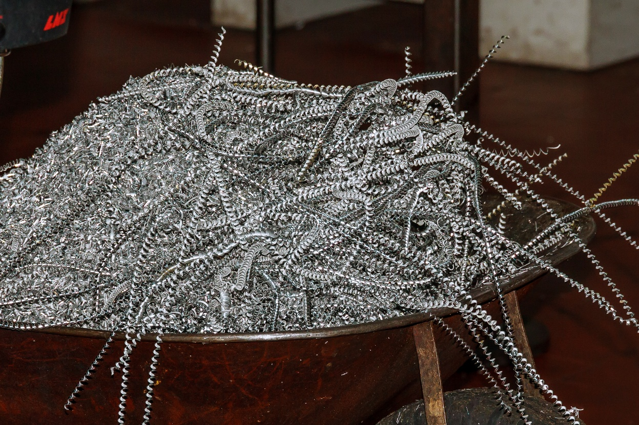
Figure 1: Aluminium swarf from machining (Image © Shutterstock/ZhakYaroslav)

The problem with swarf
- Swarf is springy, curly and incredibly messy.
- It is sharp, and handling loose swarf can easily cause cuts to operators.
- CNC machines use liquid coolants and oils. Loose swarf holds onto these fluids, creating fire and slip hazards.
- Swarf is also mostly air! A massive bin of swarf is about 90% empty space and only 10% metal. This makes it expensive to store and transport.

What is a ‘briquette’?
A metal briquette, or swarf brick, is a solution to the problems listed above. By applying immense pressure to the loose swarf, we squeeze out the air and the residual cutting fluids, compressing the metal into a highly dense, neat and solid block (Figure 2).
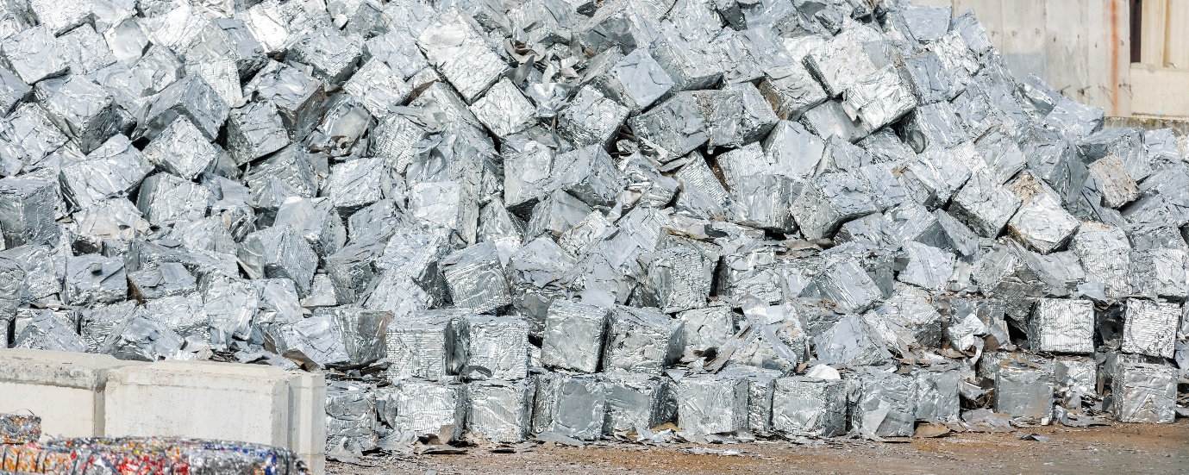
Figure 2: Aluminium briquettes (Image © Shutterstock/ K-FK)

Why are briquettes the solution?
- They greatly reduce the storage volume of the waste.
- Clean, solid blocks of aluminium are worth significantly more to recycling companies than loose, messy shavings.
- The oils and coolants squeezed out of the metal during compression can be captured and reused.

How does a manual lever machine work?
You are designing a mechanical manual lever machine, with no hydraulics or electric motors. To help you, imagine a heavy duty, industrial version of a household wall-mounted can crusher or a workshop toggle press.
Your design will have three primary mechanical zones: a compaction chamber, lever mechanism, and frame and mounts.

The compaction chamber (the ‘die’)
Typically, this is the heavy-duty metal chamber into which the loose swarf is loaded. It may require a lid or a slide-gate to load the loose shavings, and a flat plunger (or ram) to squeeze the swarf against the wall of the chamber. Once compressed, there will need to be a mechanism, such as a release hatch or sliding floor, to eject the finished solid brick.

The lever mechanism
Because compressing metal requires massive force, a human cannot just push the plunger directly. Think about how you can multiply human strength. For example, a long handle (a lever arm) could act as your input. In this case, you would need to determine the class of lever or link arrangement that gives you the maximum mechanical advantage at the end of the stroke, where the swarf is most compressed and hardest to squeeze.

The frame and mounts
If you use a long lever and an operator pulls down hard on it, the entire device will naturally tip over. How could you stabilise the frame? One option would be to add a heavy-duty base plate to the frame, with pre-drilled holes to bolt it directly to a wooden or steel workshop workbench, or to the floor. You also need to consider safety features, such as physical guards to shield any moving pivots so that the operator's fingers cannot accidentally get trapped.

